Supporting Information for
Integrating Overall Water Splitting with Advanced Oxidation for Wastewater Treatment Using a Bifunctional Medium-Entropy Amorphous Alloy
Yifan Cui^{1,2,3,4}, Yonghui Wang⁵, Bo Li^{1,4}, Jiaqi Huang^{1,4}, Le Bo^{1,4}, Hengqi Liu⁵, Mahlanyane Kenneth Mathe⁶, Murodjon Samadiy⁷, Shengfeng Guo⁸, Hongxian Shen^{1,4}, Jianfei Sun^{1,4}, Sida Jiang^{1,2,3,4*}
¹School of Materials Science and Engineering, Harbin Institute of Technology, Harbin 150001, P. R. China
²Laboratory for Space Environment and Physical Sciences, Harbin Institute of Technology, Harbin 150001, P. R. China
³Frontier Science Center for Interaction between Space Environment and Matter, and National Key Laboratory of Space Environment and Matter Behaviors
⁴National Key Laboratory for Precision Hot Forming, Harbin Institute of Technology, Harbin 150001, P. R. China
⁵School of Physics, Harbin Institute of Technology, Harbin 150001, P. R. China
⁶Department of Chemistry, University of South Africa, Johannesburg 1709, South Africa
⁷Department of Chemical Engineering and Biotechnology, Karshi State Technical University, Karshi 180100, Uzbekistan
⁸School of Materials and Energy, Chongqing Key Laboratory for Advanced Materials and Technologies of Clean Energies, Southwest University, Chongqing 400715, P. R. China
*Corresponding author. E-mail: jiangsida@hit.edu.cn (Sida Jiang)
Supplementary Figures and Tables
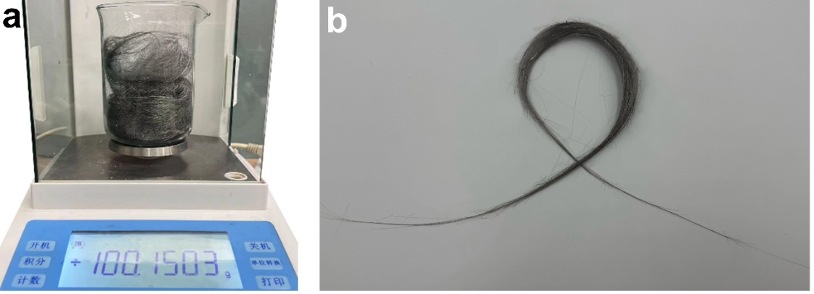
Fig. S1 a One manufacturing batch resulted in around ~ 100 g of (FeCoNi)₈₀B₂₀ fibers. b The digital photograph of the fiber prepared by melt-extraction

Fig. S2 a SEM images of the fibers with smooth surface that prepared by melt-extraction. b EDS maps of the (FeCoNi)₈₀B₂₀ as-prepared fiber surface. The SEM images demonstrated the fibers have a diameter of approximately 30 μm with uniform surface elemental distribution

Fig. S3 B 1s XPS spectra of as-prepared (FeCoNi)₈₀B₂₀ fiber. The B 1s spectrum confirmed the existence of B-B and B-O bonds

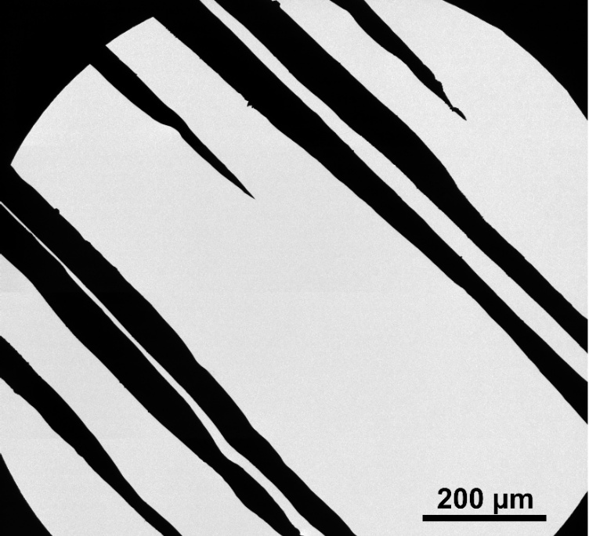

Fig. S4 TEM image of the (FeCoNi)₈₀B₂₀ fibers after ion milling. TEM analysis was performed on a thin region of the sample

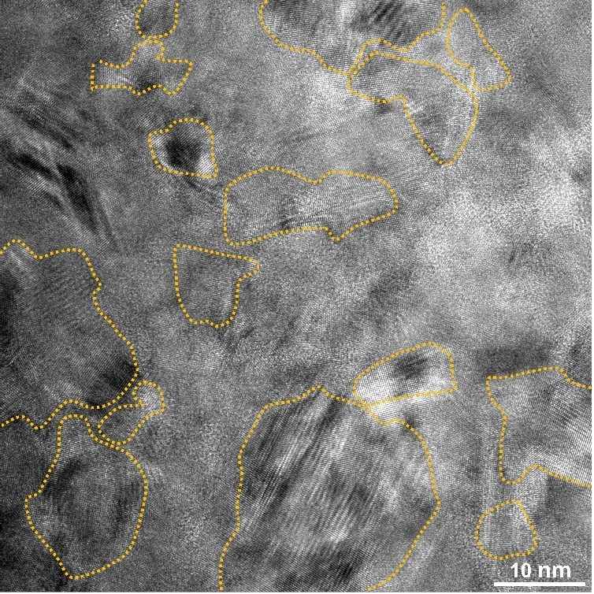

Fig. S5 HRTEM image of the (FeCoNi)₈₀B₂₀ fiber that demonstrated the construction of the crystalline–amorphous (c-a) heterostructure. The nanocrystals, with diameters ranging from 10–20 nm and present in large quantities
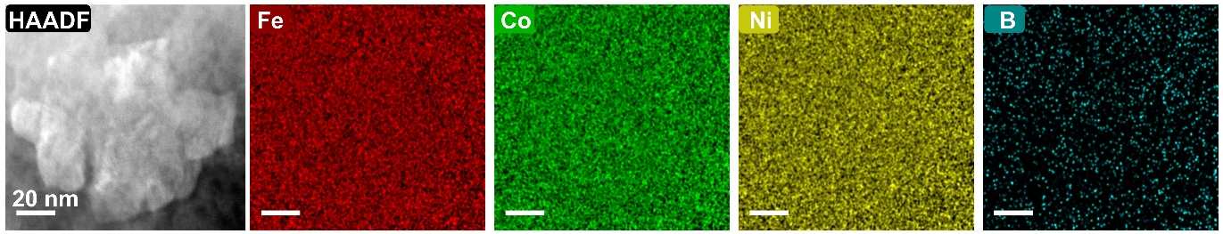
Fig. S6 EDS maps of (FeCoNi)₈₀B₂₀ fiber that exhibited a uniform elemental distribution of amorphous

Fig. S7 Reusability of Fe₈₀B₂₀ fibers. The degradation time was set at 30 and 40 seconds to evaluate the catalyst's reusability. The Fe₈₀B₂₀ fibers maintained its activity for 25 cycles

Fig. S8 Degradation efficiency of (FeCoNi)₈₀B₂₀ fibers for various a fiber dosage, b contaminant concentration and (c) temperature. The optimal operating conditions were identified as a catalyst loading of 0.5 g L⁻¹, an RhB concentration of 25 mg L⁻¹, and ambient temperature

Fig. S9 ICP-OES results of Fe, Co and Ni elements during the degradation process. During degradation, the leaching of Fe, Co, and Ni was detected, with Fe exhibiting the most pronounced release, indicating its dominant role as the primary active site in AOPs

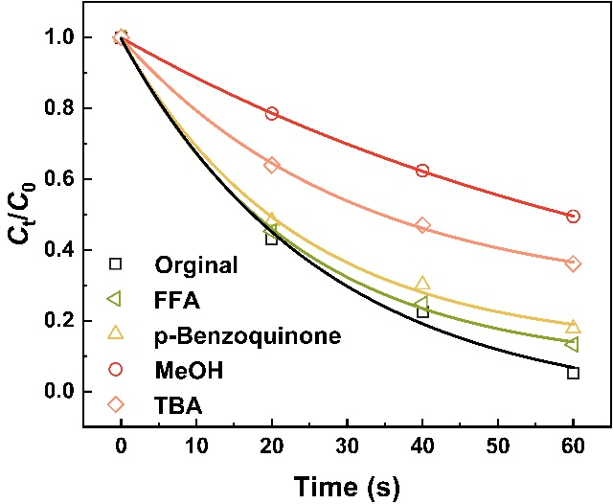
Fig. S10 Quenching experiments results of (FeCoNi)₈₀B₂₀ fibers using furfuryl alcohol (FFA), p-Benzoquinone, methyl alcohol (MeOH) and tertiary butanol (TBA) as quenching agents. The results demonstrated that the pivotal role of ·OH and SO4·⁻generated radicals in organic molecule degradation and the small amounts of O₂·⁻, and ¹O₂ species were produced during the water treatment processes

Fig. S11 Electrochemical polarization curves of Fe₈₀B₂₀, Fe₇₅Ni₂₅, Fe₃₃Co₃₃Ni₃₄ and (FeCoNi)₈₀B₂₀ fibers. Electrochemical polarization analysis using the Tafel extrapolation method revealed that (FeCoNi)₈₀B₂₀ possessed the lowest self-corrosion current density (I_{corr} = 0.0046 mA cm⁻²), indicating superior corrosion resistance
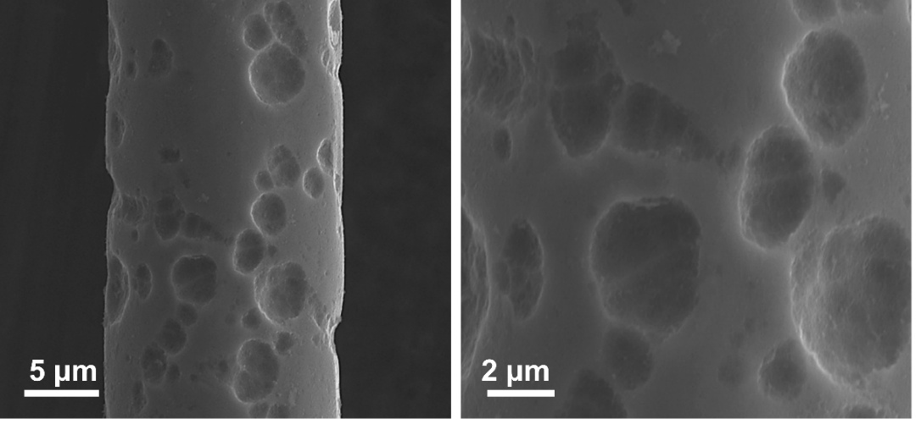

Fig. S12 SEM images of the (FeCoNi)₈₀B₂₀ fiber after 30 times cycle. The fiber surface exhibited extensive spalling accompanied by precipitate formation

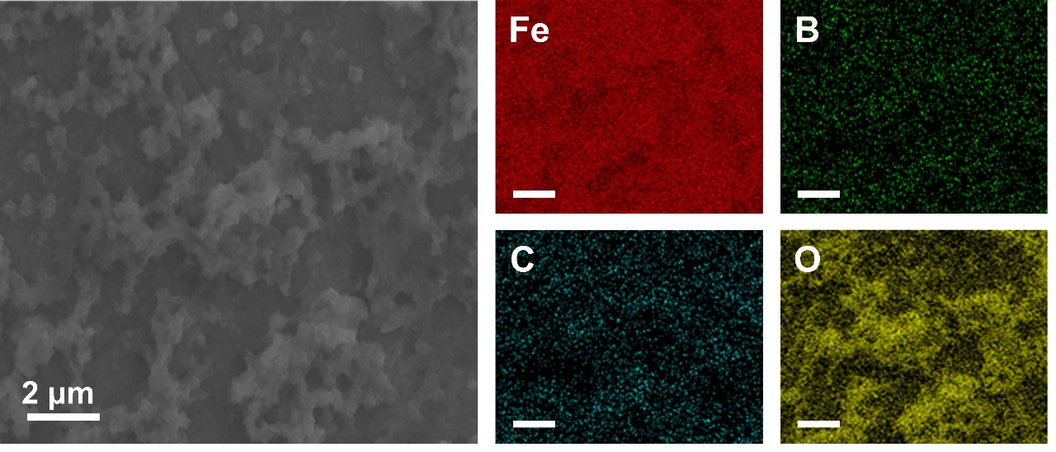
Fig. S13 EDS maps of the precipitates of (FeCoNi)₈₀B₂₀ fiber after 30 times cycle. The EDS mapping revealed that these precipitates were primarily composed of Fe, C, and O, which was identified as the main cause of catalyst deactivation

Fig. S14 Nyquist plots of the catalysts in 1.0 M KOH for OER. Among the tested samples, (FeCoNi)₈₀B₂₀ demonstrated the lowest charge-transfer resistance, indicating the accelerated Faradaic processes.

Fig. S15 CV curves of the fiber in 1 M KOH at different scan rates (10, 30, 50, 70, 90, 110 mV s⁻¹): a Fe₇₅Ni₂₅, b Fe₃₃Co₃₃Ni₃₄, and c (FeCoNi)₈₀B₂₀ fibers. d C_{dl} corresponding to different scan rates. According to the reported typical value, the specific capacitance (C_{s}) in 1 M KOH is selected as C_{s} = 0.040 mF cm². Therefore, the (FeCoNi)₈₀B₂₀ fibers exhibit the maximum ECSA value, indicating abundant active sites, which correspond to optimal OER performance

Fig. S16 Chronopotentiometry curves of (FeCoNi)₈₀B₂₀ under current density of 200 mA cm⁻² without iR correction. The (FeCoNi)₈₀B₂₀ fiber maintained stable operation for 120 h with only a modest increase in potential

Fig. S17 Electrocatalytic HER performance. a LSV curves of different samples (iR corrected, scanning rate: 5 mV s⁻¹) in 1.0 M KOH. b Tafel plots for the data presented in a. c Nyquist plots, where the inset shows the equivalent circuit model. The (FeCoNi)₈₀B₂₀ electrode revealed the lowest overpotential and R_{ct}
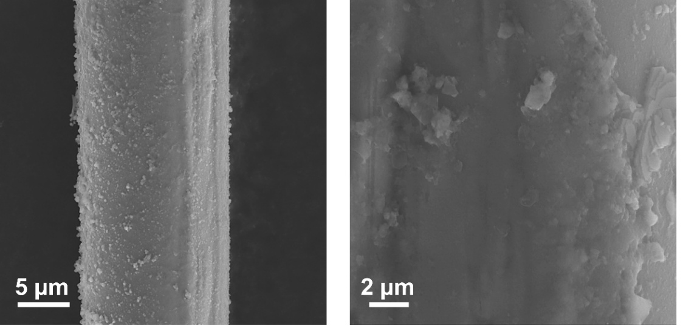

Fig. S18 SEM images of the (FeCoNi)₈₀B₂₀ fiber after after 250 h water splitting stability test. After 250 h of stability testing, the fiber surface remained smooth and self-supporting

Fig. S19 EDS maps of the (FeCoNi)₈₀B₂₀ fiber after 250 h water splitting stability test. The surface of the fiber maintained uniform elemental distribution that was obviously different with the fiber after AOPs reusability test

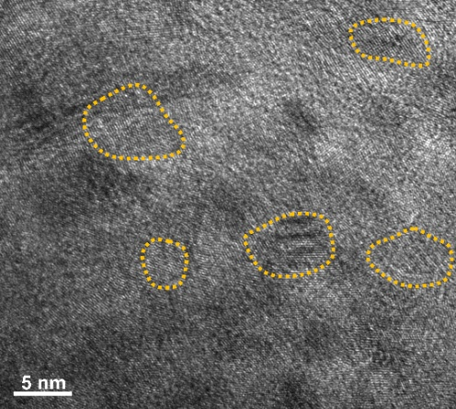

Fig. S20 HRTEM image of the (FeCoNi)₈₀B₂₀ fiber after 250 h water splitting stability test. The decrease in nanocrystal size likely contributes to the reduced OER activity

Fig. S21 a Chronopotentiometry curves of (FeCoNi)₈₀B₂₀ at 200 mA cm⁻² of the synchronized process without iR correction. b Chronopotentiometry curves of (FeCoNi)₈₀B₂₀ at 200 mA cm⁻² after degradation without iR correction. The fiber shown more excellent stable during the synchronized process

Fig. S22 The LSV curves of the addition of a RhB and b Na₂S₂O₈. c Degradation efficiency comparison on the change of applied current. The presence of RhB and Na₂S₂O₈ exerted only a negligible influence on OER performance, whereas the decolorization efficiency was significantly accelerated under an applied current owing to enhanced electron transfer

Fig. S23 a Co 2p, b B 1s and c O 1s XPS spectra of (FeCoNi)₈₀B₂₀ during the AOPs, water splitting and synchronized process. The XPS spectra exhibited no substantial changes in peak features, indicating the structural stability of (FeCoNi)₈₀B₂₀ under different operating conditions

Fig. S24 a Fe 2p and b Ni 2p XPS spectra of (FeCoNi)₈₀B₂₀ during the AOPs, water splitting and synchronized process. The Fe 2p and Ni 2p spectra displayed the evident negative shifts after the synchronized process, suggesting an increased electron density around Fe and Ni atoms, which is beneficial for catalytic activity

Fig. S25 Raman spectroscopy of (FeCoNi)₈₀B₂₀ after AOPs, water splitting and synchronized processes compared with the as-prepared fiber. The fiber after the synchronized process exhibited enhanced Raman bands at 281, 472, 554, and 715 cm⁻¹, which were characteristic of FeOOH and NiOOH, indicating the formation of the active M-OOH species during operation

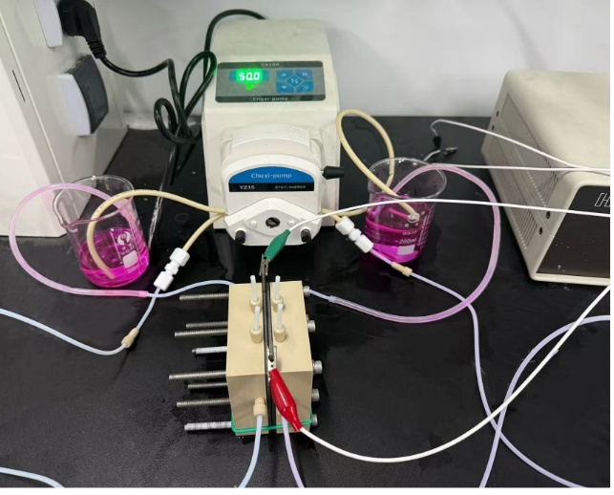
Fig. S26 The digital photograph of the AEM system of the synchronized process. A peristaltic pump was used to regulate the flow of 1.0 M KOH electrolyte to both sides of the electrolyser at a rate of 2.5 mL min⁻¹ throughout the testing
Fig. S27 X-ray diffraction patterns of (FeCoNi)₈₀B₂₀ before and after the synchronized process. The crystalline peaks became less sharp after the synchronized process, suggesting the occurrence of structural reconstruction during the process

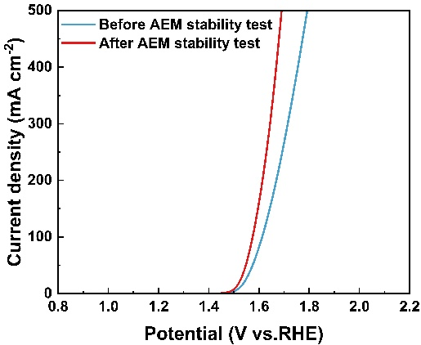

Fig. S28 LSV curves of (FeCoNi)₈₀B₂₀ before and after 100 stability tests at current density of 200 mA cm⁻² in simulated reclaimed water (iR corrected, scanning rate: 5 mV s⁻¹)

Fig. S29 (a) SEM image and (b) EDS maps of the (FeCoNi)₈₀B₂₀ after 115 h synchronized process. The SEM images demonstrated that the fibers retained their self-supporting structure, while abundant surface precipitates were observed. EDS mapping confirmed that these precipitates were primarily composed of Fe, C, and O

Fig. S30 Cyclic voltammetry (CV) curves of (a) Fe₇₅Ni₂₅, (b) Fe₃₃CO₃₃Ni₃₄ and (c) (FeCoNi)₈₀B₂₀ in 1 M KOH with and without methanol (1 M). Scan rate: 50 mV/s. The (FeCoNi)₈₀B₂₀ exhibited the moderate adsorption energy of the OH*

Fig. S31 The surface adsorption process of OER for Ni site of amorphous (FeCoNi)₈₀B₂₀ and nanocrystalline Ni₄B₃

Fig. S32 The surface adsorption process of AOPs for Fe site of amorphous (FeCoNi)₈₀B₂₀ and nanocrystalline Fe₃B

Fig. S33 Partial density of states (pDOS) for amorphous a (FeCoNi)₈₀B₂₀, b nanocrystalline Ni₄B₃ and c Fe₃B. The pDOS analysis further indicated that Fe, Co, and Ni sites collectively regulated the adsorption characteristics of (FeCoNi)₈₀B₂₀, thereby facilitating intermediate desorption in both catalytic reactions

Fig. S34 Partial radial distribution function (PRDF) between Fe, Co and Ni of the (FeCoNi)₈₀B₂₀. The analysis of the first PRDF peak reveals the specific coordination number for each sample

Table S1 Comparison of k_{obs} and reusability times for various catalysts
Materials | Reusability (times) | k_{obs} (min⁻¹) | References
Fe₃O₄ | 6 | 0.019 | [S1]
FeSiB | 3 | 0.16 | [S2]
FeSiB | 4 | 0.519 | [S3]
FeSiB | 8 | 0.8 | [S4]
FeSiB | 15 | 1.34 | [S5]
FeSiB | 20 | 0.64 | [S6]
FeSiB | 23 | 0.25 | [S7]
FeSiB/Cu | 8 | 0.217 | [S8]
FeBY | 11 | 0.011 | [S4]
FeMoB | 15 | 0.36 | [S9]
CoMoB | 20 | 2.31 | [S10]
FeCuBP | 4 | 0.4 | [S2]
FeSiBNb | 10 | 0.183 | [S11]
FeCoNiB | 30 | 1.366 | This work
FeAlCoNiB | 5 | 0.55 | [S12]
FeCoCrMoCBY | 50 | 0.57 | [S13]

Table S2 Comparison of OER overpotential and Tafel slope for various catalysts
Materials | Overpotential at  10 mA cm⁻² (mV) | Tafel slope  (mV dec⁻¹) | References
IrO₂ | 260 | 45.0 | [S14]
RuO₂ | 275 | 110.7 | [S15]
NiFe LDH | 300 | 40.0 | [S14]
FeCo LDH | 331 | 85.0 | [S16]
FeNiB | 319 | 56.0 | [S17]
FeCoB | 315 | 26.0 | [S18]
FeNiMoB | 227 | 35.0 | [S19]
CoMoO₄ | 312 | 56.0 | [S20]
FeCoNiMoPB | 281 | 36.49 | [S21]
FeNi | 335 | 53.5 | This work
FeCoNi | 288 | 45.3 | This work
FeCoNiB | 276 | 53.45 | This work

Table S3 The ICP-OES results of the electrolyte after 250 h water splitting stability test at 200 mA cm⁻²
Element | Concentration (µg/mL)
Fe | 21.39
Co | 29.70
Ni | 26.63

Table S4 The ICP-OES results of the electrolyte after AOPs and synchronized process
Reactions | Elements | Precipitation rate (µg/mL/min）
AOPs | Fe | 0.239
AOPs | Co | 0.335
AOPs | Ni | 0.346
synchronized process | Fe | 1.015
synchronized process | Co | 1.492
synchronized process | Ni | 1.5265
Table S5 Comparison of water splitting performance at high current density of medium/high entropy amorphous alloys prepared by various methods
Material | Current density  (mA cm⁻²) | Voltage  (V) | Prepared methods | References
NiCoFeP @NiCoFe-LDH | 1000 | 1.86 | Hydrothermal synthesis+Annealing | [S22]
AC-NP-CuNiCo | 10 | 1.53 | Melt-spinning method+Dealloying | [S23]
RuVCoCuZnW | 500 | 1.66 | Flash joule heating device | [S24]
AC-HEA-CuAgAuIrRu | 10 | 1.49 | Melt-spinning method+Dealloying | [S25]
FeCoNiCuMoB | 10 | 1.48 | Magnetron sputtering | [S26]
Fe-NiWB | 500 | 1.55 | Electroless plating | [S27]
NiNbIrPt | 10 | 1.51 | Melt-spinning method+Dealloying | [S28]

Supplementary References
[S1] P. V. Nidheesh, R. Gandhimathi, S. Velmathi, N. S. Sanjini. Magnetite as a heterogeneous electro fenton catalyst for the removal of rhodamine b from aqueous solution. RSC Adv. 4(11), 5698-5708 (2014). https://doi.org/10.1039/C3RA46969G
[S2] P. Zhang, Y. a. Zhu, Y. Zhang, T. Lu, Y. Pan. Heterogeneously structured fecubp amorphous–nanocrystalline alloy with excellent dye degradation efficiency. Appl. Phys. A. 127(5), 330 (2021). https://doi.org/10.1007/s00339-021-04485-x
[S3] Z. Jia, X. Duan, P. Qin, W. Zhang, W. Wang et al., Disordered atomic packing structure of metallic glass: Toward ultrafast hydroxyl radicals production rate and strong electron transfer ability in catalytic performance. Adv. Funct. Mater. 27(38), 1702258 (2017). https://doi.org//10.1002/adfm.201702258
[S4] P. Liu, J. L. Zhang, M. Q. Zha, C. H. Shek. Synthesis of an Fe rich amorphous structure with a catalytic effect to rapidly decolorize azo dye at room temperature. ACS Appl. Mater. Interfaces. 6(8), 5500-5505 (2014). https://doi.org/10.1021/am501014s
[S5] Y.-X. Ge, P.-Y. Zhu, Y. Yu, L.-C. Zhang, C. Zhang et al., Remarkably enhanced fenton-like catalytic activity and recyclability of fe-based metallic glass by alternating magnetic field: Mechanisms and industrial applications. J. Mater. Chem. A. 10(43), 23314-23322 (2022). https://doi.org/10.1039/D2TA06216J
[S6] Z. Jia, X. Duan, W. Zhang, W. Wang, H. Sun et al., Ultra-sustainable Fe₇₈Si₉B₁₃ metallic glass as a catalyst for activation of persulfate on methylene blue degradation under uv-vis light. Sci. Rep. 6(1), 38520 (2016). https://doi.org/10.1038/srep38520
[S7] Z. Jia, J.-L. Jiang, L. Sun, L.-C. Zhang, Q. Wang et al., Role of boron in enhancing electron delocalization to improve catalytic activity of fe-based metallic glasses for persulfate-based advanced oxidation. ACS Appl. Mater. Interfaces. 12(40), 44789-44797 (2020). https://doi.org/10.1021/acsami.0c13324
[S8] J. Wei, Z. Zheng, L. Huang, Z. Qiu, Q. Xia et al., Effective removal of orange ii dye by porous fe-base amorphous/cu bimetallic composite. Colloids Surf. A Physicochem. Eng. Asp. 656, 130388 (2023). https://doi.org//10.1016/j.colsurfa.2022.130388
[S9] Y.-n. Chen, S. Xiao, Y. Yang, C. Su, C. Dai et al., The rapid degradation of dye wastewater utilizing mofeb amorphous alloy wires. Colloids Surf. A Physicochem. Eng. Asp. 726, 137831 (2025). https://doi.org//10.1016/j.colsurfa.2025.137831
[S10] M. Tang, L. Lai, D. Ding, T. Liu, W. Kang et al., Rapid degradation of direct blue dye by co-based amorphous alloy wire. J. Non-Cryst. Solids. 576, 121282 (2022). https://doi.org//10.1016/j.jnoncrysol.2021.121282
[S11] J. C. Wang, Z. Jia, S. X. Liang, P. Qin, W. C. Zhang et al., Fe_{73.5}Si_{13.5}B₉Cu₁Nb₃ metallic glass: Rapid activation of peroxymonosulfate towards ultrafast eosin y degradation. Mater. Des. 140, 73-84 (2018). https://doi.org//10.1016/j.matdes.2017.11.049
[S12] S. Xie, X. Liao, X. Zeng, H. Yang, L. He. An iron-based high-entropy alloy with highly efficient degradation for p-nitrophenol. Acta Metall. Sin. (Engl. Lett.). 35(10), 1653-1664 (2022). https://doi.org/10.1007/s40195-022-01402-w
[S13] W. Luo, Q. Chen, L. Ji, X. Peng, G. Huang. Synergistic effect of various elements in Fe₄₁Co₇Cr₁₅Mo₁₄C₁₅B₆Y₂ amorphous alloy hollow ball on catalytic degradation of methylene blue. J. Rare Earths. 40(4), 605-615 (2022). https://doi.org//10.1016/j.jre.2021.02.003
[S14] D. Friebel, M. W. Louie, M. Bajdich, K. E. Sanwald, Y. Cai et al., Identification of highly active fe sites in (ni,fe)ooh for electrocatalytic water splitting. J. Am. Chem. Soc. 137(3), 1305-1313 (2015). https://doi.org/10.1021/ja511559d
[S15] Z. Kou, Y. Yu, X. Liu, X. Gao, L. Zheng et al., Potential-dependent phase transition and mo-enriched surface reconstruction of γ-coooh in a heterostructured co-mo2c precatalyst enable water oxidation. ACS Catal. 10(7), 4411-4419 (2020). https://doi.org/10.1021/acscatal.0c00340
[S16] B. Zhang, X. Zheng, O. Voznyy, R. Comin, M. Bajdich et al., Homogeneously dispersed multimetal oxygen-evolving catalysts. Science. 352(6283), 333-337 (2016). https://doi.org/doi:10.1126/science.aaf1525
[S17] H.-l. Li, Y.-y. Wang, C.-m. Liu, S.-m. Zhang, H.-f. Zhang et al., Enhanced oer performance of nifeb amorphous alloys by surface self-reconstruction. Int. J. Hydrogen Energy. 47(48), 20718-20728 (2022). https://doi.org//10.1016/j.ijhydene.2022.04.200
[S18] L. Xiao, J. Gao, X. Yao, X. Dong, F. Yang et al., Unraveling the role of nanocrystalline in amorphous nanoporous fecob catalysts for turning oxygen evolution activity and stability. Appl. Surf. Sci. 640, 158395 (2023). https://doi.org//10.1016/j.apsusc.2023.158395
[S19] B. Li, S.-D. Jiang, Q. Fu, R. Wang, W.-Z. Xu et al., Tailoring nanocrystalline/amorphous interfaces to enhance oxygen evolution reaction performance for feni-based alloy fibers. Adv. Funct. Mater. 35(2), 2413088 (2025). https://doi.org//10.1002/adfm.202413088
[S20] M. Q. Yu, L. X. Jiang, H. G. Yang. Ultrathin nanosheets constructed comoo4 porous flowers with high activity for electrocatalytic oxygen evolution. Chem. Commun. 51(76), 14361-14364 (2015). https://doi.org/10.1039/C5CC05511C
[S21] H. Chen, Y. Xin, Y. Wu, J. Jiang, D. Ding et al., Boosting the activity and stability of self-supporting feconimopb amorphous alloy for oxygen evolution. J. Alloys Compd. 947(169478 (2023). https://doi.org//10.1016/j.jallcom.2023.169478
[S22] X. Fu, H. Liao, Z. Zhang, Y. Zheng, J. Lu et al., Medium-entropy heterostructure of crystalline nicofep @ amorphous nicofe-ldh for industrial-current density and ultrastable overall water splitting. Chem. Eng. J. 505(159520 (2025). https://doi.org//10.1016/j.cej.2025.159520
[S23] M. Liu, S. Ning, D. Xiao, Y. Zhang, J. Han et al., Amorphous/crystalline heterostructured nanoporous high-entropy metallic glasses for efficient water splitting. Mater. Futures. 4(2), 025303 (2025). https://doi.org/10.1088/2752-5724/add415
[S24] K. Li, W. Qiao, N. Li, M. Lü, C. Gu et al., Ultrafast microwave construction of stabilized ruco alloys for overall water splitting. J. Chem. Phys. 162(24), (2025). https://doi.org/10.1063/5.0268895
[S25] X. Yu, X. Gong, H. Qiao, X. Liu, C. Ma et al., Amorphous-crystalline heterostructured nanoporous high-entropy alloys for high-efficiency ph-universal water splitting. Small Methods. 8(10), 2400793 (2024). https://doi.org//10.1002/smtd.202400793
[S26] S. Wang, H. Yan, W. Huo, A. Davydok, M. Zając et al., Engineering multiple nano-twinned high entropy alloy electrocatalysts toward efficient water electrolysis. Appl. Catal. B: Environ. 363(124791 (2025). https://doi.org//10.1016/j.apcatb.2024.124791
[S27] Y. Liao, L. Li, J. Zhang, Y. Chen, S. Luo et al., Colloid-mediated synthesis of hierarchically porous amorphous catalyst for durable industrial-scale water electrolysis. Adv. Mater. e16751 (2025). https://doi.org//10.1002/adma.202516751
[S28] Y. Zhang, R. Li, X. Wang, Q. Guo, Q. Zhang et al., Surface active-site engineering of low-noble-metal-alloyed metallic glass catalyst for boosting water electrolysis. Adv. Funct. Mater. 34(51), 2410379 (2024). https://doi.org//10.1002/adfm.202410379

