Supporting Information for
Bioinspired Self-Assembly Reinforced Ion Transport and Interface Regulation Enables Sustainable Metal-Ion Batteries for Wearable Electronics
Kang Ma^{1, 2, 3, #}, Ran Zeng^{1, 2, 3, #}, Shuang Chen^{2, 4}, Yu Zhang^{2, 3}, Jiqian Wang^{3, 5}, Xuzhi Hu⁶, Yinzhu Jiang^{2, 4}, Hai Xu^{3, 5}, Hongge Pan^{4, 7}, Deqing Mei¹, Ehud Gazit^{2, 8, 9,} *, Kai Tao^{1, 2, 3,} *
¹ State Key Laboratory of Fluid Power and Mechatronic Systems, Zhejiang Key Laboratory of Advanced Equipment Manufacturing and Measurement Technology, School of Mechanical Engineering, Zhejiang University, Hangzhou 310058, P. R. China
² Zhejiang-Israel Joint Laboratory of Self-Assembling Functional Materials, ZJU-Hangzhou Global Scientific and Technological Innovation Center, Hangzhou 311215, P. R. China
³ Zhejiang-Ireland Joint Laboratory of Bio-Organic Dielectrics & Devices, Zhejiang University, Hangzhou 310058, P. R. China
⁴ State Key Laboratory of Silicon and Advanced Semiconductor Materials, School of Materials Science and Engineering, Zhejiang University, Hangzhou 310058, P. R. China
⁵ Department of Biological and Energy Chemical Engineering, China University of Petroleum (East China), 66 Changjiang West Road, Qingdao 266580, P. R. China
⁶ State Key Laboratory of Solid Lubrication, Lanzhou Institute of Chemical Physics, Chinese Academy of Sciences, No.18, Tianshui Middle Road, Lanzhou 730000, P. R. China
⁷ Institute of Science and Technology for New Energy, Xi'an Technological University, Xi'an 710021, P. R. China
⁸ The Shmunis School of Biomedicine and Cancer Research, George S. Wise Faculty of Life Sciences, Tel Aviv University, Tel Aviv 6997801, Israel
⁹ Department of Materials Science and Engineering, The Iby and Aladar Fleischman Faculty of Engineering, Tel Aviv University, Tel Aviv 6997801, Israel
#Kang Ma and Ran Zeng contributed equally to this work.
*Corresponding authors. E-mail: ehudg@post.tau.ac.il (Ehud Gazit); kai.tao@zju.edu.cn (Kai Tao)
Supplementary Figures and Tables
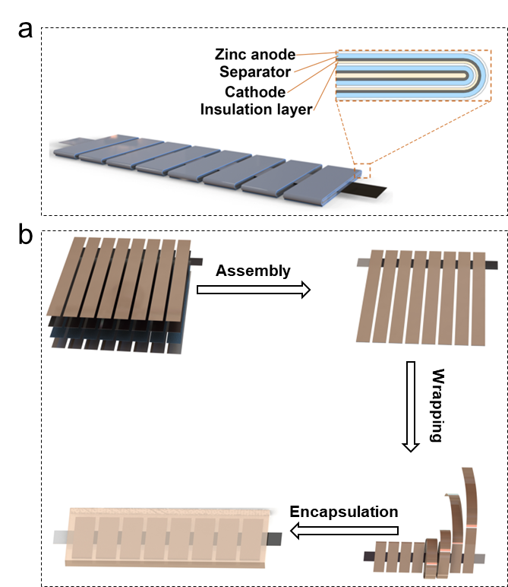
Fig. S1 Schematic cartoon showing the fabrication process of the scorpion tail-mimic flexible battery. a, Structural scheme and internal configuration of the scorpion tail-mimic Zn||MnO₂ flexible cell. b, Fabrication process: the multilayered electrodes are cut into the designed shape, the extending strips are then wound around the central trunk to form the scorpion tail-like structures

Fig. S2 Flow chart representing the synthesizing process of the designed C₁₆K lipopeptide through the Fmoc solid-phase peptide synthesis strategy

Fig. S3 RP-HPLC and MS spectra of the synthesized C₁₆K lipopeptide. a, RP-HPLC profile of the synthesized C₁₆K. The purity was analyzed to be more than 97.8%. A gradient elution mode was employed. The monitoring wavelength was set at 220 nm, and the flow rate was 1.0 mL min⁻¹. b, MS pattern of the lipopeptide, showing its relative molecular weight of 383.30 [384.30 = MW + H]

Fig. S4 FTIR spectra of the pristine Zn foil and Zn soaked in the ZnSO₄ electrolyte at the presence of C₁₆K (ZnSO₄: 2.0 M, C₁₆K: 0.10 mM).
The peaks at 3440 cm⁻¹, 3031 cm⁻¹, 1617 cm⁻¹ and 1092 cm⁻¹ were assigned to the stretching vibrations of v_{(N-H)}, v_{(C-H)}, v_{(C=O)} and the bending vibration of σ_{(C-H)}, respectively, indicating the adsorption of C₁₆K molecules onto the Zn foil.

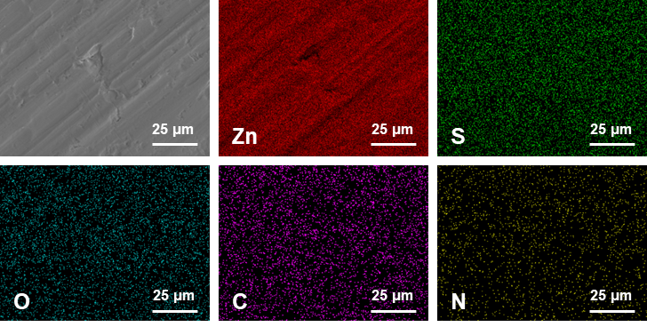
Fig. S5 SEM image and corresponding EDS mappings of the Zn foil soaked in the ZnSO₄ electrolyte at the presence of C₁₆K (ZnSO₄: 2.0 M, C₁₆K: 0.10 mM)

Table S1 The weight percentage and corresponding standard deviation of different elements from Fig. S5
Element | Signal type | (wt.)% | (wt.)% sigma
C | EDS | 11.91 | 0.36
N | EDS | 1.14 | 0.24
O | EDS | 1.97 | 0.09
S | EDS | 1.13 | 0.03
Zn | EDS | 83.85 | 0.41
Total |  | 100
Combining Fig. S5 and Table S1, it was revealed a uniform distribution of C₁₆K molecules across the Zn foil.

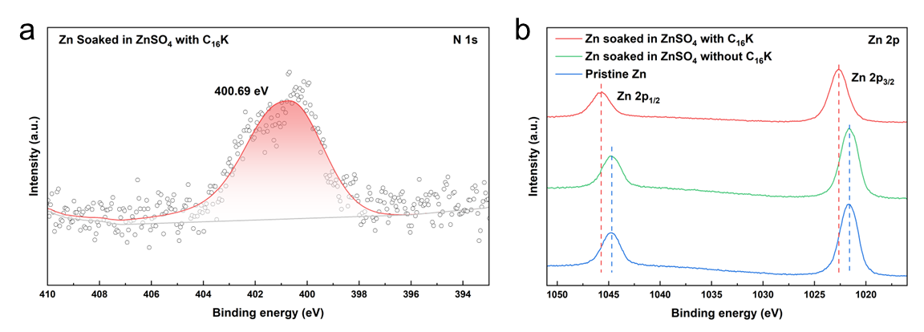
Fig. S6 High-resolution XPS spectra of Zn foils: a N1s spectra of the Zn foil soaked in the ZnSO₄ electrolyte at the presence of C₁₆K (ZnSO₄: 2.0 M, C₁₆K: 0.10 mM). b Zn 2p spectra of pristine Zn and Zn foils soaked in the ZnSO₄ electrolyte in the absence or at the presence of C₁₆K for 30 min (ZnSO₄: 2.0 M, C₁₆K: 0.10 mM)
The XPS profiles showed a noticeable positive shift of Zn 2p peaks to higher binding energies after immersion in the ZnSO₄ electrolyte at the presence of C₁₆K, signaling the formation of chemical bonds between C₁₆K and the Zn surficial atoms.

Fig. S7 Concentration-dependent dynamic adsorption curves of C₁₆K on the liquid-solid interface

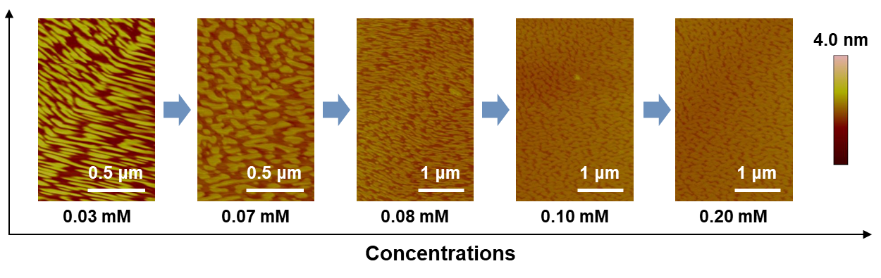
Fig. S8 AFM images showing concentration-dependent topological evolution of the interfacial self-assembly of C₁₆K. From left to right: 0.03 mM, 0.07 mM, 0.08 mM, 0.10 mM, 0.20 mM

Fig. S9 Height profiles along Line #2 and #3 in Fig. 1d in the main text. Combined with the value from Line#1, the statistical average height of the membrane was 3.3 ± 0.2 nm from AFM results

Table S2 Summary of the structural parameters extracted from fitting of the NR data in Fig. 1e in the main text
 | Substrate | Bottom Lysine (K) | Palmitic acid alkyl chain (C₁₆) | Top Lysine (K)
t (Å) | 20 | 6 | 20 | 6
VF (%) | - | 35 | 35 | 35
M  (mg m⁻²) | - | 2.84 | 9.45 | 2.84
Tip: t, VF and M are the scattering thickness, volume fraction and adsorbed mass, respectively.

Fig. S10 Statistical diameter distributions of the C₁₆K self-assembled nanotubes. a, inner diameter, b, outer diameter

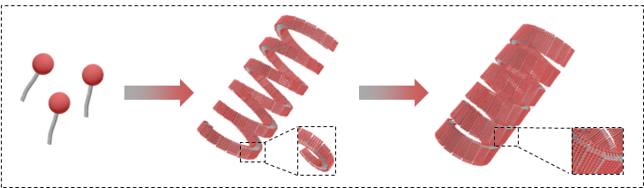
Fig. S11 Schematic cartoon illustrating the morphological evolution of C₁₆K bulk self-assembly

Fig. S12 Raman spectra of the ZnSO₄ electrolyte (top panel) in the absence or (lower panel) at the presence of C₁₆K (ZnSO₄: 2.0 M, C₁₆K: 0.10 mM)

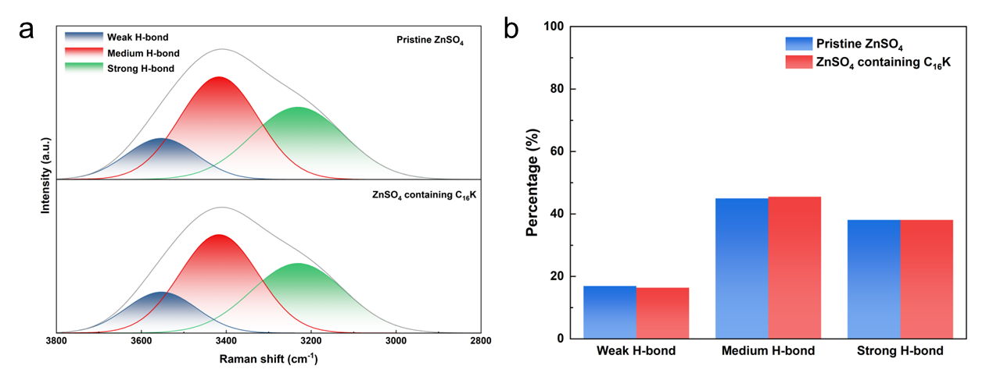
Fig. S13 Comparison of the hydrogen bonds in the ZnSO₄ electrolyte in the absence or at the presence of C₁₆K (ZnSO₄: 2.0 M, C₁₆K: 0.10 mM). a, Raman spectra and corresponding fitting curves in the range of 3800 cm⁻¹ - 2800 cm⁻¹. b, Ratios of different hydrogen bonds calculated from the fitting results in (a)

Fig. S14 FTIR spectra of the ZnSO₄ electrolyte in the absence or at the presence of C₁₆K (ZnSO₄: 2.0 M, C₁₆K: 0.10 mM)

Fig. S15 ¹H-NMR spectra of the ZnSO₄ electrolyte in the absence or at the presence of C₁₆K (ZnSO₄: 2.0 M, C₁₆K: 0.10 mM, D₂O as the solvent)

Fig. S16 ESP distribution of (top)a water molecule and (bottom) a C₁₆K molecule

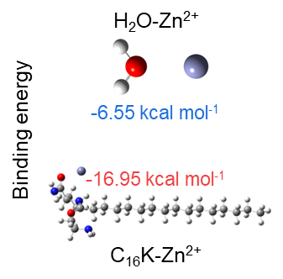
Fig. S17 Calculated binding energies of H₂O-Zn²⁺ and C₁₆K-Zn²⁺
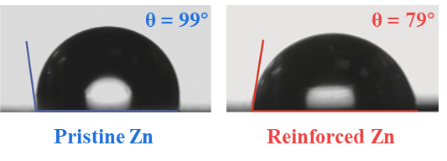
Fig. S18 Contact angle measurements of the (left) pristine and (right) C₁₆K-modified Zn foil
Fig. S19 Zeta potential statistics of the Zn powder in the absence or at the presence of C₁₆K (ZnSO₄: 2.0 M, C₁₆K: 0.10 mM)
Fig. S20 CV curves of the a pristine and b lipopeptide self-assembly reinforced Zn||Zn symmetric cells at various scan rates

Fig. S21 Tafel plots of the pristine Zn and C₁₆K-modified Zn at varying concentrations

Fig. S22 LSV curves of the Zn electrode tested in the absence or at the presence of C₁₆K (ZnSO₄: 2.0 M, C₁₆K: 0.10 mM) using the three-electrode system. The values represent the initial HER potentials of the systems

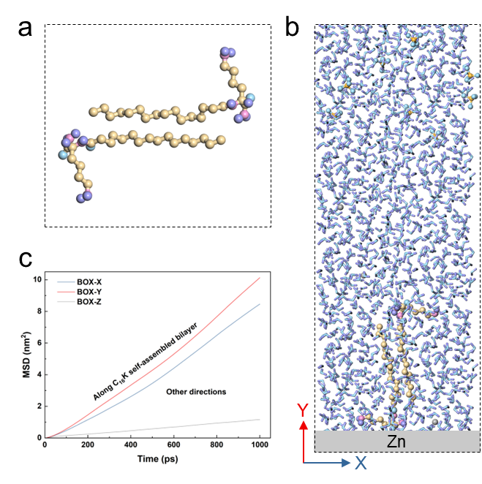
Fig. S23 Migration behavior simulations of Zn²⁺ at the presence of the C₁₆K self-assembled bilayers. a, Detailed view of the molecular structure of a pair of interdigitated lipopeptides in the self-assembled bilayer during the CGMD simulations. b, Snapshot of the interdigitated lipopeptide pair at the anode/electrolyte interface during the CGMD simulations. c, MSD of Zn²⁺ along the C₁₆K self-assembled bilayer and in other directions from CGMD simulations

Fig. S24 Nucleation overpotential and growth overpotential of Zn plating in Zn||Cu asymmetric cell in the absence or at the presence of C₁₆K (ZnSO₄: 2.0 M, C₁₆K: 0.10 mM, current density: 1 mA cm⁻²)
The nucleation overpotential ($η_{n}$) is defined as the potential difference between the equilibrium potential (0 V) and the most negative potential at the onset of Zn plating, whereas the growth overpotential ($η_{g}$) is defined as the potential difference between the equilibrium potential and the subsequent quasi-steady plating potential. The overshoot $Δη$ is defined as ${Δη=η_{n}-η}_{g}$.

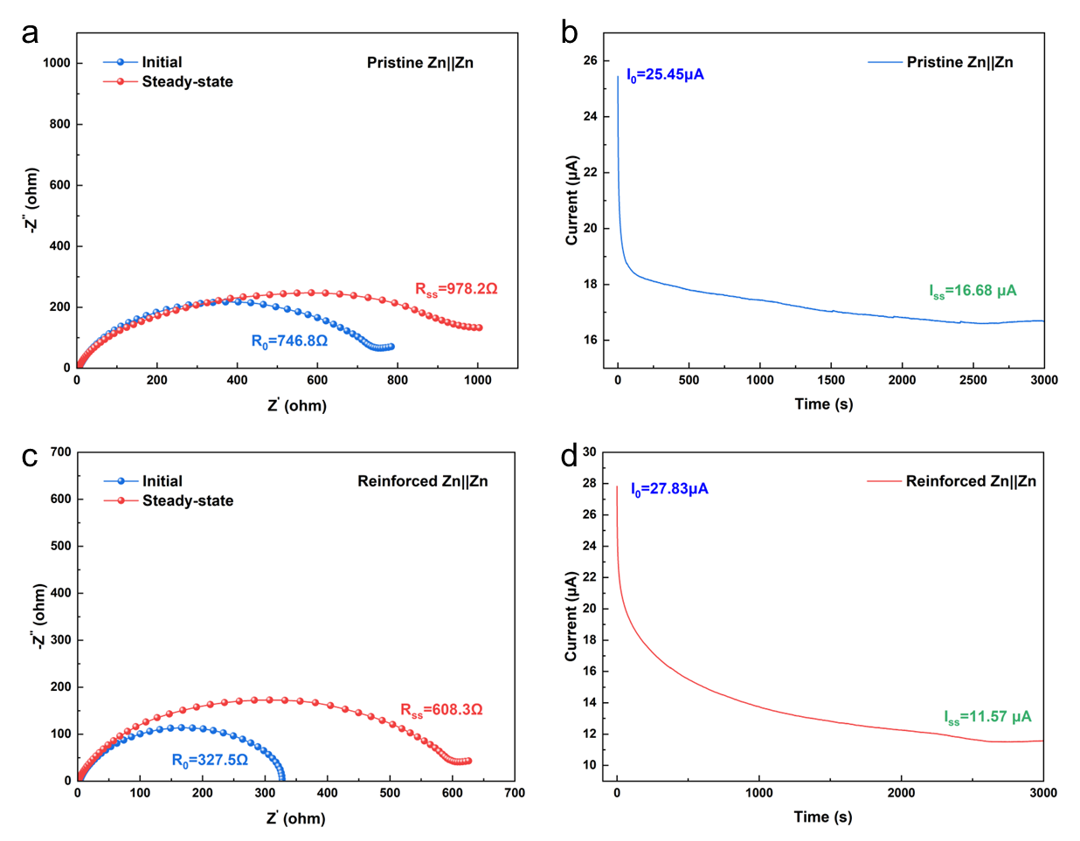
Fig. S25 EIS profiles and corresponding amperometric i-t curves. a and c, EIS profiles of the Zn||Zn symmetric cells a in the absence or c at the presence of C₁₆K (ZnSO₄: 2.0 M, C₁₆K: 0.10 mM). b and d, The corresponding amperometric i-t curves b in the absence or d at the presence of C₁₆K under an applied overpotential of 20 mV

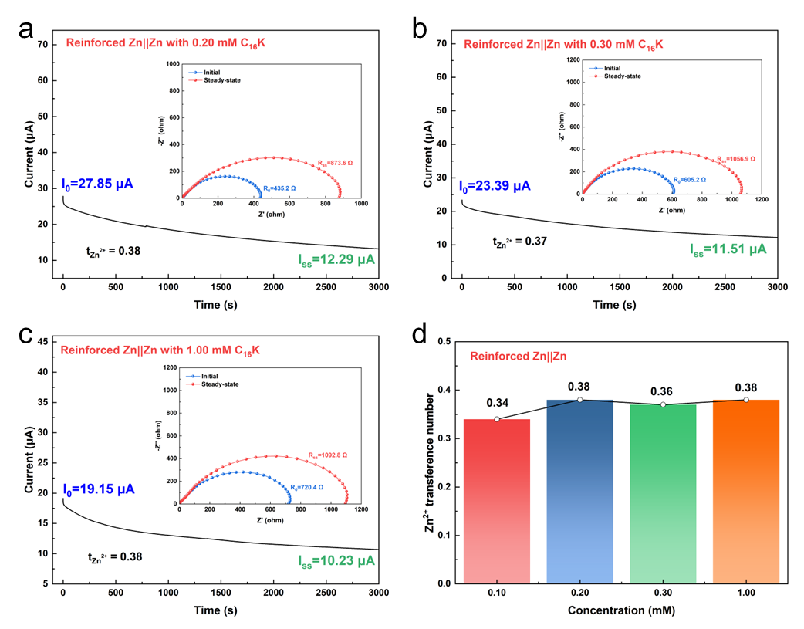
Fig. S26 Zn²⁺ transference numbers of the reinforced Zn||Zn symmetric cells with different C₁₆K concentrations. a-c Amperometric i-t curves of the reinforced Zn||Zn cells with (a) 0.20 mM, (b) 0.30 mM, and (c) 1.00 mM C₁₆K, together with the EIS profiles recorded before and after polarization (insets). d Summary of the Zn²⁺ transference number at different C₁₆K concentrations
Table S3 Calculated Zn²⁺ transfer numbers ($t\left({Zn}^{2+}\right)$) of the Zn||Zn symmetric cells
Cell | R₀(ohm) | I₀(μA cm⁻²) | R_{ss}(ohm) | I_{ss}(μA cm⁻²) | t_{Zn}²⁺
Pristine Zn||Zn | 746.8 | 25.45 | 978.2 | 16.68 | 0.18
Reinforced Zn||Zn with 0.10 mM C₁₆K | 327.5 | 27.83 | 608.3 | 11.57 | 0.34

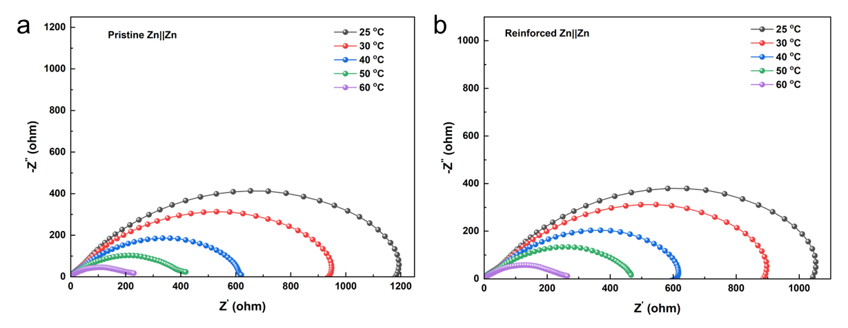
Fig. S27 Nyquist plots of the Zn||Zn symmetric cells tested under various temperatures a in the absence or b at the presence of C₁₆K

Fig. S28 CV curves of the Zn||Cu asymmetric cells in the absence or at the presence of C₁₆K (ZnSO₄: 2.0 M, C₁₆K: 0.10 mM, current density: 1 mA cm⁻², scan rate: 2 mV s⁻¹). Point A denotes the crossover potential, while points B and C indicate the onset potential of Zn²⁺ deposition reactions

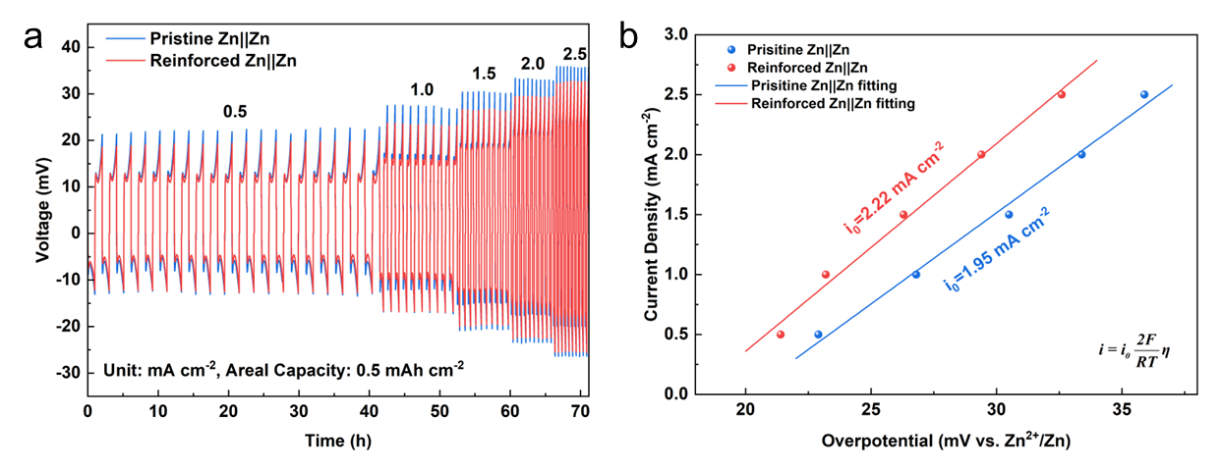
Fig. S29 Exchange current density measurements of the Zn||Zn symmetric cells tested in the absence or at the presence of C₁₆K. a, Galvanostatic cycling performances under current densities ranging from 0.5 to 2.5 mA cm⁻². b, Exchange current density plots derived from the Zn plating/stripping measurements

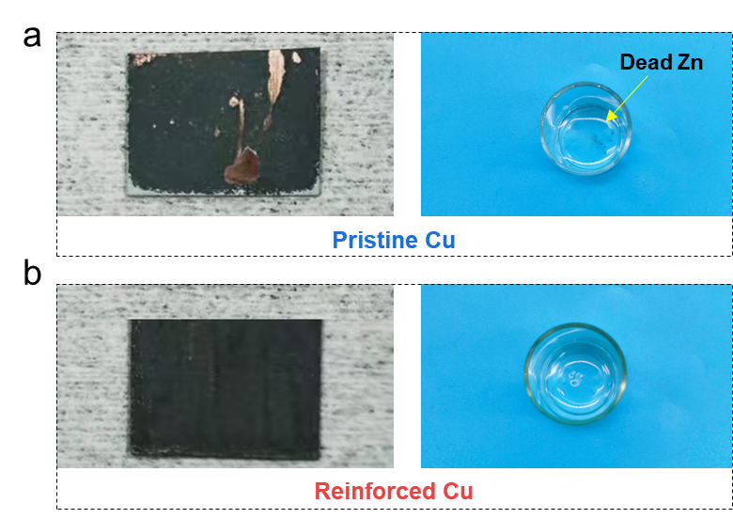
Fig. S30 Optical images of the Zn deposited on Cu foils and corresponding electrolytes a in the absence or b at the presence of C₁₆K (ZnSO₄: 2.0 M, C₁₆K: 0.10 mM, test conditions: 5 mA cm⁻² for 1 h)
Fig. S31 Line roughness analysis. Surface profiles extracted along the white dotted lines in Fig. 3e in the main text

Fig. S32 Time-evolved in-situ optical microscopy images of the Zn electrodes during Zn plating in the Zn||Zn symmetric cells. a, In the absence of C₁₆K. b, At the presence of C₁₆K. (ZnSO₄: 2.0 M, C₁₆K: 0.10 mM, test conditions: 1 mA cm⁻² & 1 mAh cm⁻²)

Fig. S33 Schematic illustration of Zn plating in native ZnSO₄ electrolyte, showing intense byproducts formation and HER side reactions

Table S4 Comparison of the electrochemical performances in diverse Zn||Zn symmetric cells with different treatment strategies.
Strategy |  | Current density  (mA cm⁻²) | Areal capacity  (mAh cm⁻²) | Cycle lifespan  (h) | CPC  (Ah cm⁻²) | Ref.
Eelectrolyte additives | Synergistic reinforcement of ion transport and interfacial stability | 1 | 1 | 4000 | 2 | This work
Eelectrolyte additives |  | 5 | 5 | 2250 | 5.625 | This work
Eelectrolyte additives |  | 10 | 5 | 1020 | 5.1 | This work
Eelectrolyte additives | HSE-10 m | 0.5 | 0.5 | 1200 | 0.3 | [49]
Eelectrolyte additives | BE/5Cor | 10 | 10 | 600 | 3 | [50]
Eelectrolyte additives | ZnSO₄-C₃N₄QDs | 5 | 1 | 400 | 1 | [51]
Eelectrolyte additives | HDES | 1 | 1 | 4500 | 2.25 | [52]
Eelectrolyte additives | 0.5 M Zn(HBS)₂ | 5 | 1 | 1600 | 4 | [53]
Eelectrolyte additives | 0.05 M BmBr/ZSO | 1 | 1 | 2700 | 1.35 | [54]
Eelectrolyte additives | 0.1-LBG | 2 | 2 | 1160 | 1.16 | [55]
Eelectrolyte additives | ZnSO₄-1% Py | 0.5 | 0.5 | 3300 | 0.825 | [56]
Eelectrolyte additives | SP-ZnCl₂ | 5 | 2 | 1200 | 3 | [57]
Eelectrolyte additives | ZnOTF/MAAC | 4 | 4 | 700 | 1.4 | [58]
Gel electrolytes | Asymmetric electrolyte | 10 | 10 | 700 | 3.5 | [59]
Gel electrolytes | ZIG-20wt% | 1 | 0.5 | 900 | 0.45 | [60]
Coatings | Zn@PAH/PAA | 5 | 5 | 340 | 0.85 | [61]
Coatings | CN10@Zn | 4 | 2 | 1100 | 2.2 | [62]
Separators | HTS | 2 | 2 | 3000 | 3 | [63]

Fig. S34 Voltage profiles of the pristine (blue) and reinforced (red) Zn||Zn symmetric cells at a current density of 10 mA cm⁻² for 5 mAh cm⁻²

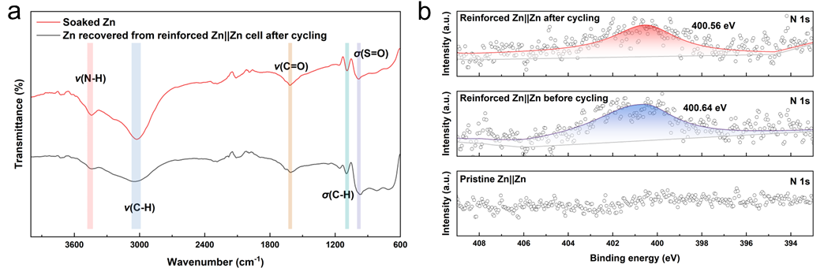
Fig. S35 a FTIR spectra of the Zn soaked in the ZnSO₄ electrolyte at the presence of C₁₆K and Zn recovered from reinforced Zn||Zn cell after cycling. b High-resolution N1s XPS spectra of Zn recovered from pristine Zn||Zn and reinforced Zn||Zn cells before and after cycling

Fig. S36 XRD patterns of the pristine and reinforced Zn anodes after cycling for 50 cycles at 1 mA cm⁻² for 1 mAh cm⁻²

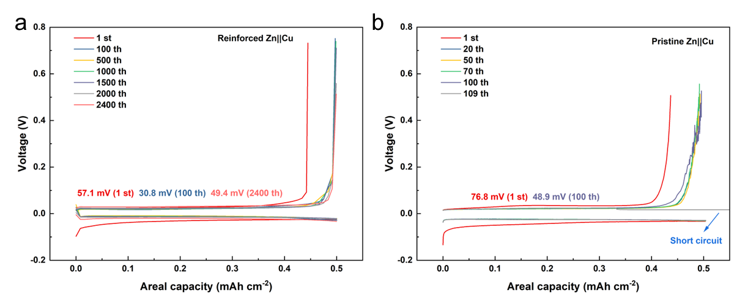
Fig. S37 Representative capacity-voltage profiles of the a reinforced and b pristine Zn||Cu asymmetric cells at a current density of 1 mA cm⁻² for 0.5 mAh cm⁻²
Fig. S38 CE comparison of the reinforced (red) and pristine (blue) Zn||Cu asymmetric cells at 5 mA cm⁻² for 2.5 mAh cm⁻²

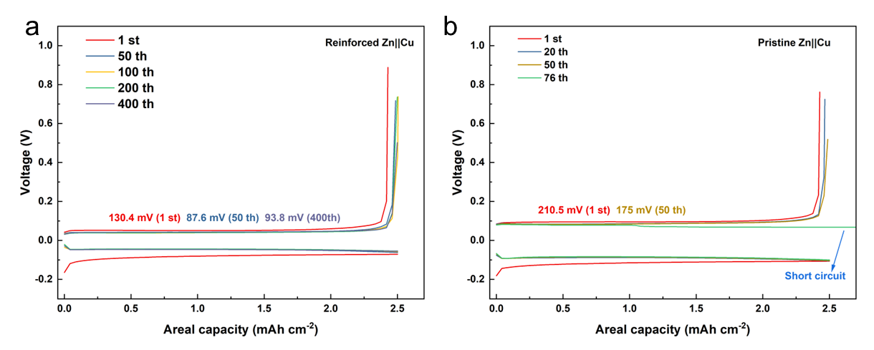
Fig. S39 Representative capacity-voltage profiles of the a reinforced and b pristine Zn||Cu asymmetric cells at a current density of 5 mA cm⁻² for 2.5 mAh cm⁻²

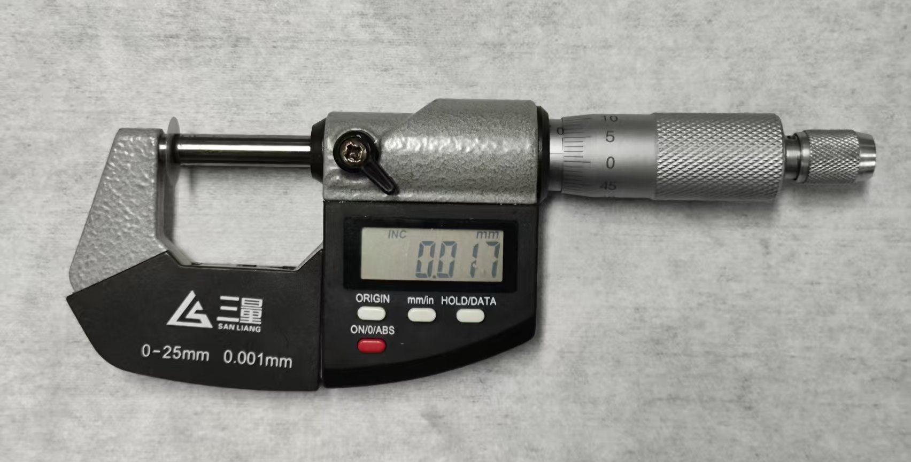
Fig. S40 Measurement of the thickness of the Zn foil employed in the experiment at a high Zn utilization rate of 50% DoD

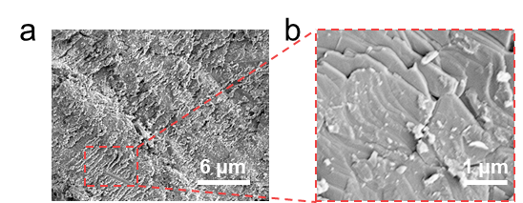
Fig. S41 SEM images of the Zn anode after 300 h of cycling at a high Zn utilization rate of 50% DoD. b is a magnified view of the selected region in a

Fig. S42 a XRD pattern and b SEM image of the synthesized β-MnO₂ cathode (PDF#24-0735) by a hydrothermal method. The results demonstrate that the cathode material possessed needle-like morphologies and high crystallinity with the characteristic peaks of β-MnO₂

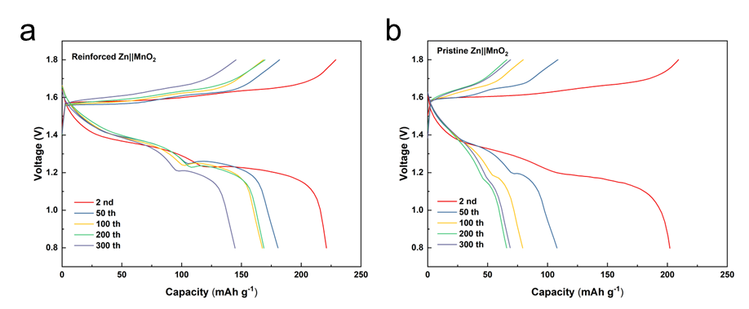
Fig. S43 The charge/discharge profiles of the a reinforced and b pristine Zn||MnO₂ full cells at 1.0 A g⁻¹. The charge/discharge profiles of the C₁₆K self-assembly reinforced Zn||MnO₂ full cells exhibit a more stable discharge plateau with lower voltage hysteresis contrast to the untreated counterpart

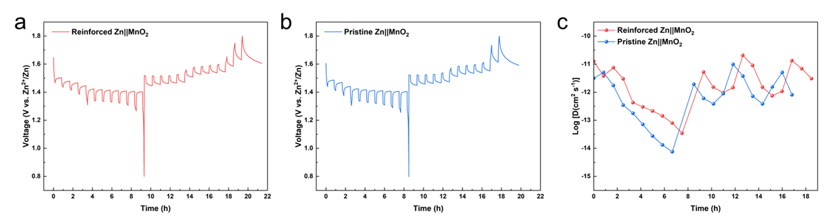
Fig. S44 GITT curves of (a) reinforced and (b) pristine Zn||MnO₂ cells at 0.1 A g⁻¹, and (c) the corresponding diffusion coefficient values calculated for both cells

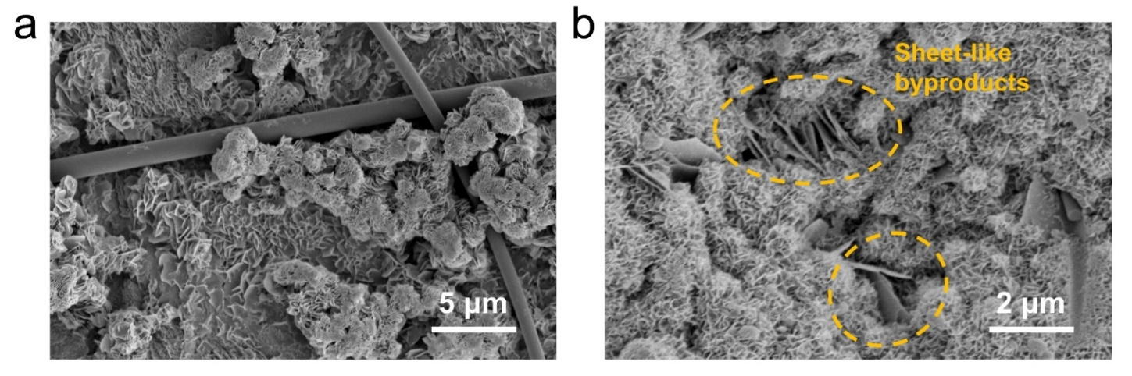
Fig. S45 SEM images of the a Zn anode and b MnO₂ cathode in the pristine Zn||MnO₂ full cells after 50 cycles
Fig. S46 Long-term cycling performance of the (red) reinforced and (blue) pristine Zn||MnO₂ full cells at 5.0 A g⁻¹

Fig. S47 MS spectrum of the electrolyte extracted from the reinforced Zn||MnO₂ cell after charging to 1.8 V, showing a predominant peak at m/z 384.36 corresponding to the [M+H]⁺ of C₁₆K
Fig. S48 High-resolution N1s XPS spectrum of the cathode from the reinforced Zn||MnO₂ cell after charging to 1.8 V
Fig. S49 a XRD pattern and b SEM image of the (NH₄)₂V₄O₉ cathode (PDF#23-0791) synthesized by a hydrothermal method. The results demonstrate that the cathode material possessed lamellar morphologies and high crystallinity with the typical peaks of (NH₄)₂V₄O₉

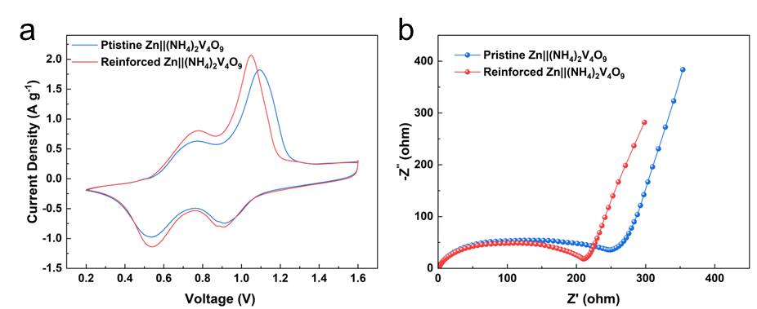
Fig. S50 a CV curves and b EIS of the (red) C₁₆K self-assembly reinforced and (blue) pristine Zn||(NH₄)₂V₄O₉ full cells at a scan rate of 0.5 mV s⁻¹

Fig. S51 Rate performances of the (red) reinforced and (blue) pristine Zn||(NH₄)₂V₄O₉ full cells

Fig. S52 Long-term cycling performance of the (red) reinforced and (blue) pristine Zn||(NH₄)₂V₄O₉ full cells at 2.0 A g⁻¹

Fig. S53 Long-term cycling performance of the (red) C₁₆K self-assembly reinforced and (blue) pristine Zn||(NH₄)₂V₄O₉ full cells at 5.0 A g⁻¹

Table S5 Comparison of the cycling performance of full cells employing bio-inspired electrolytes
Strategy | Cathode  materials | Cycling number | Retention (%) | Rate | Ref.
Synergistic reinforcement of ion transport and interfacial stability | β-MnO₂ | 200 | 75% | 1.0 A g⁻¹ | This work
 | β-MnO₂ | 500 | 61% | 3.0 A g⁻¹ | This work
 | (NH₄)₂V₄O₉ | 500 | 70% | 2.0 A g-1 | This work
 | (NH₄)₂V₄O₉ | 1000 | 84% | 5.0 A g⁻¹ | This work
BE/5Cor | NaV₃O₈ 1.5H₂O | 500 | 70.6% | 1.0 A g⁻¹ | [S1]
BE/5Cor | NaV₃O₈ 1.5H₂O | 500 | 70.8% | 5.0 A g⁻¹ | [S1]
Cll+ZOF | VO₂ | 1200 | 94% | 2.0 A g⁻¹ | [S2]
SAM-Zn | NH₄V₄O₁₀ | 1000 | ~86% | 5.0 A g⁻¹ | [S3]
NCAP-Glu-ZSO | NH₄V₄O₁₀ | 200 | ~71.4% | 0.5 A g⁻¹ | [S4]
SAB-Zn | MnO₂ | 500 | 64.7% | 1 C | [S5]
ZnSO₄/BICINE-10 | NH₄V₄O₁₀ | 1000 | 69.8% | 3.0 A g⁻¹ | [S6]
Val-H | AC@I₂ | 1000 | 78% | 0.2 A g⁻¹ | [S7]
ZSO/Phe | LMO | 300 | 77.3% | 1 C | [S8]
ZnSO₄+Glucose | MnO₂ | 1000 | ~80% | 10 C | [S9]
L-C/Zn(OTf)₂ | NH₄V₄O₁₀ | 500 | 80.59% | 1.0 A g⁻¹ | [S10]
1 M ZnSO₄+75 mM Ert | δ-MnO₂ | 500 | 79.5% | 1.0 A g⁻¹ | [S11]
2 M ZS+10% Xos | Zn_{x}V₂O₅ | 300 | ~60% | 2.0 A g⁻¹ | [S12]
PZS | Zn_{0.25}V₂O₅ | 1000 | 77.8% | 1.2 A g⁻¹ | [S13]

Fig. S54 Cycling performance of the C₁₆K self-assembly reinforced Zn||MnO₂ pouch cell at 125 mA g⁻¹

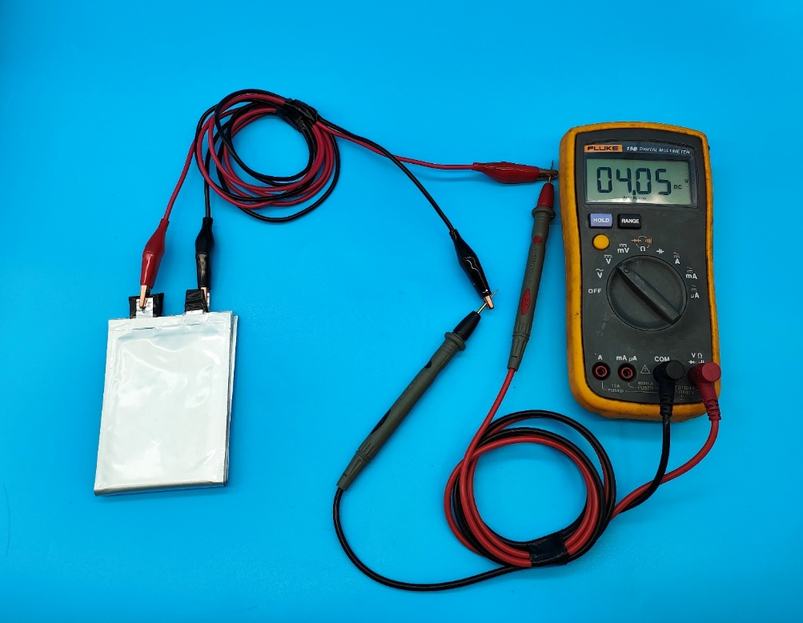
Fig. S55 Photographic image showing the voltage measurement of three interconnected reinforced Zn||MnO₂ pouch cells using a voltmeter. The interconnected pouch cells output a stable voltage of up to 4.05 V

Fig. S56 CV characterization of the scorpion tail-mimic reinforced Zn||MnO₂ flexible battery at a scan rate of 0.5 mV s⁻¹

Fig. S57 Long-term cycling performance of the scorpion tail-mimic reinforced Zn||MnO₂ flexible battery at 1.0 A g⁻¹

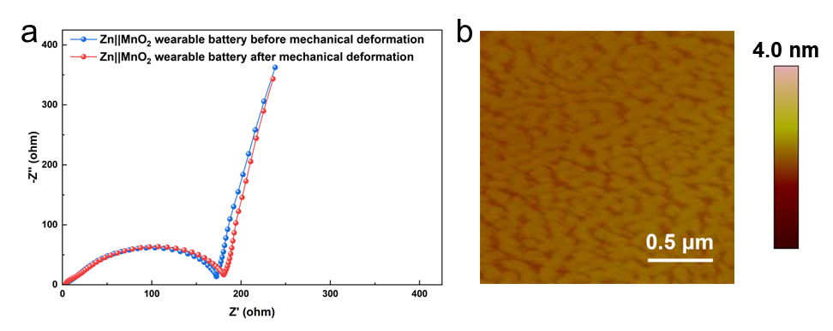
Fig. S58 a EIS of the Zn||MnO₂ wearable battery before and after mechanical deformation. b AFM image of the interfacial self-assembly of C₁₆K after mechanical deformation

Supplementary References
[S1] Z. Luo, Y. Xia, S. Chen, X. Wu, E. Akinlabi et al. A homogeneous plating/stripping mode with fine grains for highly reversible Zn anodes. Energy Environ. Sci. 17(18), 6787-6798 (2024). https://doi.org/10.1039/D4EE02264E
[S2] J. Gao, B. Qiu, J. Huang, J. Wen, M. Yang et al. Collagen-mediated solvent sheathing and derived interfacial manipulation toward ultrahigh-rate Zn anodes. Adv. Funct. Mater. 35(2), 2412791 (2024). https://doi.org/10.1002/adfm.202412791
[S3] D. Li, Y. Tang, S. Liang, B. Lu, G. Chen et al. Self-assembled multilayers direct a buffer interphase for long-life aqueous zinc-ion batteries. Energy Environ. Sci. 16(8), 3381-3390 (2023). https://doi.org/10.1039/D3EE01098H
[S4] X. Fan, L. Chen, Y. Wang, X. Xu, X. Jiao et al. Selection of negative charged acidic polar additives to regulate electric double layer for stable zinc ion battery. Nano-Micro Lett. 16(1), 270 (2024). https://doi.org/10.1007/s40820-024-01475-5
[S5] S. Chen, Y. Xia, R. Zeng, Z. Luo, X. Wu et al. Ordered planar plating/stripping enables deep cycling zinc metal batteries. Sci. Adv. 10(10), eadn2265 (2024). https://doi.org/10.1126/sciadv.adn2265
[S6] Z. Peng, S. Guo, D. Xu, D. Zhao, H. Qi et al. Trace-level green bio-derived amino acid molecular leveling agent enables dendrite-free and long-lifespan zinc metal anodes. Adv. Mater. e11603 (2025). https://doi.org/10.1002/adma.202511603
[S7] J. Lin, C. Ji, G. Guo, Y. Luo, P. Huang et al. Interfacial H-bond network/concentration fields/electric fields regulation achieved by d-valine anions realizes the highly efficient aqueous zinc ion batteries. Angew. Chem. Int. Ed. 64(24), e202501721 (2025). https://doi.org/10.1002/anie.202501721
[S8] A. Zhou, H. Wang, F. Zhang, X. Hu, Z. Song et al. Amphipathic phenylalanine-induced nucleophilic–hydrophobic interface toward highly reversible Zn anode. Nano-Micro Lett. 16(1), 164 (2024). https://doi.org/10.1007/s40820-024-01380-x
[S9] P. Sun, L. Ma, W. Zhou, M. Qiu, Z. Wang et al. Simultaneous regulation on solvation shell and electrode interface for dendrite-free Zn ion batteries achieved by a low-cost glucose additive. Angew. Chem. Int. Ed. 60(33), 18247-18255 (2021). https://doi.org/10.1002/anie.202105756
[S10] Z. Chen, Y. Xu, R. Jiang, H. Zhu, Q. Zhang et al. Chelation and interfacial engineering for long-term cycling and self-healing aqueous zinc batteries. Adv. Funct. Mater. e12356 (2025). https://doi.org/10.1002/adfm.202512356
[S11] S. Zhang, Q. Gou, W. Chen, H. Luo, R. Yuan et al. Co-regulating solvation structure and hydrogen bond network via bio-inspired additive for highly reversible zinc anode. Adv. Sci. 11(35), 2404968 (2024). https://doi.org/10.1002/advs.202404968
[S12] W. Guo, L. Xu, Y. Su, L. Zhao, Y. Ding, et al. Synchronous modulation of h-bond interaction and steric hindrance via bio-molecular additive screening in Zn batteries. Angew. Chem. Int. Ed. 64(5), e202417125 (2025). https://doi.org/10.1002/anie.202417125
[S13] S. Wang, S. Wang, Z. Wei, Y. Wang, D. Zhang et al. A parts-per-million scale electrolyte additive for durable aqueous zinc batteries. Nat. Comm. 16(1), 1800 (2025). https://doi.org/10.1038/s41467-025-56607-1

