Supporting information for
Induction Effect of Fluorine-Grafted Polymer-Based Electrolytes for High-Performance Lithium Metal Batteries
Haiman Hu¹, Jiajia Li¹, Fei Lin¹, Jiaqi Huang¹, Huaiyang Zheng¹, Haitao Zhang^{2,}*, Xiaoyan Ji^{1,}*
¹ Energy Engineering, Division of Energy Science, Luleå University of Technology, Luleå 97187, Sweden
² CAS Key Laboratory of Green Process and Engineering, Beijing Key Laboratory of Ionic Liquids Clean Process, Institute of Process Engineering, Chinese Academy of Sciences, Beijing 100190, P. R. China
*Corresponding authors. E-mail: xiaoyan.ji@ltu.se (Xiaoyan Ji); htzhang@ipe.ac.cn (Haitao Zhang)
S1 Experimental
S1.1 Characterization
Fourier transformation infrared (FTIR) was obtained using a Thermo Nicolet 380 spectrometer, covering a range from 600 to 4000 cm^{‒1}. The Raman spectra were measured with a HORIBA Scientific LabRAM HR Evolution, focusing on a wavenumber range of 700 to 900 cm^{‒1}. The thermal stability was assessed through thermogravimetric analysis (TGA) with an STA7200RV instrument from Hitachi High-Tech. The differential scanning calorimetry (DSC) measurements were conducted using a Perkin Elmer Diamond apparatus, to determine the glass transition temperature (T_{g}) across a temperature range of -90 to 25 °C, with a heating rate of 10 °C per minute. Additionally, ⁷Li NMR spectra were recorded on a Bruker AVANCE II 400 spectrometer, and X-ray photoelectron spectroscopy (XPS) was conducted with an ESCALAB 250Xi instrument. For the Time-of-flight secondary ion mass spectrometry (ToF-SIMS), the analysis was performed using a PHI nanoTOFII system, operated under vacuum conditions.
S1.2 Electrochemical measurements
The ionic conductivity was measured using symmetrical cells with stainless steel (SS) electrodes. The electrochemical impedance spectroscopy (EIS) was performed over a temperature range of 25 to 85 °C with a CHI660E electrochemical workstation, covering a frequency range from 0.01 to 1 000,000 Hz. The ionic conductivity (σ) was then calculated using the following equation:
$σ=\frac{L}{RS}$ (S1)
where L represents the thickness of the electrolyte, R is the resistance of the bulk electrolyte measured through EIS, and S denotes the area in contact with the 16 mm diameter stainless steel.
The Li⁺ transference number (t_{Li}⁺) was determined through the potentiostatic polarization using a symmetric Li/QSCEs/Li cell at 60 °C. The EIS was performed over a frequency from 0.01 to 1,000,000 Hz with an amplitude of 20 mV. t_{Li}⁺ was calculated by:
t_{Li}⁺ = $\frac{I_{s}\left(ΔV−I_{0}R_{0}\right)}{I_{0}\left(ΔV−I_{s}R_{s}\right)}$ (S2)
where I₀ and I_{S} are the initial and steady-state currents, R₀ and R_{S} are the interface resistances of the cell before and after polarization, respectively, and ΔV represents the applied voltage.
The electrochemical stabilities of QSCEs were assessed through the linear sweep voltammetry (LSV). The asymmetric cell (SS/QSCEs/Li) underwent testing with a voltage sweep from 2.0 to 6.0 V at a scan rate of 0.1 mV·s^{‒1}. The interfacial stability of the electrolytes to Li metal was evaluated using the symmetric Li//Li cells. The cycling performance for the LiFePO₄/QSCE/Li and NCM622/QSCE/Li cells was tested using the LAND cell testing system (CT2001A LANHE). The cells were all exposed to a 60 °C oven for 12 h to enhance the interface fusion between the electrolyte and the cathode.
S1.3 Computer simulations
The DFT calculations were carried out by employing the Gaussian 16 software package. [S1] Geometry optimization and frequency analysis were executed utilizing the B3LYP/6-311G(d,p) level of theory, [S2, S3] with the DFT-D3BJ method by Grimme employed for the dispersion correction. [S4, S5] The single-point energy calculations were performed with M06-2X/def2tzvp level of theory. [S6, S7] A structural unit of F-QSCE and H-QSCE was considered to represent the polymer chain. The binding energy of Li (E_{(binding)}) was calculated as Equation (S1) [S8]:
E_{(binding)} = E_{(M+Li)} ‒ E_{(M)} ‒ E_{(Li)} (S3)
Where E_{(M+Li)}, E_{(M)}, and E_{(Li)} denote the energies associated with F-QCSE-Li or H-QCSE-Li, F-QCSE or H-QCSE, and a single Li atom, respectively.
Molecular dynamics (MD) simulations were utilized to investigate the microstructure and interactions of the systems. The OPLS all-atom parameters [S9] (OPLS-AA) were used for F-QSCE, H-QSCE, and Li⁺, generated by web-based LigParGen [S10-S12]. The PYR₁₃⁺ and TFSI‒ were modeled by the CL&P force field [S13, S14], which was compatible with OPLS-AA. The system consisted of 100 ILs, 1000 LiTFSI molecules, and 100 F-QSCE or H-QSCE molecules in each simulation.
The initial configurations for all the systems were prepared using the PACKMOL package. [S15] All the MD simulations were conducted in the NPT ensemble with the MD package GROMACS [S16] by the Parrinello-Rahman barostat [S17] at 1 bar with a coupling constant of 2 ps. The temperature was controlled through the V-rescale thermostat [S18] at 298 K with coupling constants of 200 fs. The equation of motion was solved with the leap-frog integration algorithm with a time step of 1 fs. The van der Waals term and real space electrostatic interactions were calculated via direct summation with a cutoff distance of 1.5 nm. The particle-mesh Ewald method [S19] was employed to handle long-range electrostatic interactions in reciprocal space, with an FFT grid spacing of 0.15 nm and an electrostatic energy tolerance of 10⁻⁵. Each simulation started with maintaining the system at 800 K for 5 ns, followed by annealing to 298 K over another 5 ns, and an additional 10 ns to reach equilibrium. A subsequent 10 ns production run was then conducted, with data collected at 1 ps intervals for analysis.
Table S1 The ionic conductivity of electrolytes with different ratios of VBImTFSI/HFM (V/M) and content of LiTFSI
Samples | Molar ratio  (V/M) | LiTFSI  (wt.% of V/M) | Photoinitiator  (wt.% of V/M) | σ (mS cm^{‒1})
1 | 1 | 20 | 2 | 0.013
2 | 2 | 20 | 2 | 0.004
3 | 3 | 20 | 2 | 0.012
4 | 4 | 20 | 2 | 0.028
5 | 5 | 20 | 2 | 0.023
6 | 4 | 20 | 2 | 0.110
7 | 4 | 30 | 2 | 0.596
8 | 4 | 40 | 2 | 0.231
Table S2 Summary of the properties of different polymer-based electrolytes
Electrolyte | Tensile strength  (MPa) | σ  (S cm⁻¹) | Li//Li  cycling | Initial specific capacity and Capacity retention | Refs.
PTFEMA/PEO  /LiTFSI | 2.00 | 0.63 (80 °C) | 3800 h at  0.10 mA cm⁻² and 70 °C | Around 100.0 mAh g⁻¹ (LFP),  98% after 400 cycles at  70 mA g⁻¹ and 70 °C | [S20]
P(IL-OFHDODA-VEC)/IL/LiTFSI | / | 1.37 (25 °C) | 2500 h at  0.10 mA cm⁻² and 30 °C | 161.2 mAh g⁻¹ (LFP),  87% after 600 cycles at 0.5 C and 30 °C | [S21]
TFE-alt-MEGVE)/LiTFSI | / | 0.27 (85 °C) | 2600 h at  0.05 mA cm⁻² and 70 °C | Around 160.0 mAh g⁻¹ (LFP),  100% after 50 cycles at 0.1 C and 85 °C | [S22]
C2-C9-3F  (6K)/LiTFSI | / | 0.02 (25 °C) | 1500 h at  0.20 mA cm⁻² and 30 °C | / | [S23]
PEO-PVDF/LiTFSI-LLZTO/Li₂ZrO₃-CsPF₆/2,4,6-TFA | / | 0.63 (25 °C) | 1100 h at  0.10 mA cm⁻² and 30 °C | 149.7 mAh g⁻¹ (LFP),  95% after 200 cycles at 0.5 C and 30 °C | [S24]
Co-polymer  /LiTFSI/LLZTO  /SN/FEC | / | 1.11 (25 °C) | 2000 h at  0.10 mA cm⁻² and 30 °C | 172.4 mAh g⁻¹ (NCM811),  61% after 400 cycles at 0.5 C and 30 °C | [S25]
LiSPNF membrane/  PEGDA:PETEA/  Liquid electrolyte | / | 1.36 (30 °C) | 200 h at  1.00 mA cm⁻² and 30 °C | 143.2 mAh g⁻¹ (LFP),  98% after 100 cycles at 1.0 C and 30 °C | [S26]
M-S-PEGDA/LiTFSI | 9.4 | 0.23 (25 °C) | 1600 h at  0.10 mA cm⁻² and 40 °C | 143.7 mAh g⁻¹ (LFP),  86% after 500 cycles at 0.5 C and 40 °C | [S27]
PNPU-PVDF-HFP/LiTFSI | 5.2 | 0.41 (30 °C) | 1000 h at  0.10 mA cm⁻² and 30 °C | 150.0 mAh g⁻¹ (LFP),  90% after 300 cycles at 0.2 C and 40 °C | [S28]
F-QSCE | 0.09 | 1.21 (25 °C) | 4000 h at  0.1 mA cm⁻² and 60 °C | 151.8 mAh g⁻¹ (LFP),  99% after 460 cycles at  0.5 C and 60 °C | This work

Fig. S1 Ionic conductivity of polymer-based electrolytes with different molar ratios of IL/HFM

Fig. S2 Ionic conductivity of polymer-based electrolyte with the optimized IL/HFM molar ratio (4:1) and different contents of Li salt
Fig. S3 LSV of polymer-based electrolyte with the optimized IL/HFM molar ratio (4:1) and different weight contents of Li salt

Fig. S4 Tafel plot for the Li/F-QSCE@30 and QSCE@30/Li symmetric cells at 60 °C

Fig. S5 The chronoamperometry profiles and impedance spectra of F-QSCE@30 and QSCE@30 based on the Li//Li cells at 20 mV and 60 °C

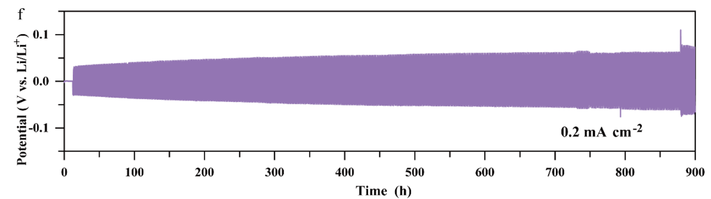

Fig. S6 The Li plating/stripping profiles of F-QSCE@30 at 0.2 mA cm⁻²
Fig. S7 Charge and discharge curves of LiFePO₄/QSCE@30/Li cell at the first, 50th, and 100th cycles

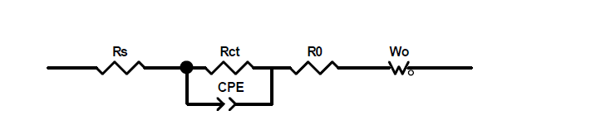
Fig. S8 Equivalent circuit model of LiFePO₄/F-QSCE@30 and QSCE@30/Li after 10 and 50 cycles at 0.5 C
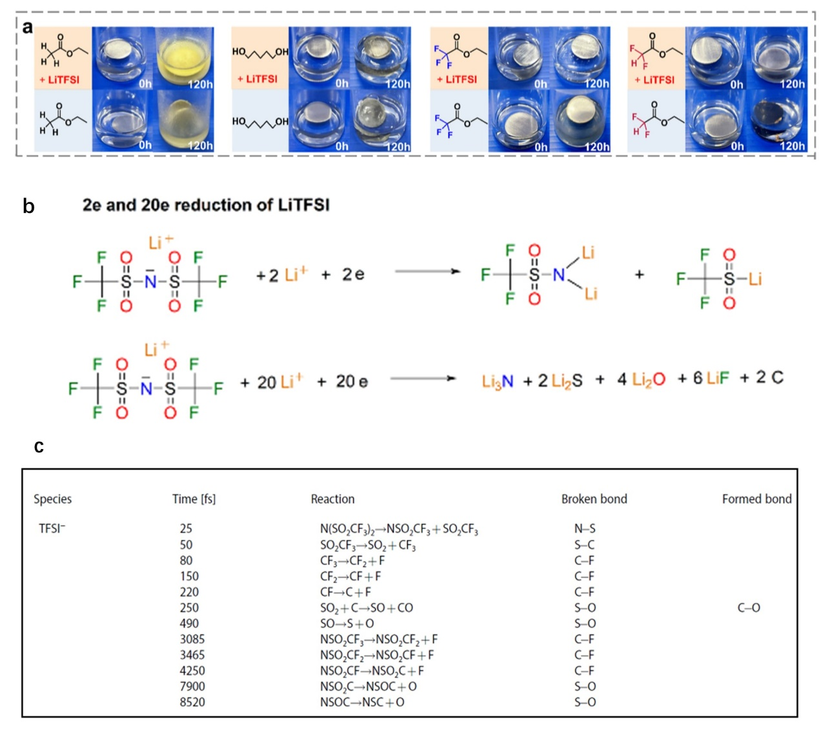Fig. S9 a Optical images of Li foil immersed in ethyl acetate, 1,5-pentanediol, ethyl trifluoroacetate, and ethyl difluoroacetate with and without LiTFSI for different times (0 and 120 h) at room temperature. (Copyright © 2024, American Chemical Society; J. Am. Chem. Soc. 2024, 146, 5940-5951) b Proposed mechanism for the reduction of LiTFSI. (Copyright © 2018, American Chemical Society; J. Am. Chem. Soc. 2018, 140, 9921−9933) c Catalog of electrolyte decomposition reactions and the approximate time they occurred during the AIMD simulations. (© 2022 Wiley‐VCH GmbH; Batteries & Supercaps 2022, 5, e202200088)
Fig. S10 ToF-SIMS depth profiles with F‒, C₂F₆S₂O₄N‒, LiF₂‒, LiS‒, and Li₃N‒ after cycling in Li/QSCE@30/Li cell
Supplementary References
- M.J. Frisch, G.W. Trucks, H.B. Schlegel, G.E. Scuseria, M.A. Robb et al., Gaussian 16 rev. C.01. (2016).
- C. Lee, W. Yang, R.G. Parr, Development of the Colle-Salvetti correlation-energy formula into a functional of the electron density. Phys. Rev. B Condens. Matter 37(2), 785–789 (1988). https://doi.org/10.1103/physrevb.37.785
- R. Krishnan, J.S. Binkley, R. Seeger, J.A. Pople, Self‐consistent molecular orbital methods. XX. A basis set for correlated wave functions. J. Chem. Phys. 72(1), 650–654 (1980). https://doi.org/10.1063/1.438955
- S. Grimme, J. Antony, S. Ehrlich, H. Krieg, A consistent and accurate ab initio parametrization of density functional dispersion correction (DFT-D) for the 94 elements H-Pu. J. Chem. Phys. 132(15), 154104 (2010). https://doi.org/10.1063/1.3382344
- S. Grimme, S. Ehrlich, L. Goerigk, Effect of the damping function in dispersion corrected density functional theory. J. Comput. Chem. 32(7), 1456–1465 (2011). https://doi.org/10.1002/jcc.21759
- Y. Zhao, D.G. Truhlar, The M06 suite of density functionals for main group thermochemistry, thermochemical kinetics, noncovalent interactions, excited states, and transition elements: two new functionals and systematic testing of four M06-class functionals and 12 other functionals. Theor. Chem. Acc. 120(1), 215–241 (2008). https://doi.org/10.1007/s00214-007-0310-x
- F. Weigend, R. Ahlrichs, Balanced basis sets of split valence, triple Zeta valence and quadruple Zeta valence quality for H to Rn: Design and assessment of accuracy. Phys. Chem. Chem. Phys. 7(18), 3297–3305 (2005). https://doi.org/10.1039/b508541a
- Y.-F. Huang, T. Gu, G. Rui, P. Shi, W. Fu et al., A relaxor ferroelectric polymer with an ultrahigh dielectric constant largely promotes the dissociation of lithium salts to achieve high ionic conductivity. Energy Environ. Sci. 14(11), 6021–6029 (2021). https://doi.org/10.1039/D1EE02663A
- W.L. Jorgensen, D.S. Maxwell, J. Tirado-Rives, Development and testing of the OPLS all-atom force field on conformational energetics and properties of organic liquids. J. Am. Chem. Soc. 118(45), 11225–11236 (1996). https://doi.org/10.1021/ja9621760
- W. L. Jorgensen, J. Tirado-Rives. Potential energy functions for atomic-level simulations of water and organic and biomolecular systems. Proc. Natl. Acad. Sci. 102(19), 6665-6670 (2005). http://10.1073/pnas.0408037102
- L. S. Dodda, J. Z. Vilseck, J. Tirado-Rives, W. L. Jorgensen. 1.14* CM1A-LBCC: Localized bond-charge corrected CM1A charges for condensed-phase simulations. J. Phys. Chem. B 121, 3864–3870 (2017). https://doi.org/10.1021/acs.jpcb.7b00272
- L.S. Dodda, I. Cabeza de Vaca, J. Tirado-Rives, W. L. Jorgensen. LigParGen web server: An automatic OPLS-AA parameter generator for organic ligands. Nucleic Acids Res. 45, 331-336 (2017). http://doi/10.1093/nar/gkx312
- J.N. Canongia Lopes, J. Deschamps, A. A. Pádua. Modeling ionic liquids using a systematic all-atom force field. J. Phys. Chem. B. 108, 2038-2047 (2004). https://doi.org/10.1021/jp0362133
- J.N. Canongia Lopes, A.A. Padua, Molecular force field for ionic liquids III: imidazolium, pyridinium, and phosphonium cations; chloride, bromide, and dicyanamide anions. J. Phys. Chem. B 110(39), 19586–19592 (2006). https://doi.org/10.1021/jp063901o
- L. Martínez, R. Andrade, E.G. Birgin, J.M. Martínez, PACKMOL: a package for building initial configurations for molecular dynamics simulations. J. Comput. Chem. 30(13), 2157–2164 (2009). https://doi.org/10.1002/jcc.21224
- M.J. Abraham, T. Murtola, R. Schulz, S. Páll, J.C. Smith et al., GROMACS: High performance molecular simulations through multi-level parallelism from laptops to supercomputers. SoftwareX 1, 19–25 (2015). https://doi.org/10.1016/j.softx.2015.06.001
- M. Parrinello, A. Rahman, Polymorphic transitions in single crystals: a new molecular dynamics method. J. Appl. Phys. 52(12), 7182–7190 (1981). https://doi.org/10.1063/1.328693
- G. Bussi, D. Donadio, M. Parrinello, Canonical sampling through velocity rescaling. J. Chem. Phys. 126(1), 014101 (2007). https://doi.org/10.1063/1.2408420
- U. Essmann, L. Perera, M.L. Berkowitz, T. Darden, H. Lee et al., A smooth particle mesh Ewald method. J. Chem. Phys. 103(19), 8577–8593 (1995). https://doi.org/10.1063/1.470117
- Y. Su, X. Rong, A. Gao, Y. Liu, J. Li et al., Rational design of a topological polymeric solid electrolyte for high-performance all-solid-state alkali metal batteries. Nat. Commun. 13(1), 4181 (2022). https://doi.org/10.1038/s41467-022-31792-5
- L. Tang, B. Chen, Z. Zhang, C. Ma, J. Chen et al., Polyfluorinated crosslinker-based solid polymer electrolytes for long-cycling 4.5 V lithium metal batteries. Nat. Commun. 14(1), 2301 (2023). https://doi.org/10.1038/s41467-023-37997-6
- M. Ma, F. Shao, P. Wen, K. Chen, J. Li et al., Designing weakly solvating solid main-chain fluoropolymer electrolytes: synergistically enhancing stability toward Li anodes and high-voltage cathodes. ACS Energy Lett. 6(12), 4255–4264 (2021). https://doi.org/10.1021/acsenergylett.1c02036
- X. Xie, P. Zhang, X. Li, Z. Wang, X. Qin et al., Rational design of F-modified polyester electrolytes for sustainable all-solid-state lithium metal batteries. J. Am. Chem. Soc. 146(9), 5940–5951 (2024). https://doi.org/10.1021/jacs.3c12094
- T. Wang, B. Chen, C. Liu, T. Li, X. Liu, Build a high-performance all-solid-state lithium battery through introducing competitive coordination induction effect in polymer-based electrolyte. Angew. Chem. Int. Ed. 63(16), e202400960 (2024). https://doi.org/10.1002/anie.202400960
- A.-G. Nguyen, M.-H. Lee, J. Kim, C.-J. Park, Construction of a high-performance composite solid electrolyte through in situ polymerization within a self-supported porous garnet framework. Nano-Micro Lett. 16(1), 83 (2024). https://doi.org/10.1007/s40820-023-01294-0
- L. Wang, S. Xu, Z. Wang, E. Yang, W. Jiang et al., A nano fiber–gel composite electrolyte with high Li+ transference number for application in quasi-solid batteries. eScience 3(2), 100090 (2023). https://doi.org/10.1016/j.esci.2022.100090
- H. Wang, Q. Wang, X. Cao, Y. He, K. Wu et al., Thiol-branched solid polymer electrolyte featuring high strength, toughness, and lithium ionic conductivity for lithium-metal batteries. Adv. Mater. 32(37), e2001259 (2020). https://doi.org/10.1002/adma.202001259
- Y. Ye, X. Zhu, N. Meng, F. Lian, Largely promoted mechano-electrochemical coupling properties of solid polymer electrolytes by introducing hydrogen bonds-rich network. Adv. Funct. Mater. 33(45), 2307045 (2023). https://doi.org/10.1002/adfm.202307045

