Supporting Information for
Piezotronic Sensor for Bimodal Monitoring of Achilles Tendon Behavior
Zihan Wang¹, Shenglong Wang¹, Boling Lan ¹, Yue Sun¹, Longchao Huang ¹, Yong Ao¹, Xuelan Li¹, Long Jin¹, Weiqing Yang ^{1,2}, Weili Deng^{1,} *
¹Key Laboratory of Advanced Technologies of Materials (Ministry of Education), School of Materials Science and Engineering, Southwest Jiaotong University, Chengdu 610031, P. R. China
²Research Institute of Frontier Science, Southwest Jiaotong University, Chengdu 610031, P. R. China
*Corresponding author. E-mail: weili1812@swjtu.edu.cn (Weili Deng)
Supplementary Figures
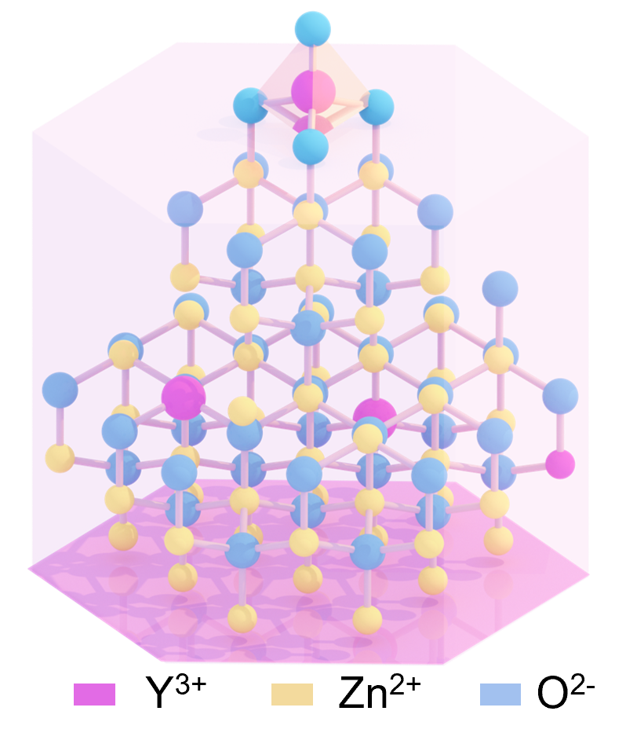
Fig. S1 Schematic crystal structure of Y-doped ZnO NRs
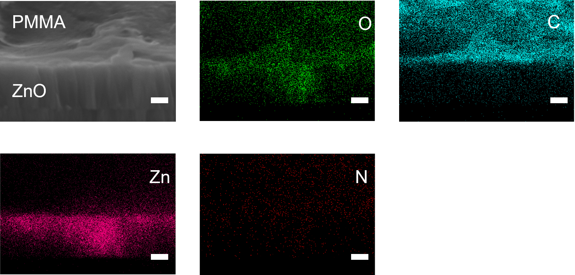
Fig. S2 SEM image of the cross-sectional morphology and corresponding elemental energy spectra of PMMA -ZnO. Scale bars, 500 nm
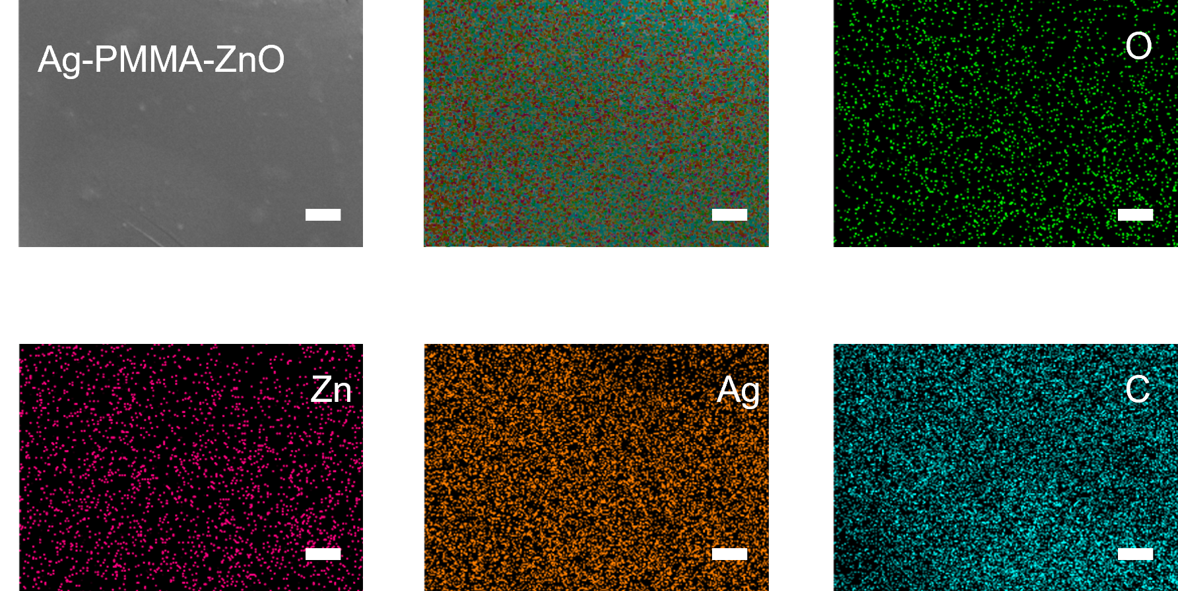
Fig. S3 SEM image of the surface morphology and corresponding elemental energy spectra of ZnO. Scale bars, 5 μm
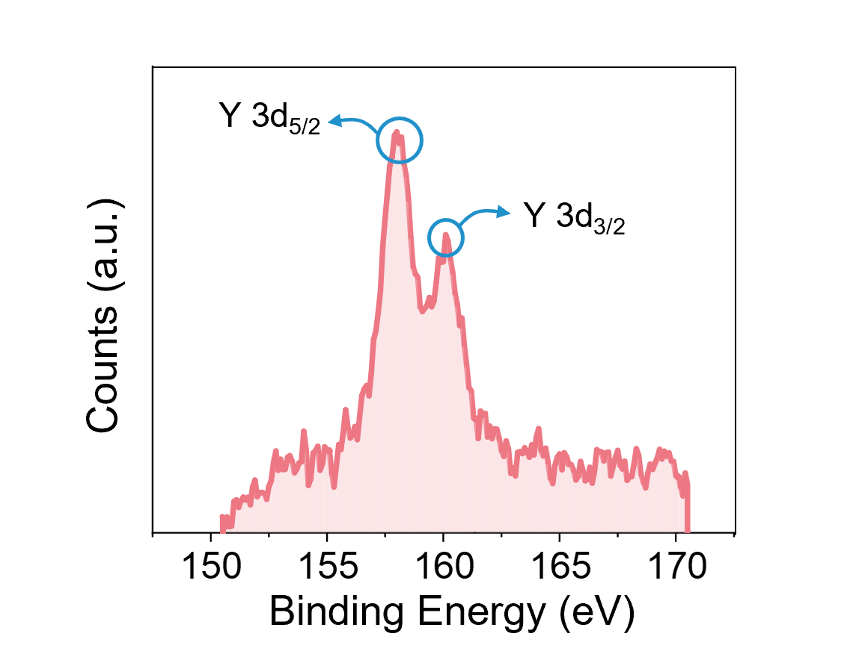
Fig. S4 XPS pattern of Y- ZnO NRs
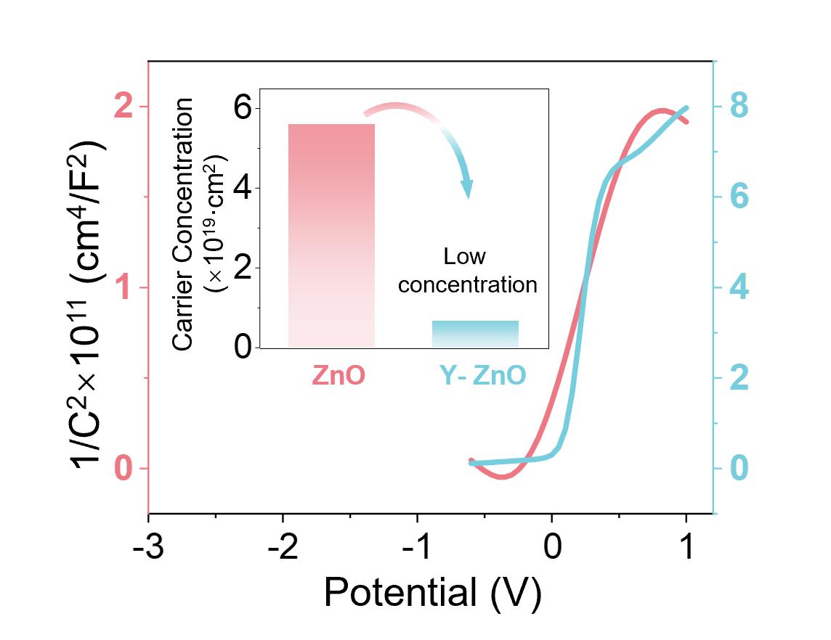
Fig. S5 Mott-Schottky plots and linear fitting curves of ZnO NRs and Y-ZnO NRs
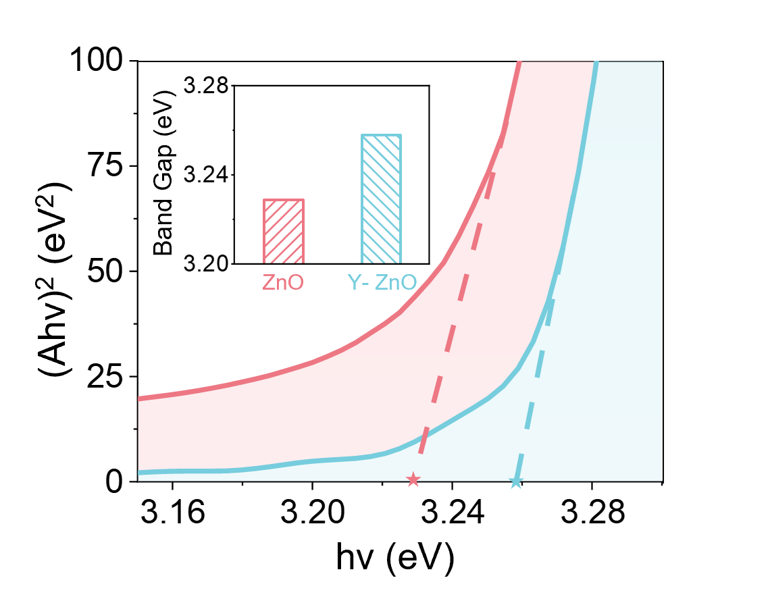
Fig. S6 (Ahν) ²-hν graph calculated from Fig. 2k and the band gap of ZnO and Y-ZnO calculated from (Ahν) ²-hν graph
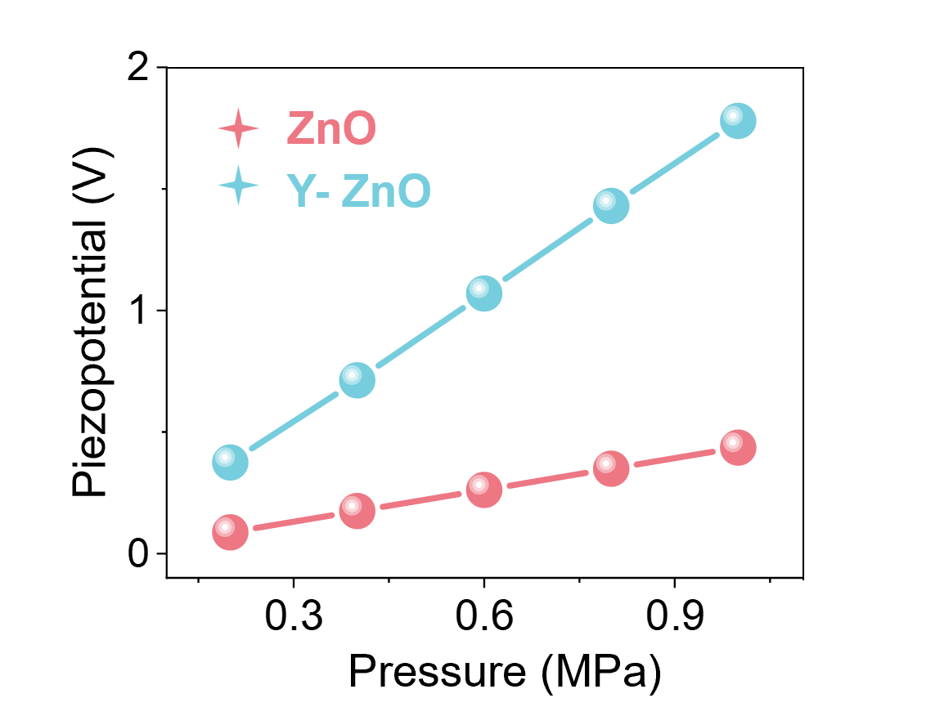
Fig. S7 Simulation results of average sensitivities of ZnO and Y-ZnO piezoelectric sensor
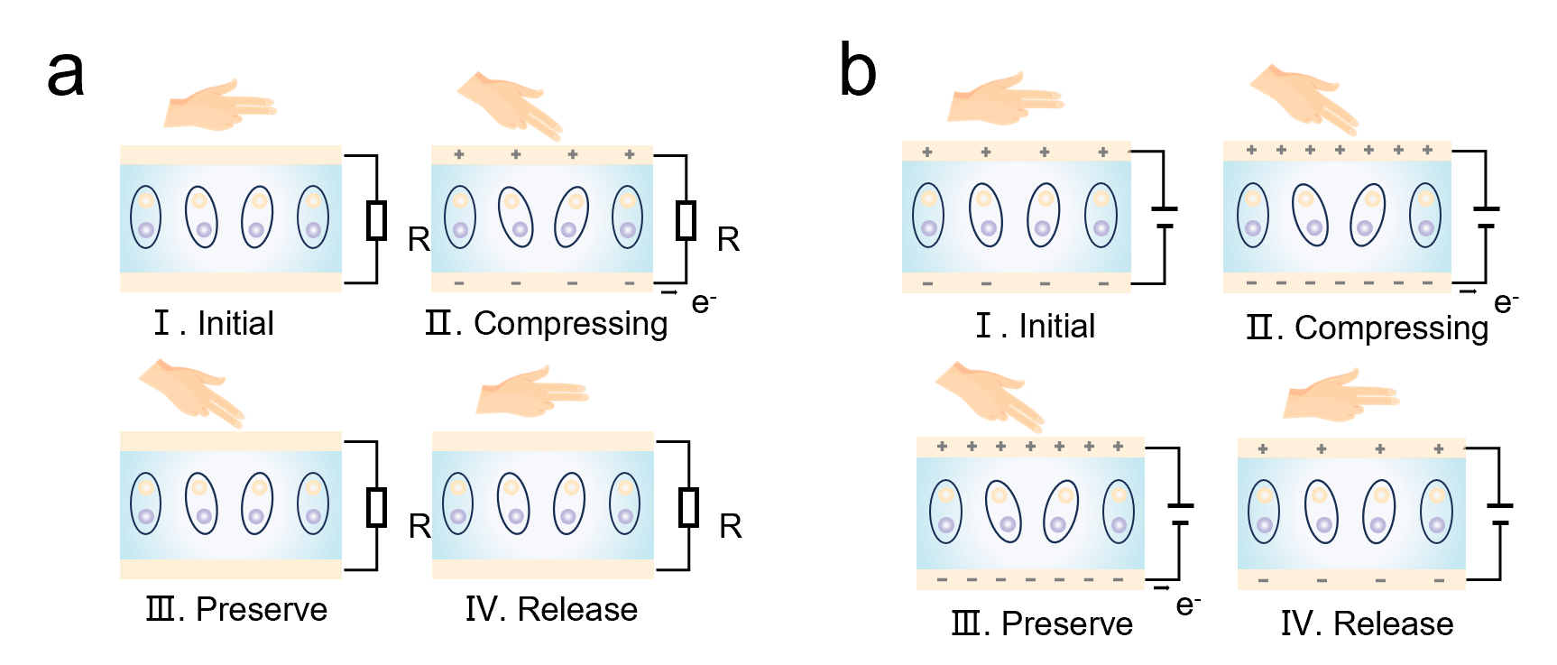
Fig. S8 Schematic diagram of the working principle of conventional and piezotronic sensor. When stress is applied to a conventional piezoelectric device (a), there is a current passing through the external circuit for a split second due to the generation of a polarization charge, which disappears when the stress continues to be maintained and cannot be maintained with the external force. When stress is applied to a BPS (b), there is a change in the current due to a change because the polarization charge changes the interface barriers, and this change can be maintained under an external force until the external force is withdrawn
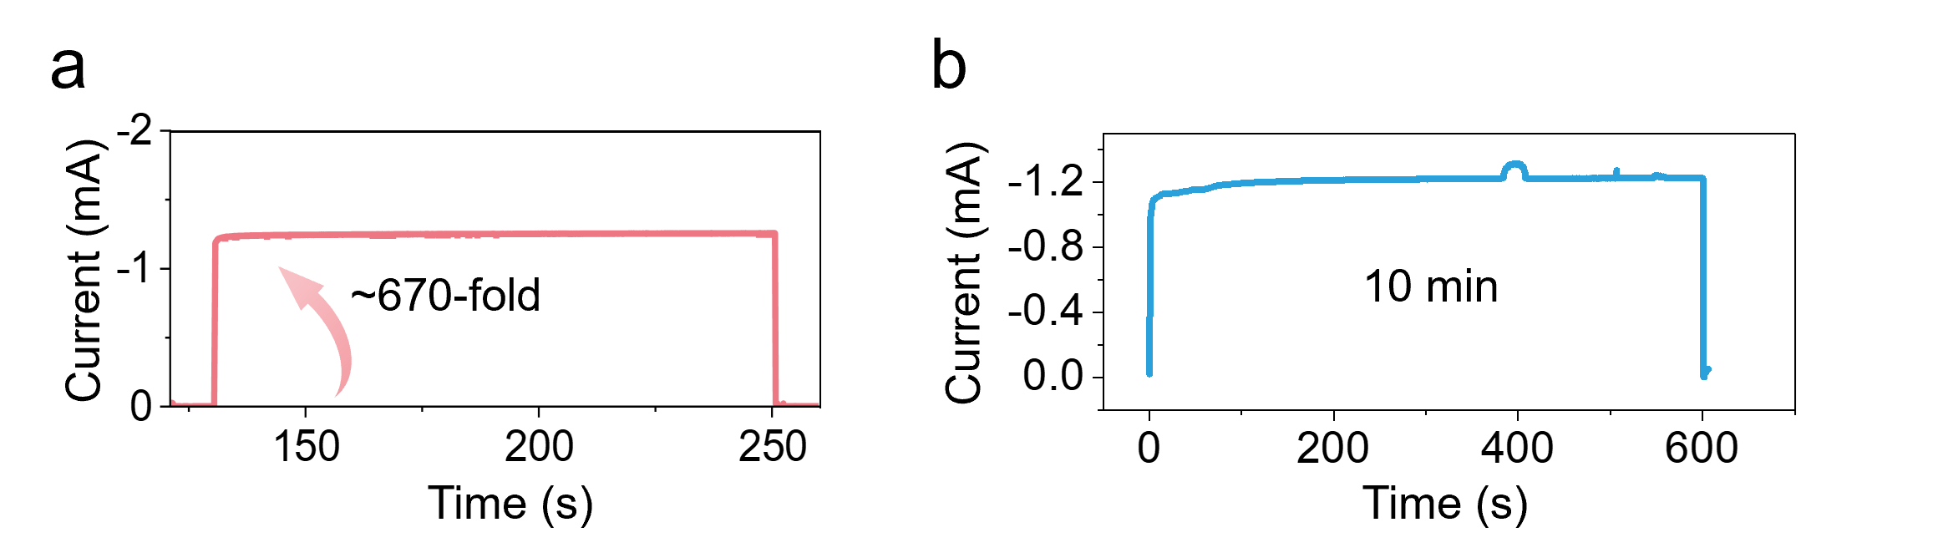
Fig. S9 I-T curve of BPS held at the force of 5 N with 120 s (a) and 600 s (b)
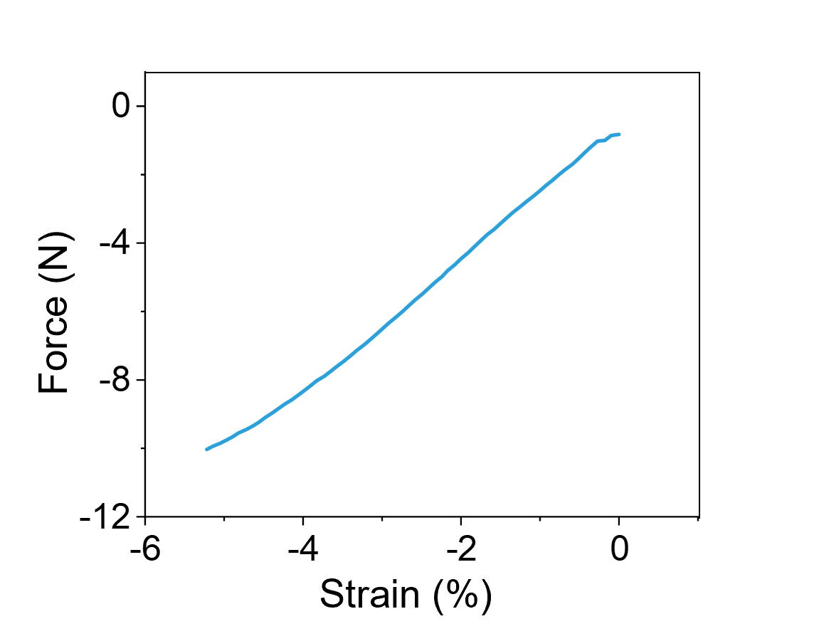
Fig. S10 Corresponding curve of stress and strain
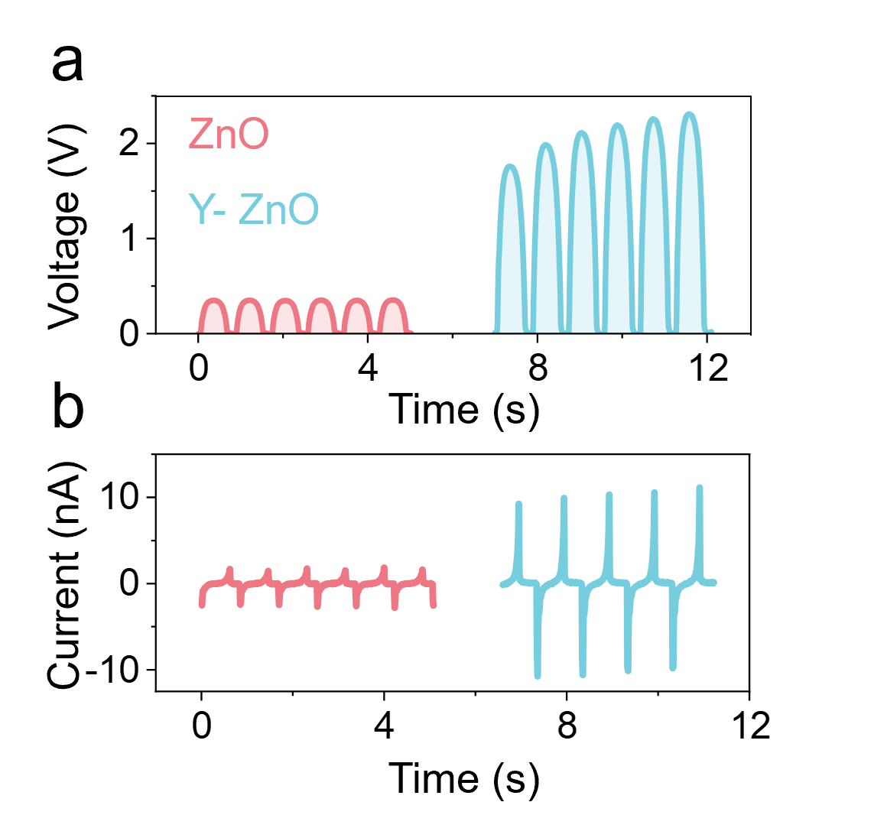
Fig. S11 Voltage output (a) and current output (b) of ZnO and Y-ZnO under the same pressure
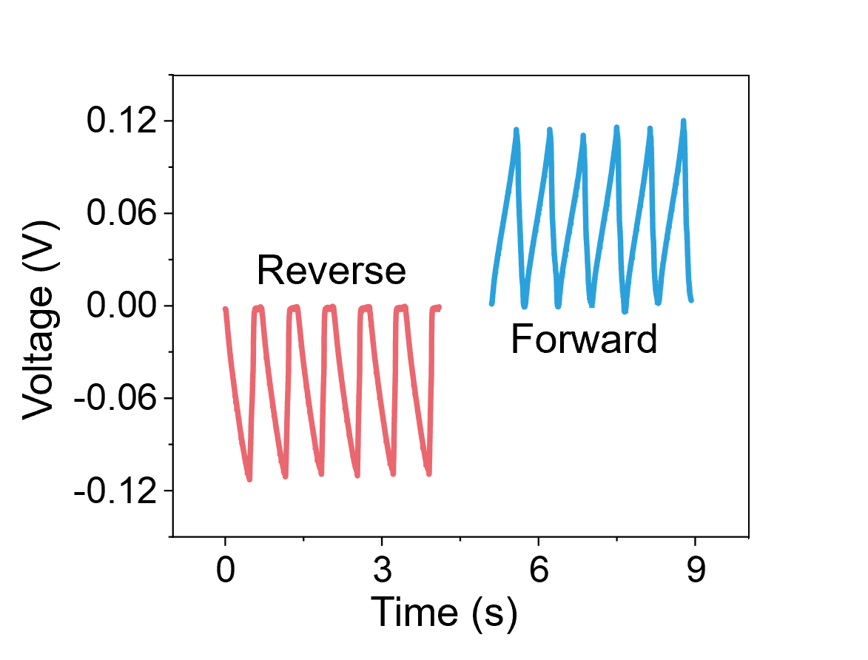
Fig. S12 Polarity switching test of ZnO piezoelectric sensors
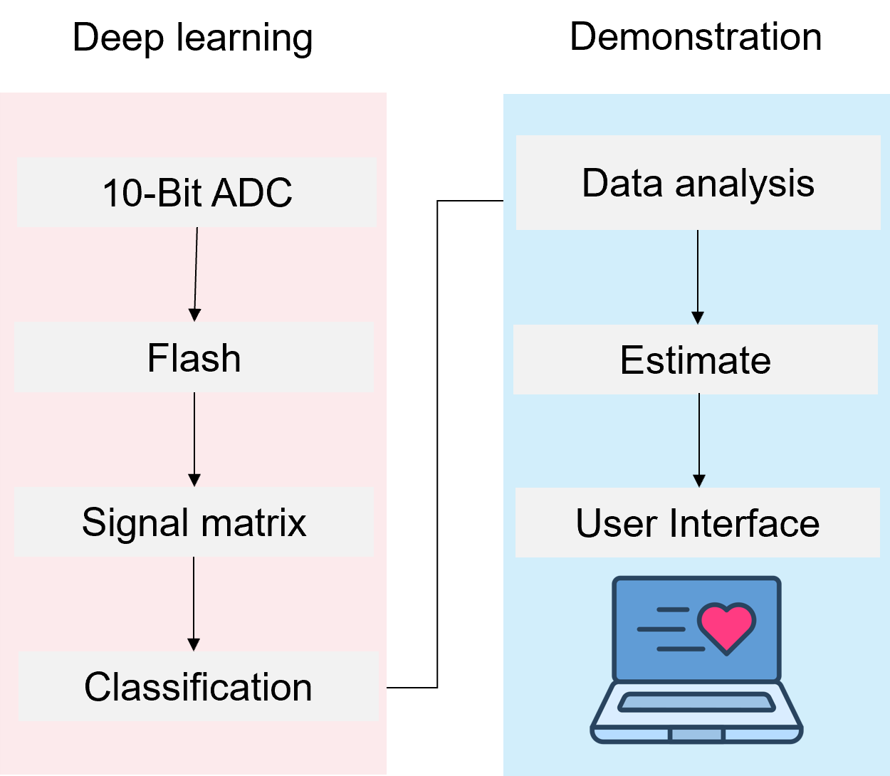
Fig. S13 Schematic illustration of the deep-learning-assisted human motion capture system
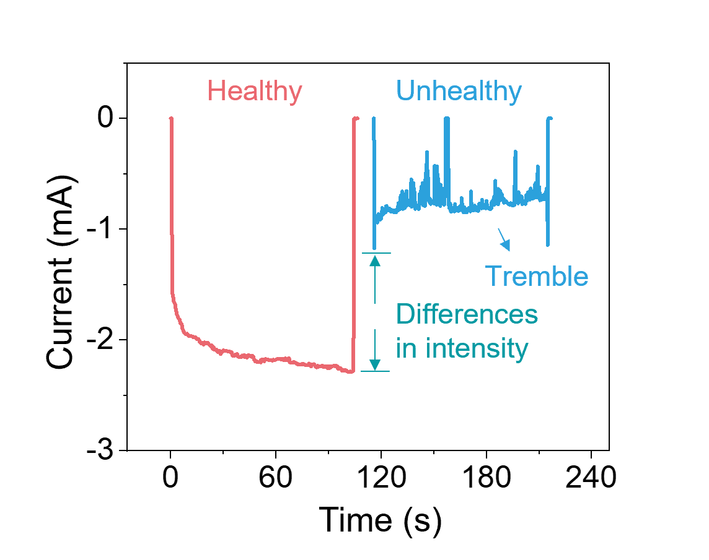
Fig. S14 Comparison of characteristic current curves of BPS in healthy and unhealthy states
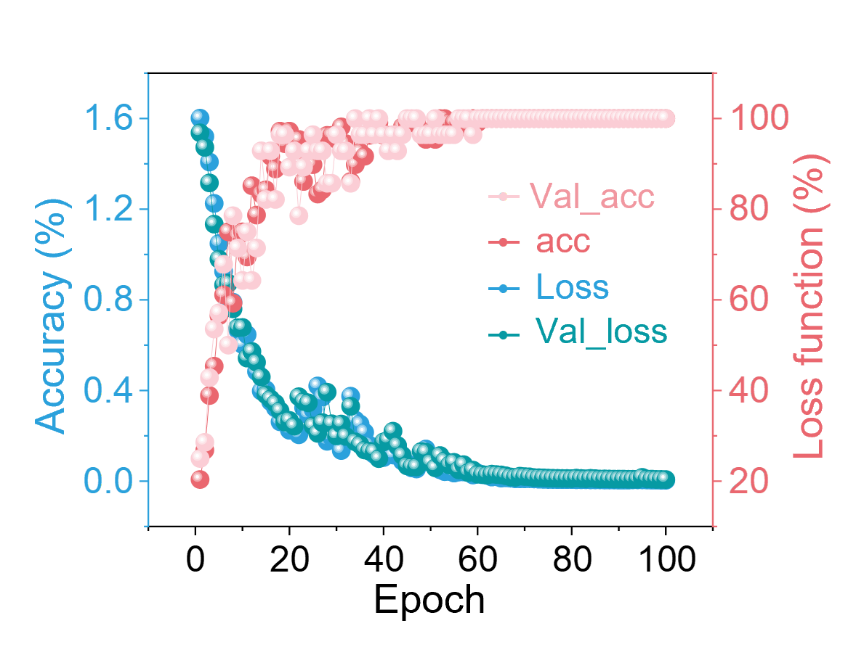
Fig. S15 Classification accuracy and loss function of training and validation datasets in 100 epochs
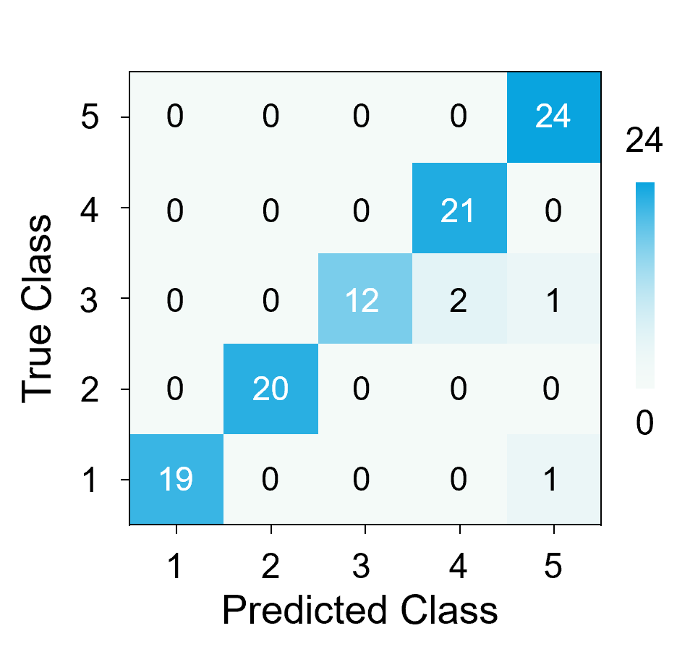
Fig. S16 Confusion matrix for the recognition of 5 Achilles tendon behaviors

