Supporting Information for
Thermally Conductive Ti₃C₂T_{x} Fibers with Superior Electrical Conductivity
Yuxiao Zhou¹, Yali Zhang¹*, Yuheng Pang¹, Hua Guo¹, Yongqiang Guo¹, Mukun Li¹, Xuetao Shi¹, Junwei Gu¹*
¹Shaanxi Key Laboratory of Macromolecular Science and Technology, School of Chemistry and Chemical Engineering, Northwestern Polytechnical University, Xi’an, Shaanxi 710072, P. R. China
*Corresponding authors. E-mail: yalizhang@nwpu.edu.cn (Yali Zhang), gjw@nwpu.edu.cn (Junwei Gu)
S1 Preparation of Ti₃C₂T_{x} dispersion
Firstly, 1.6 g LiF was added to 20 mL of 9M HCl and stirred for 30 min until completely dissolved. 1.0 g of Ti₃ACl₂ powder was slowly added and stirred at 50 ºC for 48 h under argon atmosphere. After the reaction, the mixture was washed about 8 cycles repeatedly with deionized water. Each cycle involved 5 min of centrifugation at 3500 r/min. Until the supernatant solution reached pH≈7, the resulting sediment was dispersed in deionized water with continuously vibration for 20 min. Next, the solution was then centrifuged at 1500 r/min for 30 min, and the supernatant solution was then taken and centrifuged at 4500 r/min for 20 min. Finally, the sediments were dispersed into deionized water to obtain Ti₃C₂T_{x} dispersion of various concentrations.
S2 Characterization
Fourier transform infrared spectroscopy (FT-IR, Bruker Tensor II, Bruker, Germany) was used to characterize the functional groups of Ti₃C₂T_{x} nanosheets and Ti₃C₂T_{x} fibers. X-ray photoelectron spectroscopy (XPS, Kratos Axis Ultra DLD, UK) was used to analyze the elemental composition and binding energy variations of Ti₃C₂T_{x} nanosheets and Ti₃C₂T_{x} fibers. X-ray diffraction (XRD) spectra were obtained to identify the crystal phase of Ti₃C₂T_{x} nanosheets and Ti₃C₂T_{x} fibers by an X-ray diffractometer (D8 Advance, Bruker, Germany) equipped with a Cu K𝛼 target radiation source (𝜆 = 1.54 Å). The dimensions of Ti₃C₂T_{x} nanosheets and the morphologies of Ti₃C₂T_{x} fibers were characterized using scanning electron microscopy (SEM, Verios G4, FEI, USA). The topography of Ti₃C₂T_{x} nanosheets was observed via atomic force microscope (AFM, Dimension Icon, Bruker, Germany) in tapping mode. The morphology and crystal structure of Ti₃C₂T_{x} nanosheets were taken by transmission electron microscope (TEM, Talos F200X, FEI, USA). The optical birefringence of Ti₃C₂T_{x} dispersion was recorded under a polarized optical microscope (POM, DM4P, Leica, Germany). The rheological properties of Ti₃C₂T_{x} dispersion were obtained using a rheometer (DHR-20, ‌TA Instruments, USA) under both steady shear and dynamic oscillatory conditions. The viscoelastic properties of Ti₃C₂T_{x} dispersion were investigated by measuring the storage and loss modulus as a function of frequency from 0.01 to 100 Hz. The strain amplitude remained at 0.1% with a gap of 1 mm at 25 ºC for the frequency sweep. The wide-angle X-ray scattering (WAXS) and small-angle X-ray scattering (SAXS) patterns of Ti₃C₂T_{x} fibers were conducted on a SAXS/WAXS system (XEUSS 3.0, Xenocs SAS, France) utilizing a Cu-K𝛼 targeted radiation source with a beam diameter of 900 nm on SAXS/WAXS (500 K) detectors. The electrical conductivity of Ti₃C₂T_{x} fibers was tested using a multimeter (Keithley 2700, Keithley Instruments, USA) via a standard two-probe method. The mechanical properties of Ti₃C₂T_{x} fibers were evaluated using a universal tensile testing instrument (XQ-1C, Shanghai New Fiber Instrument, China) at a loading rate of 1 mm/min with a 10 N sensor at room temperature. Infrared thermal images of Ti₃C₂T_{x} fibers were captured using infrared thermography (Ti 300, Fluke Co., USA). The area of Ti₃C₂T_{x} fibers was measured by SEM. The thermal conductivity (λ) of Ti₃C₂T_{x} fibers was measured using a cross-wire geometry.
S3 λ of Ti₃C₂T_{x} fibers measured using a cross-wire geometry
The Platinum wire with a diameter of 10 μm and a length of about 6 mm was used as the heating wire, and the heating wire and the test wire (Ti₃C₂T_{x} fiber) were welded to the copper leads as thermostatic heat sinks. The heating wire and the fiber were mounted in a cross geometry, as shown in Fig. S1, Supporting Information. In this geometry, the heating wire was perpendicular to an external magnetic field, while the fiber was parallel to the field. The self-made vacuum chamber was continuously evacuated by a molecular pump to maintain a high vacuum level of 10⁻⁴ Pa so the effect of convective heat transfer was ignored. The four-point probe technique was adopted. In the DC measurement, the constant current source (Agilent B2901A) was used to apply different currents to the heating wire, and the digital multimeter (Agilent 3458A) was used to measure the voltage across the heating wire. During the AC measurement, the lock-in amplifier (SR7265) was used to output AC signals with different frequencies of 0.1-1 Hz, and the 3ω voltage across the heating wire was measured by the same lock-in amplifier. To control the contact between the heating wire and the fiber, a direct current was imposed to the heating wire and a magnetic field was applied perpendicular to the current. The deflection of the heating wire could be in situ changed under different Ampère forces so as to contact and separate the fiber. When the two wires contacted each other, the temperature rise in the heating wire decreased since some heat would conduct out through the fiber. It was recognized that the thermal contact resistance of the bare junction plays a significant role in determining the thermal conductivity of the fiber. To overcome this problem, an AC was fed into the heating wire to measure the thermal contact resistance. λ of the fiber was obtained by comparing the temperature change of the heating wire before and after lapping the fiber.
S4 DFT calculations of borate ester bonded covalently Ti₃C₂T_{x} nanosheets
The density functional theory (DFT) calculations were undertaken using the CP2K software package. Employing the projector augmented wave (PAW) method. The Perdew-Burke-Ernzerhof (PBE) exchange-correlation energy was utilized within the generalized gradient approximation (GGA). A plane-wave basis with an energy cutoff of 400 eV was employed. A 4 × 4 × 1 k-point mesh was used for sampling the Brillouin zone with the gamma-centered method. The DFT-D3 correction was applied to account for van der Waals interactions. A vacuum thickness of no less than 15 Å in the Z direction was used to eliminate interactions between periodic cells. Convergence thresholds for forces and energies were set to 10⁻⁶ eV and 0.02 eV/Å, respectively. The charge density difference (CDD) and electron localization function (ELF) were performed by Multiwfn 3.8(dev) software packages.
S5 EMD simulation of borate ester bonded covalently Ti₃C₂T_{x} nanosheets
Equilibrium molecular dynamics (EMD) simulation based on the Green-Kubo method was performed using large-scale atomic/molecular massively parallel simulator (LAMMPS). A face-centered cubic cell of Ti₃C₂T_{x} was constructed, and then the cell was expanded to tune the atoms and doped with different ratios of B elements to build different models. The box over sizes were all set to 56 Å × 50 Å × 30 Å. All simulations were performed in the universal force field (UFF), during which the time step was set to 0.01 fs and the initial velocity of the atoms was randomly sampled from a Gaussian distribution. The conjugate gradient method in LAMMPS was used to minimize the energy and relax 5 ns at 300 K in the NPT ensemble, followed by another 5 ns in the NVT ensemble. Finally, the interfacial thermal resistance (ITR) between Ti₃C₂T_{x} nanosheets with different amounts of B in the 300 K NVE ensemble was calculated by EMD simulation where there was basically no change inside the material when the heat current auto correlation function, temperature and energy tended to be stable. By calculating the change of internal heat flow from disequilibrium to equilibrium, the λ, and thus ITR between Ti₃C₂T_{x} nanosheets was obtained.
Based on the Green-Kubo linear-response theory, the autocorrelation heat flow was obtained by counting the potential energy, kinetic energy and stress tensor of each particle in the system, and the ITR between Ti₃C₂T_{x} nanosheets was obtained from the Green-Kubo equation and the thermal resistance calculation formula, which were given by the following equations:
$λ=\frac{1}{3Vk_{B}T_{2}}\int_{0}^{∞}{\left[J\left(t\right)\right]}∗\left[J\left(0\right)\right]dt$ (S1)
where k_{B} was the Boltzmann constant, V was the volume of the system, and J was the effective heat flow, λ was the thermal conductivity of the adjacent nanosheets.
$J\left(t\right)=\frac{d}{dt}\sum_{i}{r_{i}\left(t\right)e_{i}\left(t\right)}$ (S2)
where i denoted the spatial position of particle i and e_{i} denoted the sum of potential and kinetic energies of particle i.
$e_{i}=\frac{1}{2}mv_{i}+\frac{1}{2}\sum{φ\left(r_{ij}\right)}$ (S3)
where i and j denoted different particles, v was the velocity of particle i, and (ij) is the interatomic potential energy of i and j.
$R=\frac{A}{λL}$ (S4)
where R was the ITR, L was the thickness and A was the cross-sectional area of the adjacent nanosheets.
S6 Finite element analysis of Ti₃C₂T_{x} fibers
Finite element analysis was used to simulate the transient thermal response of Ti₃C₂T_{x} fibers with different mass fractions of borate during heating with finite element analysis software COMSOL Multiphysics 6.2. The module was solid heat transfer. The domain-specific simulation models of all Ti₃C₂T_{x} fibers with different mass fractions of borate were set to 50 μm × 100 μm. The grid generation was described as using the extremely fine grid division method. Parameters including ITR of borate ester bonded covalently Ti₃C₂T_{x} nanosheets simulated by EMD in S2, interlayer spacing (d-spacing), orientation orders and porosity were used for finite element simulation. The initial conditions of the five simulation models were set to 25 ºC, and then linear heat sources with a temperature of 50 ºC were set at the bottom of the models, respectively, to measure the internal heat transfer of different models under the transient state (10 ns).
Supplementary Figures
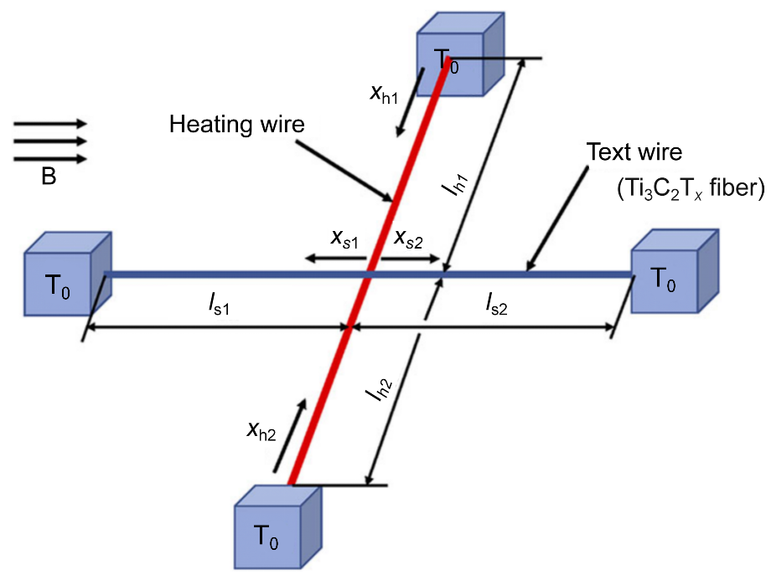
Fig. S1 Principle of the cross-wire geometry method for measuring the λ of Ti₃C₂T_{x} fiber
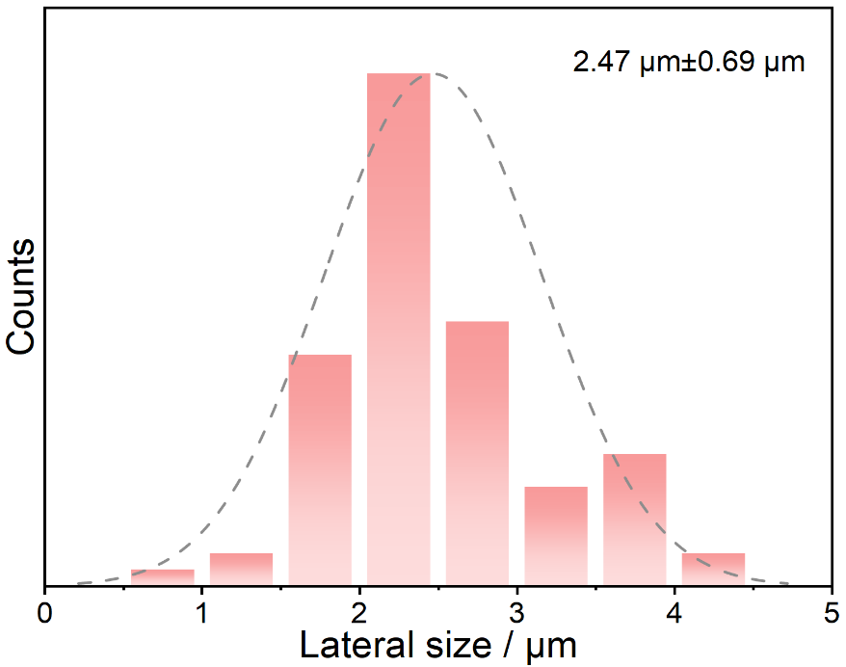
Fig. S2 Size distribution of Ti₃C₂T_{x} nanosheets
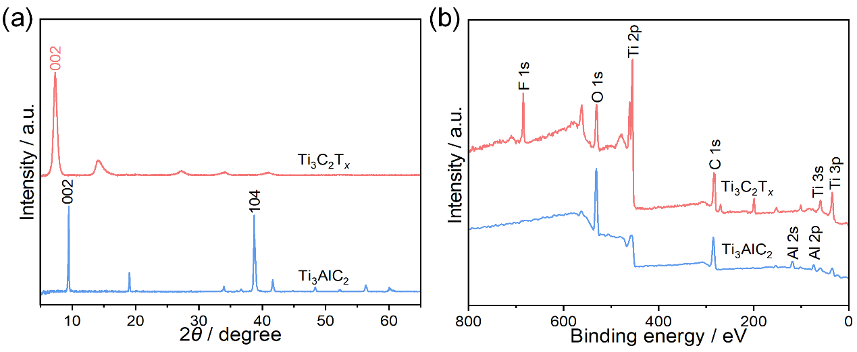
Fig. S3 (a) XRD and (b) XPS spectra of Ti₃AlC₂ and Ti₃C₂T_{x}
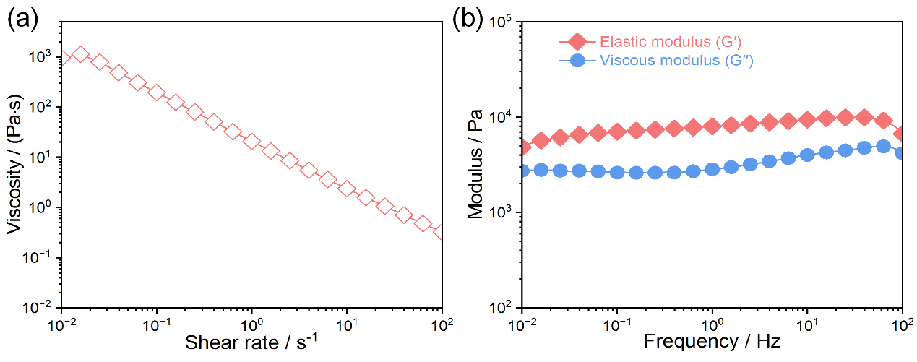
Fig. S4 (a) Viscosity as a function of shear rate versus shear rate. (b) Storage and loss modulus as a function of frequency of Ti₃C₂T_{x} liquid-crystalline dispersion at a concentration of 25 mg/mL

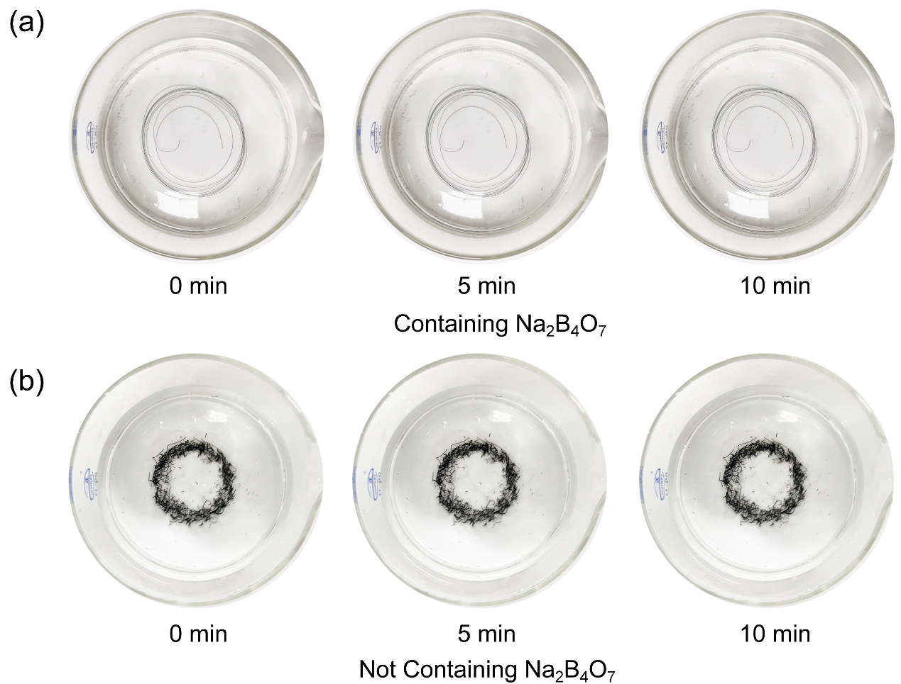
Fig. S5 Photographs of (a) the formation of continuous Ti₃C₂T_{x} gel fibers in a coagulation bath containing Na₂B₄O₇ and (b) the failure to form continuous Ti₃C₂T_{x} gel fibers in a coagulation bath without Na₂B₄O₇
Fig. S6 Photograph of continuous Ti₃C₂T_{x} fiber over 1 m (1.4 m)

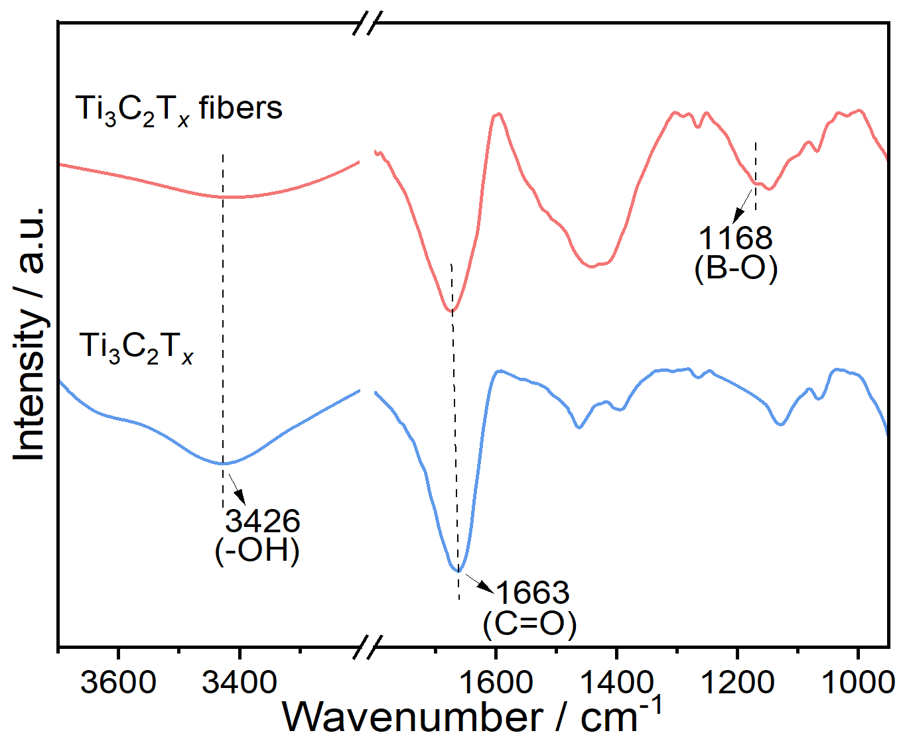
Fig. S7 FT-IR spectra of Ti₃C₂T_{x} and Ti₃C₂T_{x} fibers

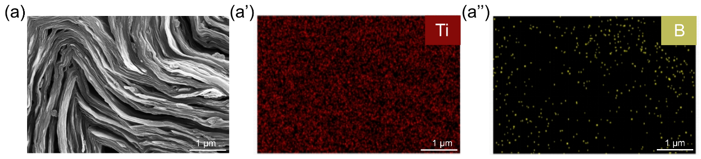
Fig. S8 (a) SEM image of the cross-section for Ti₃C₂T_{x} fiber and corresponding energy dispersive spectrometer (EDS) element distribution of (a’) Ti and (a”) B

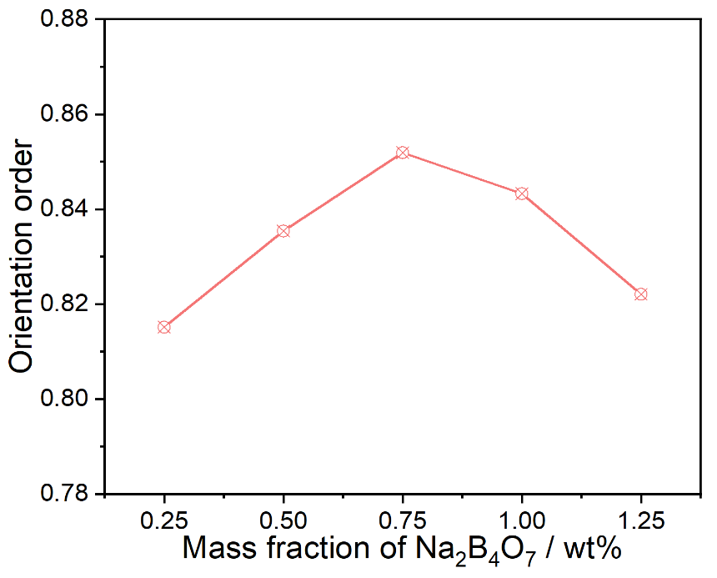
Fig. S9 Orientation order of Ti₃C₂T_{x} fibers with different Na₂B₄O₇ contents
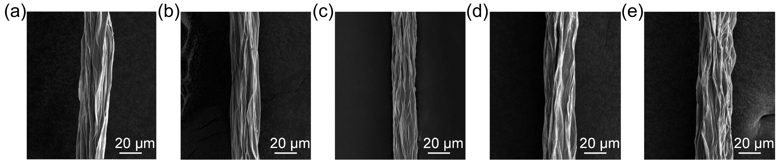
Fig. S10 SEM images of the side section for Ti₃C₂T_{x} fibers with Na₂B₄O₇ content from (a) 0.25 wt%, (b) 0.50 wt%, (c) 0.75 wt%, (d) 1.00 wt% and (e) 1.25 wt%
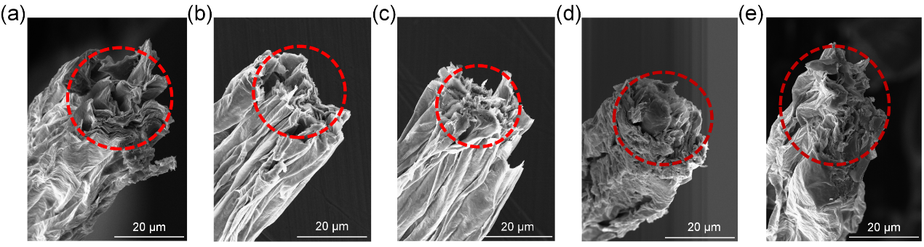
Fig. S11 SEM images of the cross section for Ti₃C₂T_{x} fibers with Na₂B₄O₇ content from (a) 0.25 wt%, (b) 0.50 wt%, (c) 0.75 wt%, (d) 1.00 wt% and (e) 1.25 wt%
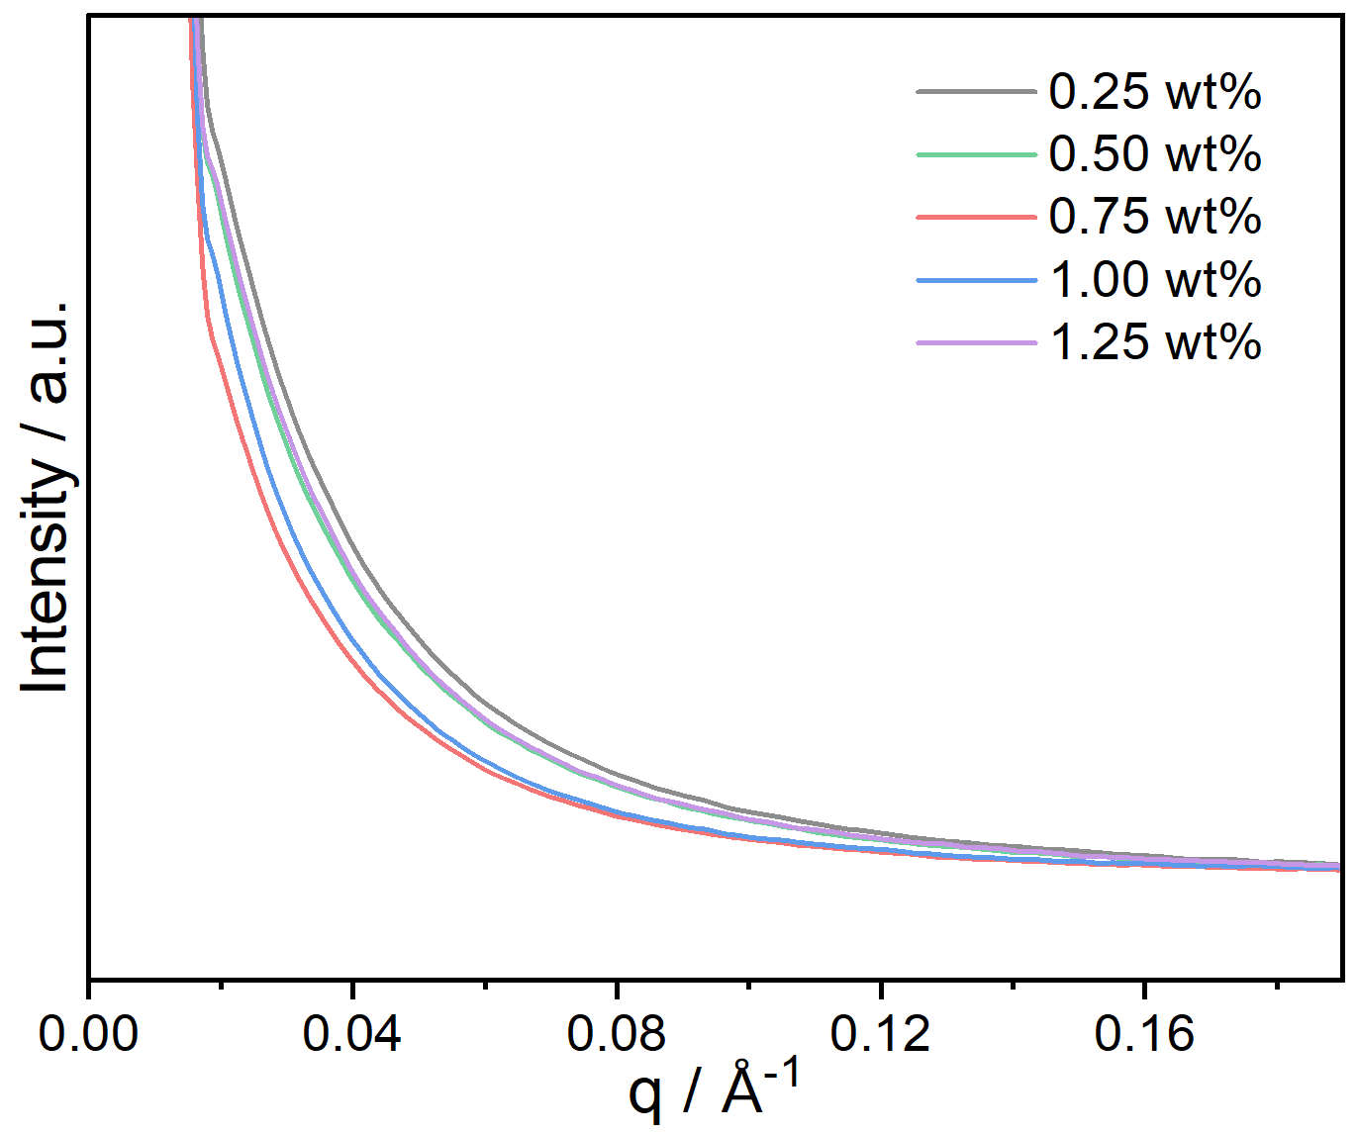
Fig. S12 Plots of the intensity vs. q for Ti₃C₂T_{x} fibers with different Na₂B₄O₇ contents according to the SAXS patterns
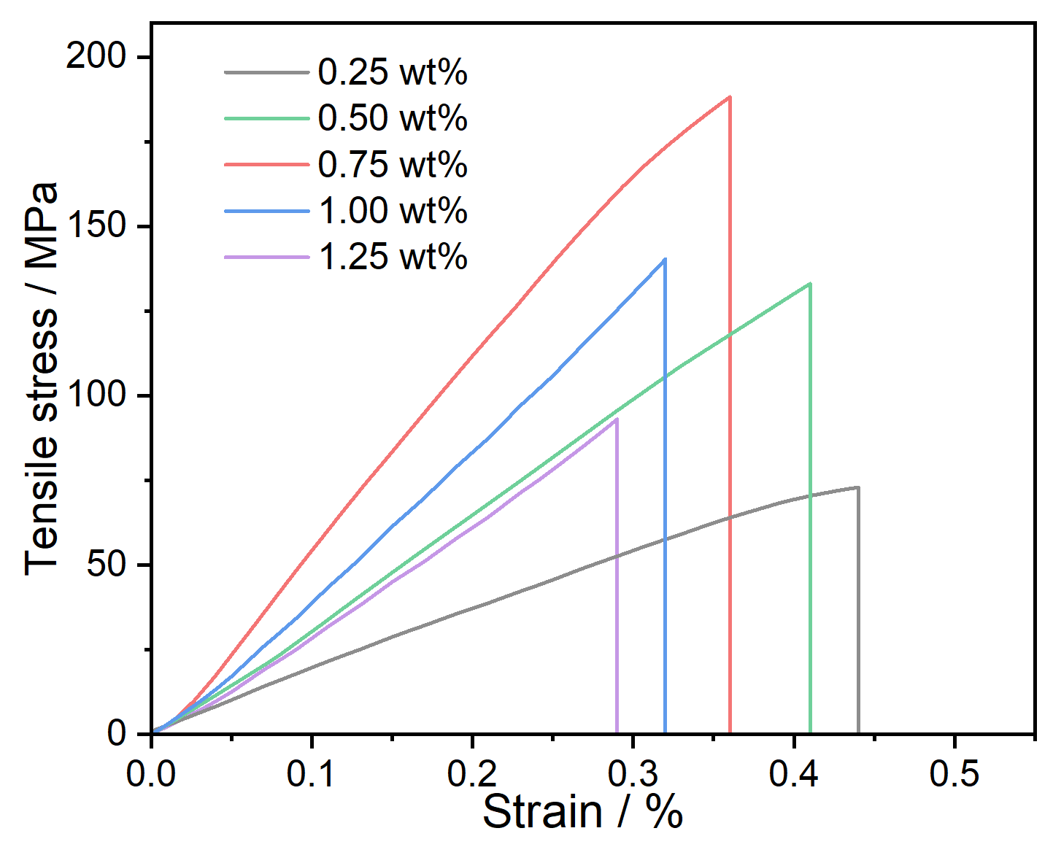
Fig. S13 Stress-strain curves of Ti₃C₂T_{x} fibers with different Na₂B₄O₇ contents
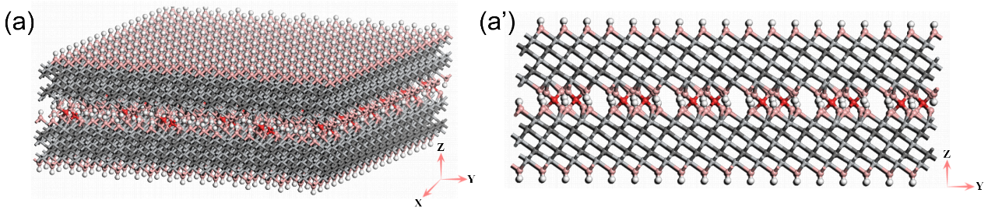
Fig. S14 (a) Three-dimensional structure and (a’) cross-sectional view of Ti₃C₂T_{x} nanosheets bonded by covalent borate ester
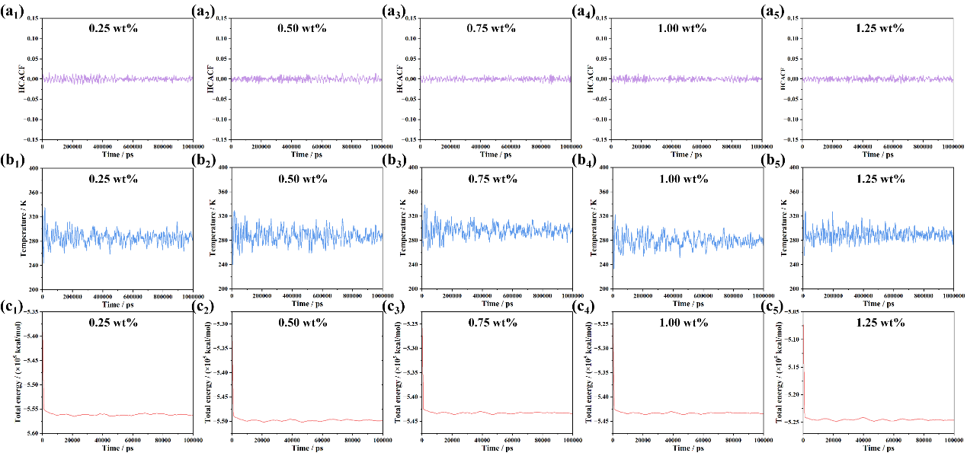
Fig. S15 Curves of (a₁-a₅) the heat current auto correlation function, (b₁-b₅) temperature and (c₁-c₅) total energy for borate ester covalently bonded Ti₃C₂T_{x} nanosheets with Na₂B₄O₇ contents from 0.25 wt%, 0.50 wt%, 0.75 wt%, 1.00 wt% and 1.25 wt%

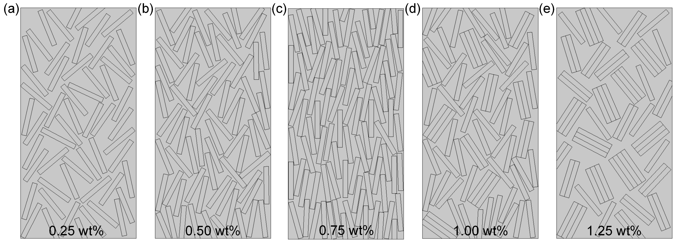
Fig. S16 FEA models of Ti₃C₂T_{x} fibers (where the long strips are Ti₃C₂T_{x} nanosheets) with Na₂B₄O₇ contents from (a) 0.25 wt%, (b) 0.50 wt%, (c) 0.75 wt%, (d) 1.00 wt% and (e) 1.25 wt%
Table S1 B content in Ti₃C₂T_{x} fibers prepared with different Na₂B₄O₇ contents, determined by XPS characterizations
Na₂B₄O₇ content in coagulant used for the fabrication of Ti₃C₂T_{x} fibers (wt%) | B content in Ti₃C₂T_{x} fibers (wt%)
0.25 | 0.052
0.50 | 0.098
0.75 | 0.142
1.00 | 0.193
1.25 | 0.246
Table S2 Comparisons of electrical conductivity and tensile strength of Ti₃C₂T_{x} fibers prepared with 0.75 wt% Na₂B₄O₇ against other reported Ti₃C₂T_{x}-based fibers and Ti₃C₂T_{x} fibers
Number | Fiber material | Tensile strength  (MPa) | Conductivity  (S/cm) | Refs.
1 | Ti₃C₂T_{x}/CNT composite fiber | 38.4 | 2.7 | [S1]
2 | Ti₃C₂T_{x}/rGO composite fiber | 145 | 28 | [S2
3 | Ti₃C₂T_{x}/rGO composite fiber | 110.7 | 743.1 | [S3]
4 | Ti₃C₂T_{x}/CDs composite fiber | 80 | 1201 | [S4]
5 | Ti₃C₂T_{x}/CNT composite fiber | 161 | 1715 | [S5]
6 | Ti₃C₂T_{x}/PU composite fiber | 37 | 1195 | [S6]
7 | Ti₃C₂T_{x}/CNF composite fiber | 46 | 916 | [S7]
8 | Ti₃C₂T_{x}/PEDOT:PSS composite fiber | 58.1 | 1489 | [S8]
9 | MXene/CMC composite fiber | 81 | 1073 | [S9]
10 | MP/Ag/MP composite fiber | 82.7 | 1575 | [S10]
11 | Ti₃C₂T_{x}/Aramid fiber | 104 | 1025 | [S11]
12 | Ti₃C₂T_{x}/ANF composite fiber | 130 | 25.15 | [S12]
13 | Ti₃C₂T_{x}/CNC composite fiber | 60 | 3000 | [S13]
14 | Ti₃C₂T_{x} fiber | 36 | 1801 | [S9]
15 | Ti₃C₂T_{x} ribbon fiber | 40 | 2548 | [S14]
16 | N-round Ti₃C₂T_{x} fiber | 52 | 1260 | [S15]
17 | N-flat Ti₃C₂T_{x} fiber | 60 | 2680 | [S15]
18 | Zn-Ti₃C₂T_{x} fiber | 150.7 | 3637.9 | [S16]
19 | Ti₃C₂T_{x} fiber | 40.5 | 7748 | [S17]
20 | Ti₃C₂T_{x} fiber | 63.9 | 7713 | [S18]
21 | O-flat Ti₃C₂T_{x} fiber | 118 | 7200 | [S15]
22 | Ti₃C₂T_{x} fiber | 188.7 | 7781 | This work

Supplementary References
- C.Y. Yu, Y.J. Gong, R.Y. Chen, M.Y. Zhang, J.Y. Zhou et al., A solid-state fibriform supercapacitor boosted by host–guest hybridization between the carbon nanotube scaffold and MXene nanosheets. Small 14(29), 1801203 (2018). https://doi.org/10.1002/smll.201801203
- Q. Yang, Z. Xu, B. Fang, T. Huang, S. Cai et al., MXene/graphene hybrid fibers for high performance flexible supercapacitors. J. Mater. Chem. A 5(42), 22113–22119 (2017). https://doi.org/10.1039/c7ta07999k
- N. He, S. Patil, J. Qu, J. Liao, F. Zhao et al., Effects of electrolyte mediation and MXene size in fiber-shaped supercapacitors. ACS Appl. Energy Mater. 3(3), 2949–2958 (2020). https://doi.org/10.1021/acsaem.0c00024
- H. Wang, W. Zhao, Z. Zhang, W. Hou, L. Yin et al., Synergizing electron and ion transports of Ti₃C₂T_{X} MXene fiber via dot-sheet heterostructure and covalent Ti─C─Ti cross-linking for efficient charge storage and thermal management. Adv. Funct. Mater. 34(48), 2408508 (2024). https://doi.org/10.1002/adfm.202408508
- X. Zhao, J. Zhang, K. Lv, N. Kong, Y. Shao et al., Carbon nanotubes boosts the toughness and conductivity of wet-spun MXene fibers for fiber-shaped super capacitors. Carbon 200, 38–46 (2022). https://doi.org/10.1016/j.carbon.2022.08.045
- X. Zhao, J. Zhang, K. Lv, N. Kong, Y. Shao et al., Carbon nanotubes boosts the toughness and conductivity of wet-spun MXene fibers for fiber-shaped super capacitors. Carbon 200, 38–46 (2022). https://doi.org/10.1016/j.carbon.2022.08.045
- Q. Liang, K. Liu, T. Xu, Y. Wang, M. Zhang et al., Interfacial modulation of Ti3C2Tx MXene by cellulose nanofibrils to construct hybrid fibers with high volumetric specific capacitance. Small 20(17), 2307344 (2024). https://doi.org/10.1002/smll.202307344
- J. Zhang, S. Seyedin, S. Qin, Z. Wang, S. Moradi et al., Highly conductive Ti₃C₂T_{x} MXene hybrid fibers for flexible and elastic fiber-shaped supercapacitors. Small 15(8), 1804732 (2019). https://doi.org/10.1002/smll.201804732
- H. Wang, Y. Wang, J. Chang, J. Yang, H. Dai et al., Nacre-inspired strong MXene/cellulose fiber with superior supercapacitive performance via synergizing the interfacial bonding and interlayer spacing. Nano Lett. 23(12), 5663–5672 (2023). https://doi.org/10.1021/acs.nanolett.3c01307
- M.M. Ovhal, H.B. Lee, V.V. Satale, B. Tyagi, S. Chowdhury et al., One-meter-long, all-3D-printed supercapacitor fibers based on structurally engineered electrode for wearable energy storage. Adv. Energy Mater. 14(6), 2303053 (2024). https://doi.org/10.1002/aenm.202303053
- Q. Liu, A. Zhao, X. He, Q. Li, J. Sun et al., Full-temperature all-solid-state Ti3C2Tx/aramid fiber supercapacitor with optimal balance of capacitive performance and flexibility. Adv. Funct. Mater. 31(22), 2010944 (2021). https://doi.org/10.1002/adfm.202010944
- L. Wang, M. Zhang, B. Yang, J. Tan, Lightweight, robust, conductive composite fibers based on MXene@Aramid nanofibers as sensors for smart fabrics. ACS Appl. Mater. Interfaces 13(35), 41933–41945 (2021). https://doi.org/10.1021/acsami.1c13645
- K.A.S. Usman, J. Zhang, S. Qin, Y. Yao, P.A. Lynch et al., Inducing liquid crystallinity in dilute MXene dispersions for facile processing of multifunctional fibers. J. Mater. Chem. A 10(9), 4770–4781 (2022). https://doi.org/10.1039/d1ta09547a
- C. Zhu, F. Geng, Macroscopic MXene ribbon with oriented sheet stacking for high-performance flexible supercapacitors. Carbon Energy 3(1), 142–152 (2021). https://doi.org/10.1002/cey2.65
- S. Li, Z. Fan, G. Wu, Y. Shao, Z. Xia et al., Assembly of nanofluidic MXene fibers with enhanced ionic transport and capacitive charge storage by flake orientation. ACS Nano 15(4), 7821–7832 (2021). https://doi.org/10.1021/acsnano.1c02271
- X. Cao, G. Wu, K. Li, C. Hou, Y. Li et al., High-performance Zn²⁺-crosslinked MXene fibers for versatile flexible electronics. Adv. Funct. Mater. 34(46), 2407975 (2024). https://doi.org/10.1002/adfm.202407975
- J. Zhang, S. Uzun, S. Seyedin, P.A. Lynch, B. Akuzum et al., Additive-free MXene liquid crystals and fibers. ACS Cent Sci 6(2), 254–265 (2020). https://doi.org/10.1021/acscentsci.9b01217
- W. Eom, H. Shin, R.B. Ambade, S.H. Lee, K.H. Lee et al., Large-scale wet-spinning of highly electroconductive MXene fibers. Nat Commun 11(1), 2825 (2020). https://doi.org/10.1038/s41467-020-16671-1

