Supporting Information for
Tailoring Artificial Solid Electrolyte Interphase via MoS₂ Sacrificial Thin-Film for Li-Free All-Solid-State Batteries
Dong-Bum Seo^{1,†}, Dohun Kim^{2,†}, Mee-Ree Kim², Jimin Kwon², Hyeong Jun Kook³, Saewon Kang¹, Soonmin Yim¹, Sun Sook Lee¹, Dong Ok Shin³, Ki-Seok An^{1,}*, and Sangbaek Park^{2,}*
¹Thin Film Materials Research Center, Korea Research Institute of Chemical Technology (KRICT), 141 Gajeong-ro, Yuseong-gu, Daejeon 34114, Republic of Korea
²Department of Materials Science and Engineering, Chungnam National University, Daejeon, 34134, Republic of Korea
³Intelligent Sensors Research Section, Electronics and Telecommunications Research Institute (ETRI), Daejeon, 34129, Republic of Korea
† Dong-Bum Seo and Dohun Kim contributed equally to this work.
* Corresponding authors. E-mail: ksan@krict.re.kr (Ki-Seok An); sb.park@cnu.ac.kr (Sangbaek Park)
Supplementary Figures and Tables
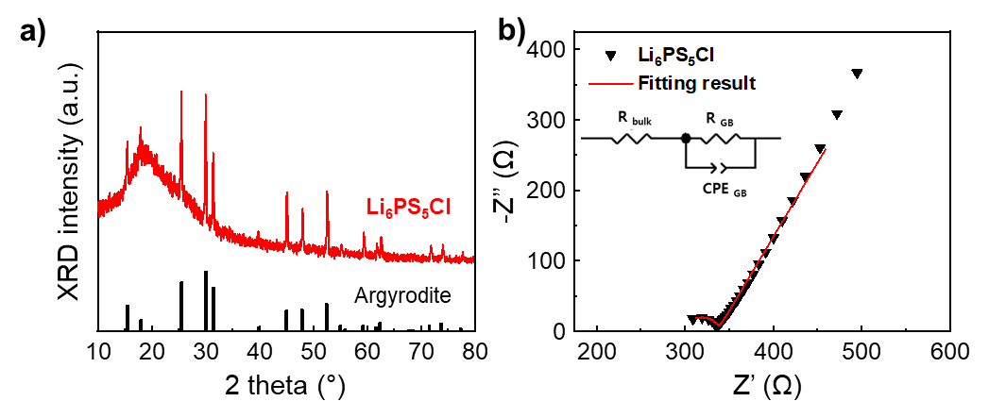
Fig. S1 (a) XRD pattern of prepared Li₆PS₅Cl electrolyte. (b) Nyquist plots of Li₆PS₅Cl at RT
Table S1 Electrochemical impedance spectroscopy (EIS) properties of Li₆PS₅Cl as calculated from the Nyquist plot
R_{bulk} (Ω) | R_{GB} (Ω) | Impedance (Ω) | Area (cm²) | Thickness (cm) | Conductivity (mS cm⁻¹)
299.31 | 37.14 | 336.44 | 0.2826 | 0.171 |  | 1.8

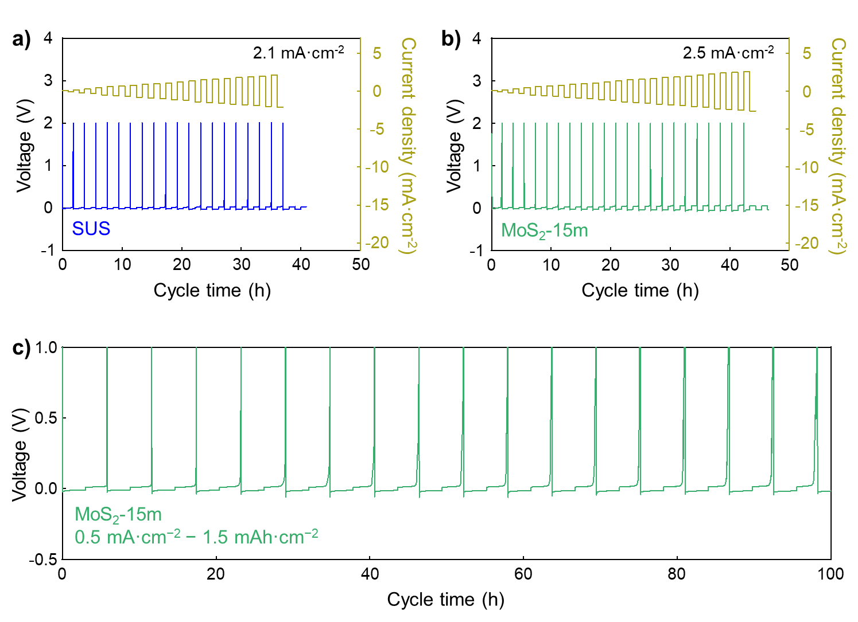
Fig. S2 The critical current density (CCD) analysis of (a) SUS and (b) MoS₂-15m. (c) The galvanostatic cycling test of MoS₂-15m conducted at a current density of 0.5 mA cm⁻² with an areal capacity of 1.5 mAh cm⁻²

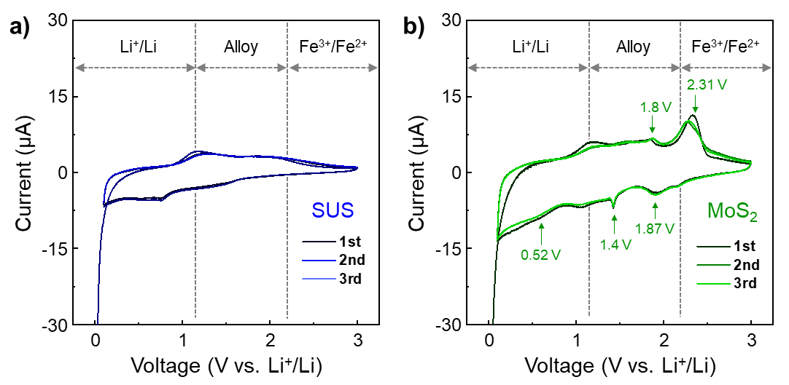
Fig. S3 CV curve obtained using a liquid electrolyte with (a) SUS and (b) MoS₂-15m

Table 2 Redox reaction voltage value and equation with MoS₂ based on liquid electrolyte
Voltage (V) | Redox reaction equation
0.52 | Li_{x}MoS₂ + 4Li+ + 4e⁻ → 2Li₂S + Mo
1.4 | MoS₂ + 4Li+ + 4e⁻ → Li_{x}MoS₂
1.87 | 2Li⁺ + 2e⁻ + S → Li₂S
1.8 | Mo + 2S → MoS₂
2.31 | Li₂S → 2Li+ + 2e⁻ + S
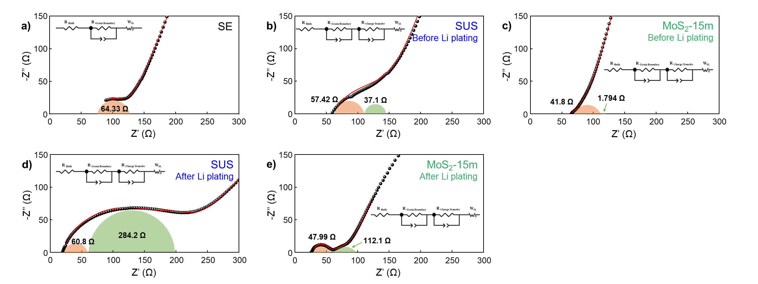
Fig. S4 (a) Nyquist plots of Li₆PS₅Cl. (b-c) Nyquist plots of full-cell structures with (b) SUS and (c) MoS₂-15m before Li plating. (d-e) Nyquist plots of full-cell structures with (d) SUS and (e) MoS₂-15m after Li plating
Table 3 EIS properties of SUS CC and MoS₂-15m as calculated from the Nyquist plot
Structure | Lithium Plating | R _{Bulk}  (Ω) | R _{Grain Boundary}  (Ω) | R _{Charge Transfer}  (Ω)
SUS | LPSCl | SUS | - | 62.84 | 64.3 | -
Cathode | LPSCl | SUS | Before | 57 | 57.42 | 37.1
Cathode | LPSCl | SUS | After | 39.88 | 60.8 | 284.2
Cathode | LPSCl | MoS₂ | Before | 65.72 | 41.8 | 1.794
Cathode | LPSCl | MoS₂ | After | 54.51 | 47.99 | 112.1
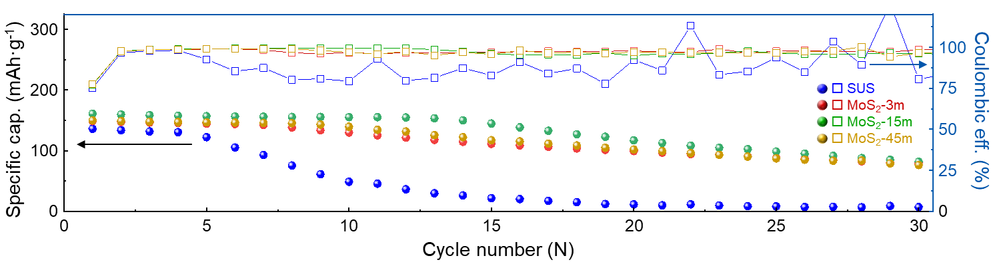
Fig. S5 Cycling performance of various samples (SUS, MoS₂-3m, MoS₂-15m, and MoS₂-45m) at a current density of 0.2 C

