Supporting Information for
Engineering Bipolar Doping in a Janus Dual-Atom Catalyst for Photo-Enhanced Rechargeable Zn-Air Battery
Ning Liu¹, Yinwu Li¹, Wencai Liu¹, Zhanhao Liang¹, Bin Liao¹, Fang Yang², Ming Zhao³, Bo Yan¹, Xuchun Gui⁴, Hong Bin Yang³, Dingshan Yu²*, Zhiping Zeng¹*, Guowei Yang¹
¹State Key Laboratory of Optoelectronic Materials, School of Materials Science and Engineering, Sun Yat-sen University, Guangzhou 510275, P. R. China
²Key Laboratory for Polymeric Composite and Functional Materials of Ministry of Education, Key Laboratory of High-Performance Polymer-Based Composites of Guangdong Province, School of Chemistry, Sun Yat-Sen University, Guangzhou 510275, P. R. China
³School of Materials Science and Engineering, Suzhou University of Science and Technology, Suzhou 215009, P. R. China
⁴State Key Laboratory of Optoelectronic Materials and Technologies, School of Electronics and Information Technology, Sun Yat-sen University, Guangzhou 510275, P. R. China
*Corresponding authors. E-mail: zzhip8@mail.sysu.edu.cn (Zhiping Zeng); yudings@mail.sysu.edu.cn (Dingshan Yu)
Supplementary Figures and Tables
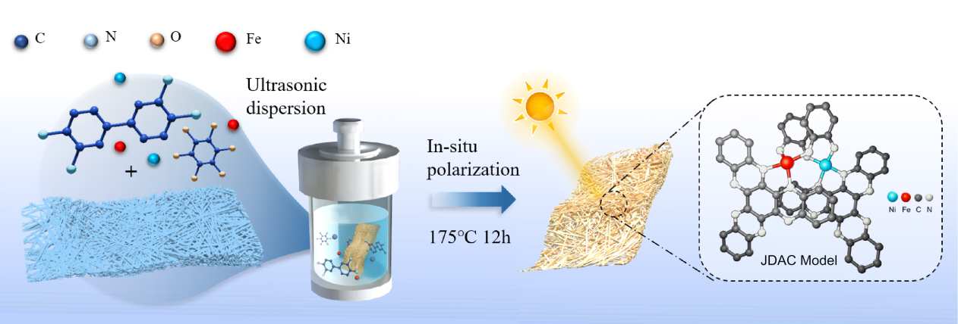
Fig. S1 Schematic illustration of the preparation of JDAC
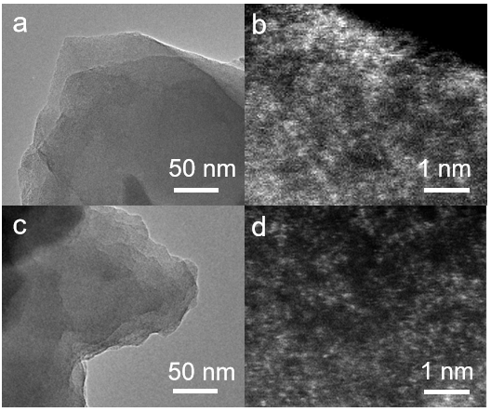
Fig. S2 TEM images of (a, b) Fe-C₄N, (c, d) Ni-C₄N

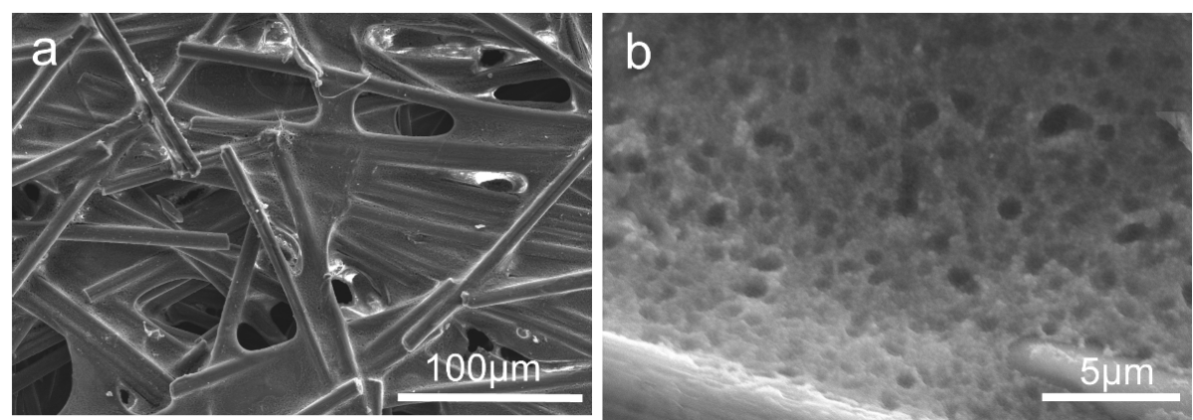
Fig. S3 SEM images of JDAC in-situ grown on carbon paper (a) Scale bar: 100 μm, (b) 5 μm

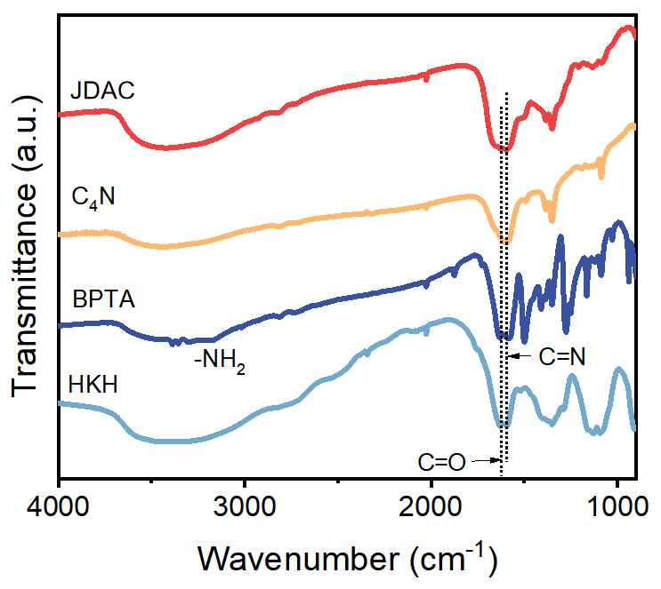
Fig. S4 FT-IR spectra of precursors, C₄N and JDAC

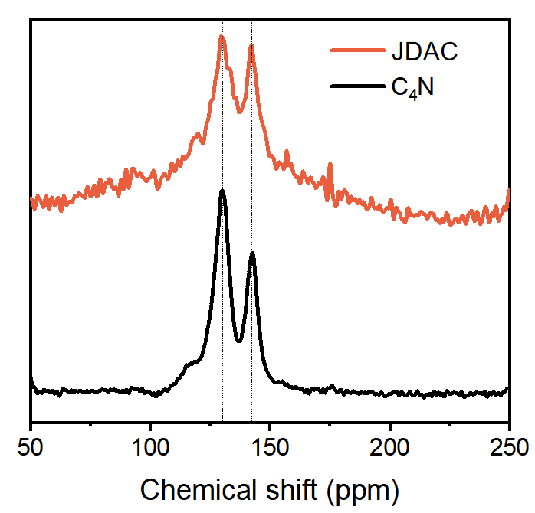
Fig. S5 Solid-state ¹³C NMR spectrum of JDAC and C₄N

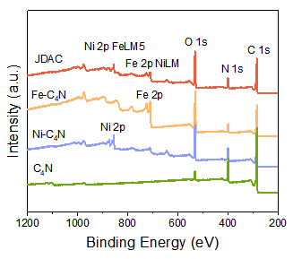
Fig. S6 XPS spectra of JDAC, Fe-C₄N, Ni-C₄N, and C₄N
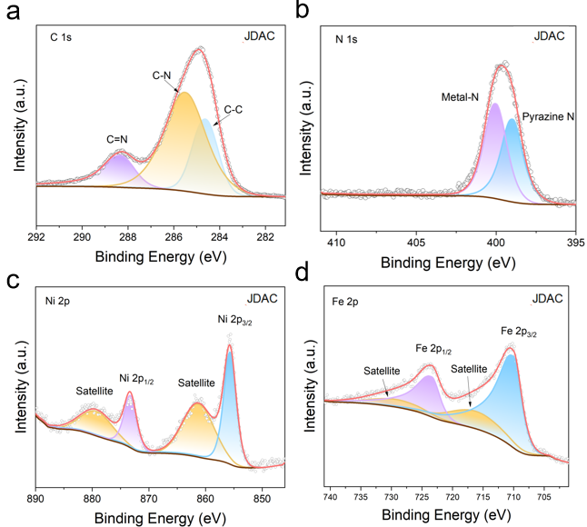
Fig. S7 High-resolution XPS spectra of JDAC regarding (a) C 1s, (b) N 1s, (c) Ni 2p, and (d) Fe 2p
Note: The peaks of the configurations in JDAC are located at C=N (288.3 eV), C-N (285.5 eV), C-C (284.6 eV), metal-N (400.0 eV), pyrazine N (398.8 eV), Ni 2p_{1/2} (873.5 eV), Ni 2p_{3/2} (855.6 eV), Fe 2p_{1/2} (723.9 eV) and Fe 2p_{3/2} (710.2 eV), respectively.
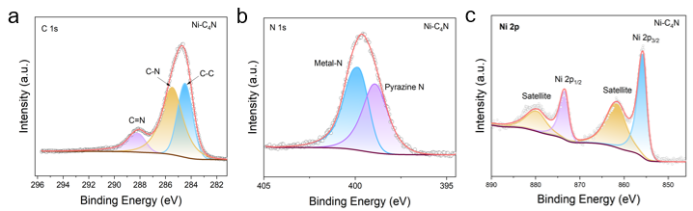
Fig. S8 High-resolution XPS spectra of Ni-C₄N regarding (a) C 1s, (b) N 1s, and (c) Ni 2p
Note: The peaks of the configurations in Ni-C₄N are located at C=N (288.2 eV), C-N (285.5 eV), C-C (284.6 eV), metal-N (400.0 eV), pyrazine N (398.8 eV), Ni 2p_{1/2} (873.5 eV), and Ni 2p_{3/2} (855.8 eV), respectively.

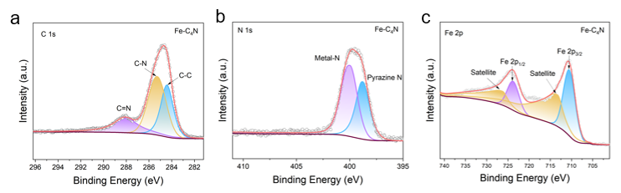
Fig. S9 High-resolution XPS spectra of Fe-C₄N regarding (a) C 1s, (b) N 1s, and (c) Fe 2p
Note: The peaks of the configurations in Fe-C₄N are located at C=N (288.3 eV), C-N (285.5 eV), C-C (284.6 eV), metal-N (400.0 eV), pyrazine N (398.8 eV), Fe 2p_{1/2} (723.9 eV) and Fe 2p_{3/2} (710.5 eV), respectively.

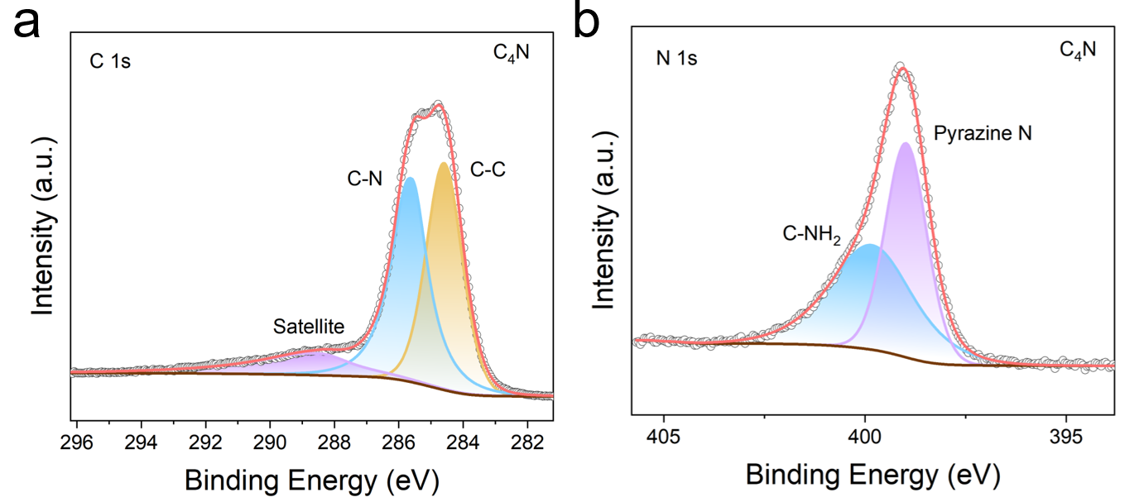
Fig. S10 High-resolution XPS spectra of C₄N regarding (a) C 1s and (b) N 1s
Note: The peaks of the configurations in C₄N are located at C-N (285.5 eV), C-C (284.6 eV), residual -NH₂ groups (399.9 eV), pyrazine N (398.8 eV), respectively.
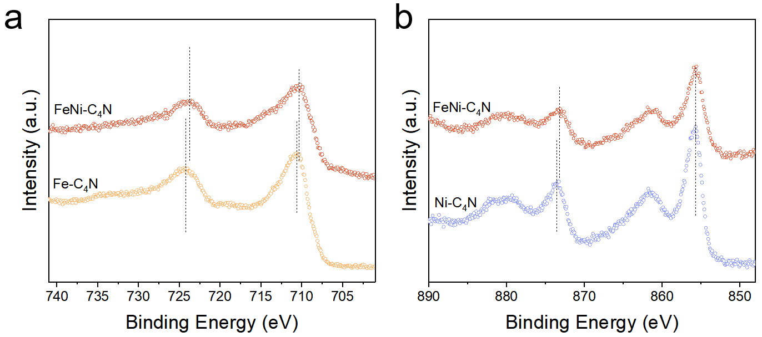
Fig. S11 High resolution XPS survey of (a) Fe 2p in JDAC and Fe-C₄N, (b) Ni 2p in JDAC and Ni-C₄N
Note: The peaks positions of Fe 2p in JDAC shows a negative shift from 724.1 eV to 723.4 eV, and from 710.8 eV to 710.7 eV compared to Fe-C₄N. The peaks positions of Ni 2p in JDAC also shows a negative shift from 873.5 eV to 873.4 eV, and 855.9 eV to 855.8 eV compared to Ni-C₄N.
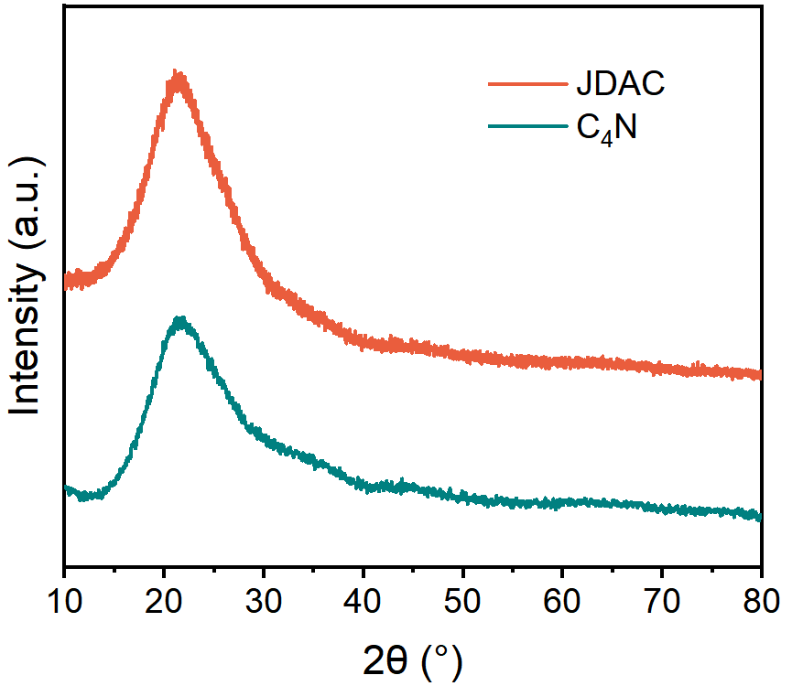
Fig. S12 XRD patterns of JDAC and C₄N

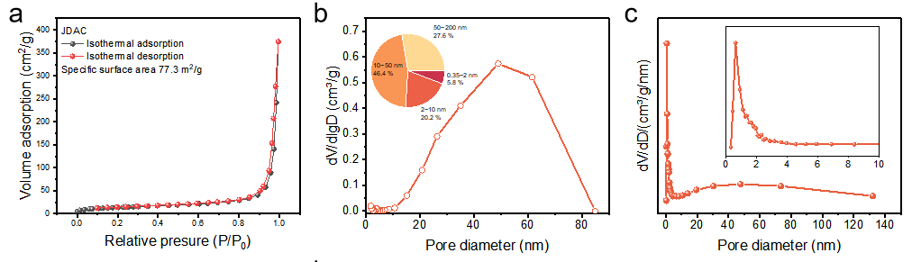
Fig. S13 (a) Nitrogen adsorption isotherms measured at 77 K of JDAC. (b) BJH (desorption) pore volume and pore size logarithm curve (inset: pore size distribution) and (c) differential integral pore volume pore size distribution by NLDFT of JDAC

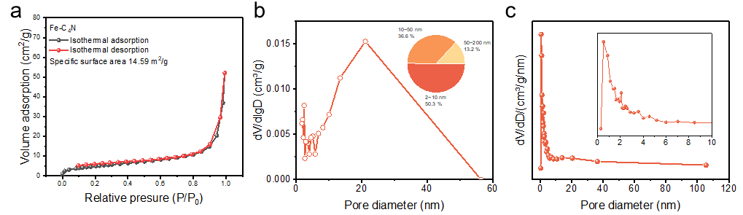
Fig. S14 (a) Nitrogen adsorption isotherms measured at 77 K of Fe-C₄N. (b) BJH (desorption) pore volume and pore size logarithm curve (inset: pore size distribution), and (c) differential integral pore volume pore size distribution by NLDFT of Fe-C₄N

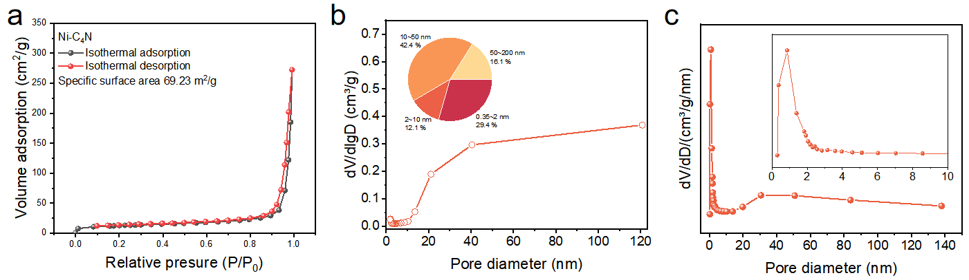
Fig. S15 (a) Nitrogen adsorption isotherms measured at 77 K of Ni-C₄N. (b) BJH (desorption) pore volume and pore size logarithm curve (inset: pore size distribution), and (c) differential integral pore volume pore size distribution by NLDFT of Ni-C₄N

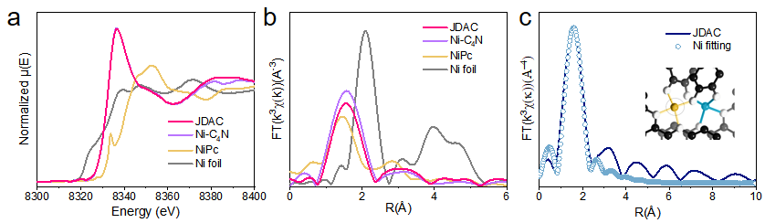
Fig. S16 (a) XANES spectra of Ni k-edge. (b) Fourier transformation-EXAFS of Ni. (c) EXAFS fitting curves of Ni

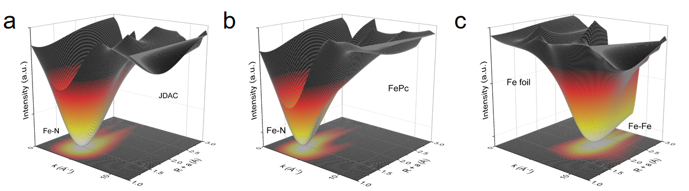
Fig. S17 Wavelet transform -EXAFS of Fe k-edge in (a) JDAC, (b) FePc,and (c) Fe foil

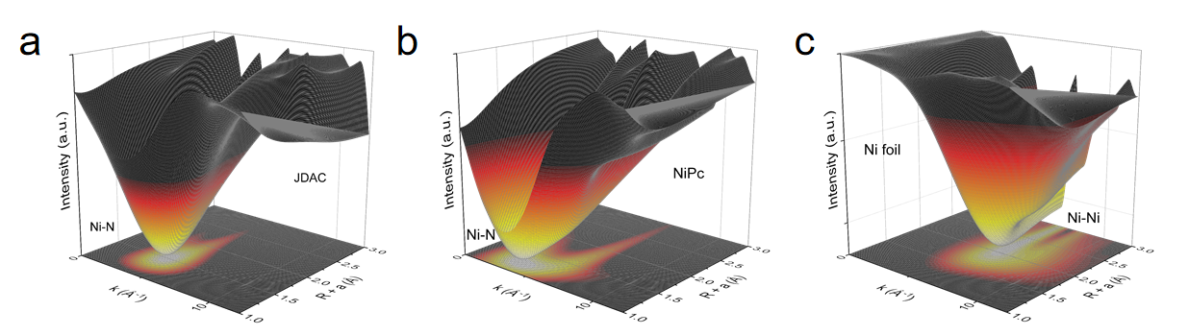
Fig. S18 Wavelet transform -EXAFS of Ni k-edge in (a) JDAC, (b) NiPc, and (c) Ni foil

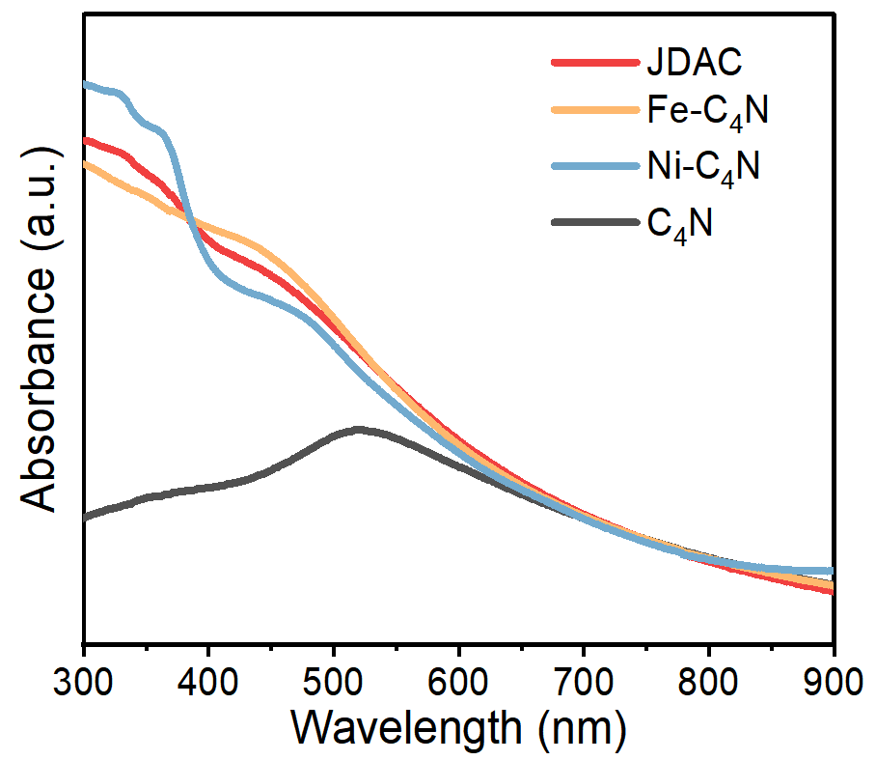
Fig. S19 UV-Vis absorption spectrum of JDAC, Fe-C₄N, Ni-C₄N and C₄N

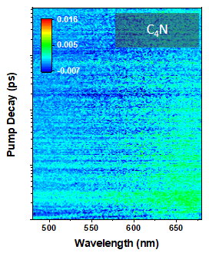
Fig. S20 Femtosecond transient absorption spectroscopy (fs-TAS) of C₄N

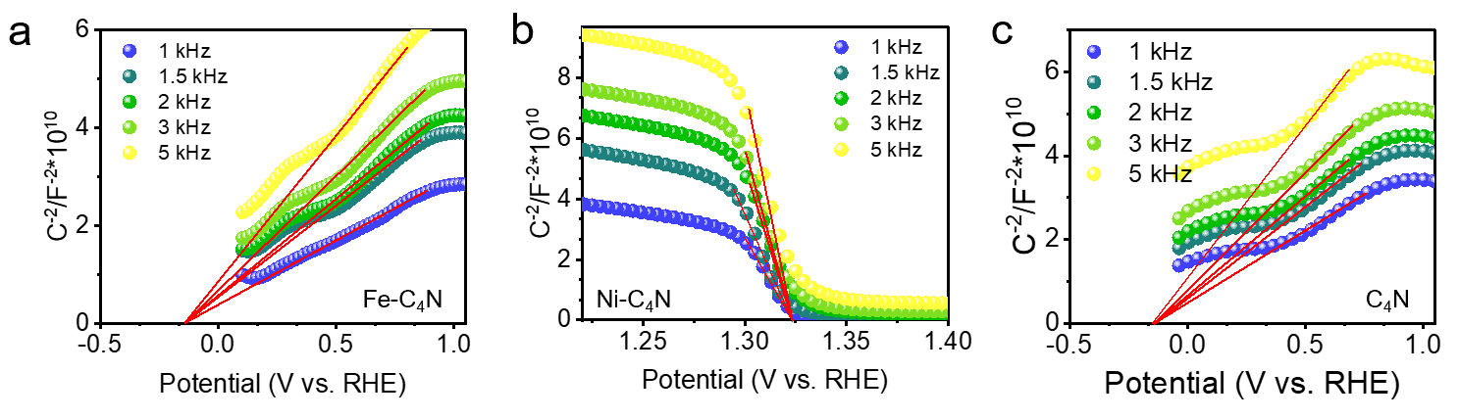
Fig. S21 Mott-Schottky plots of C_{scL}⁻² vs. E of (a) Fe-C₄N, (b) Ni-C₄N, and (c) C₄N

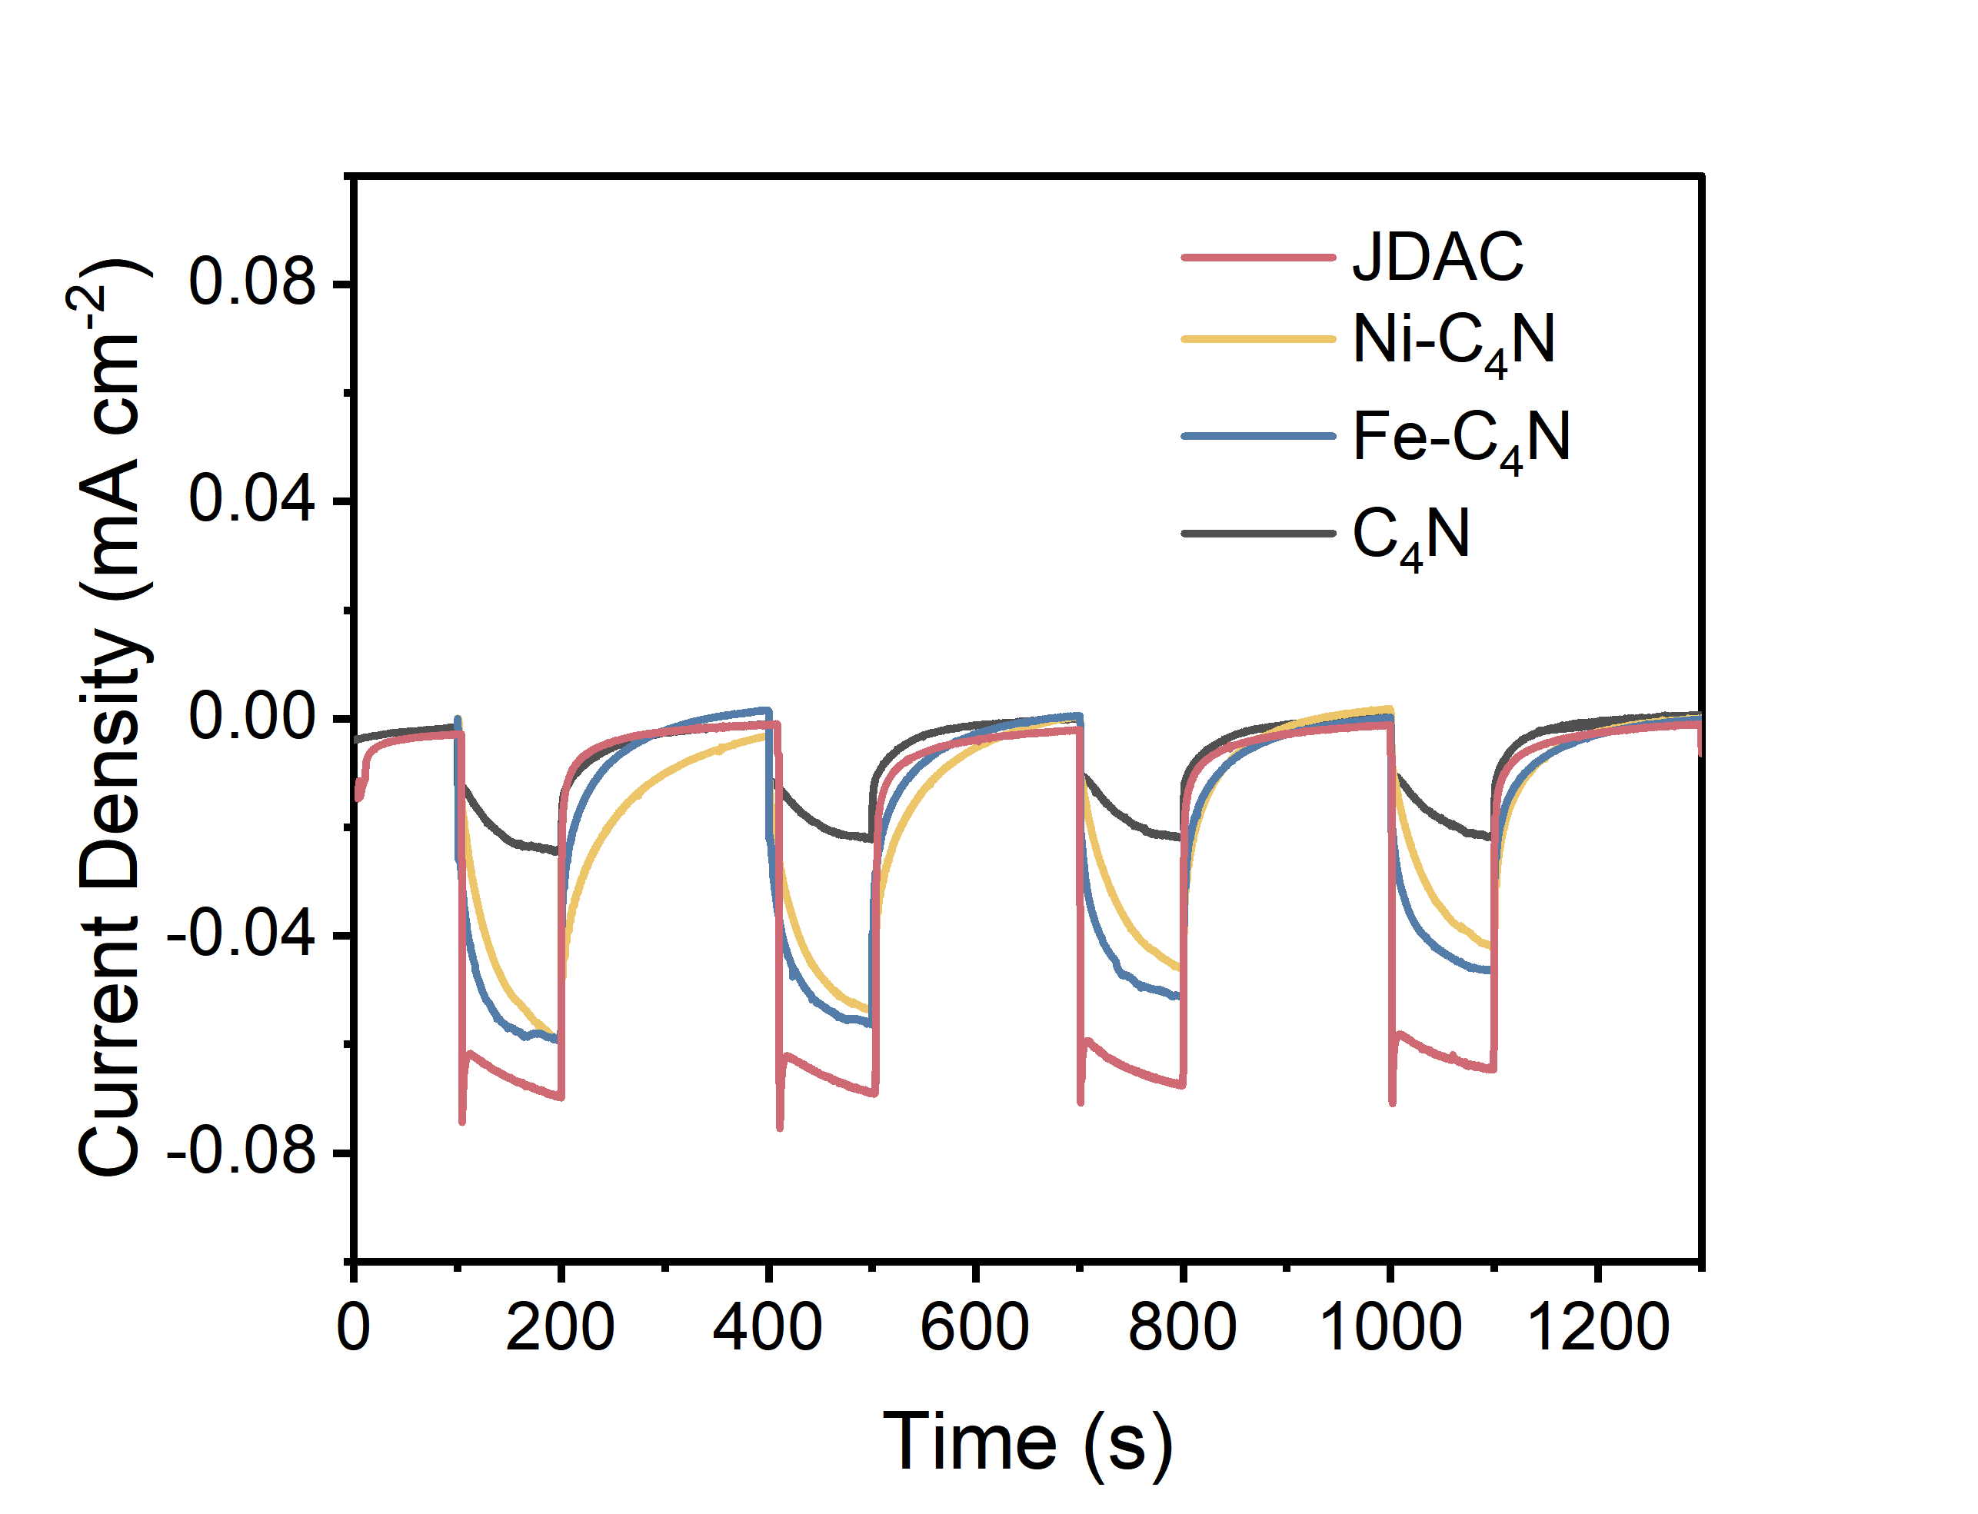
Fig. 22 Comparison of the photocurrent of JDAC, Fe-C₄N, Ni-C₄N, and C₄N

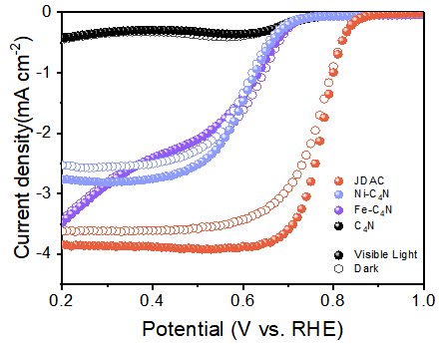
Fig. S23 Linear sweep voltammograms of JDAC, Ni-C₄N, Fe-C₄N and C₄N with and without visible light

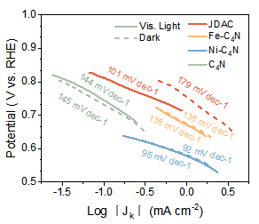
Fig. S24 Tafel slopes for oxygen reduction reaction (ORR)
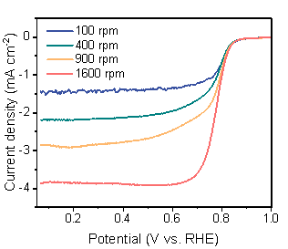
Fig. S25 Linear sweep voltammograms curves of JDAC at 100 rpm, 400 rpm, 900 rpm and 1600 rpm under 420 cutoff visible light illumination

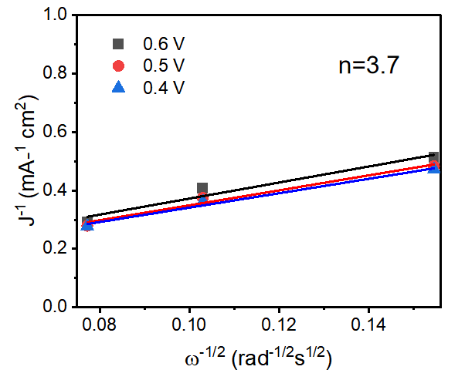
Fig. S26 Koutecký-Levich plots of JDAC

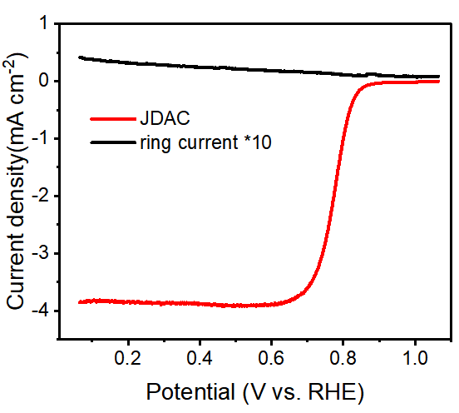
Fig. S27 Rotating ring disk electrode measurements of JDAC under visible light illumination
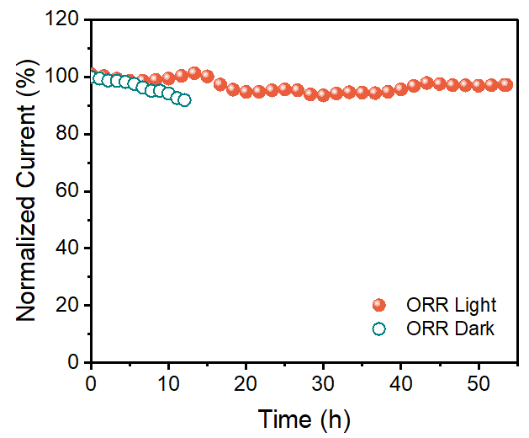
Fig. S28 Stability measurement of JDAC in 0.1 M KOH solution with saturated O₂ and under a bias voltage of 0.5 V (vs. RHE)

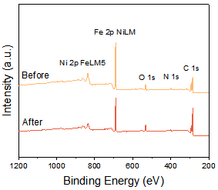
Fig. S29 XPS spectra of JDAC before and after cycling tests

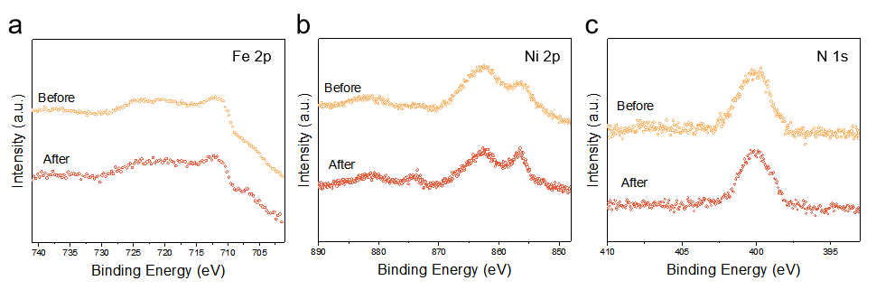
Fig. S30 High-resolution XPS spectra of (a) Fe 2p, (b) Ni 2p, and (c) N 1s of JDAC before and after cycling tests
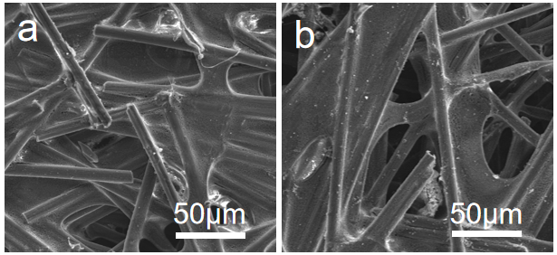
Fig. S31 Comparison of the FESEM images of JDAC on carbon paper a) before and b) after stability measurements at 10 mA cm⁻² for 1000 cycles

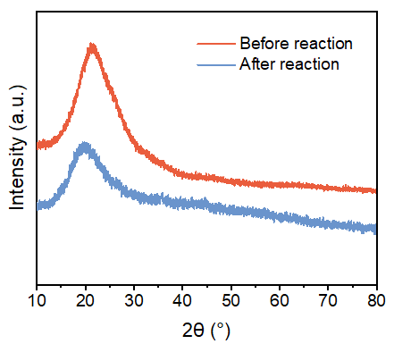
Fig. S32 Comparison of the XRD spectra of JDAC before and after stability measurements at 10 mA cm⁻² for 1000 cycles

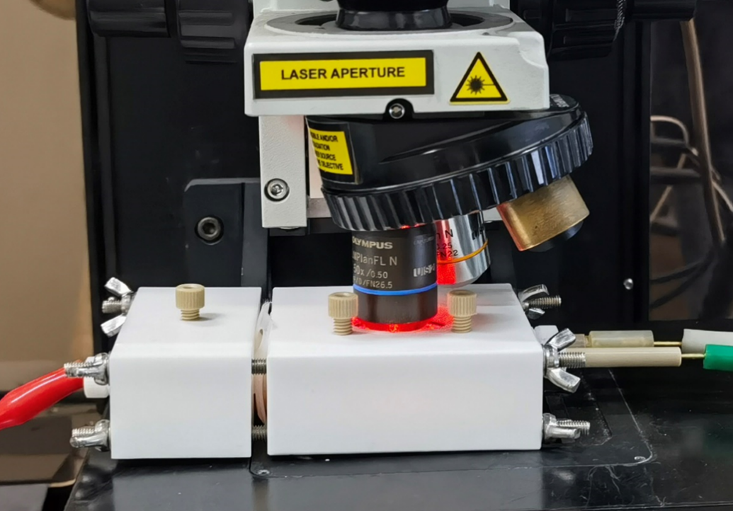
Fig. S33 The digital photograph of the setup for in-situ Raman spectroscopy measurement
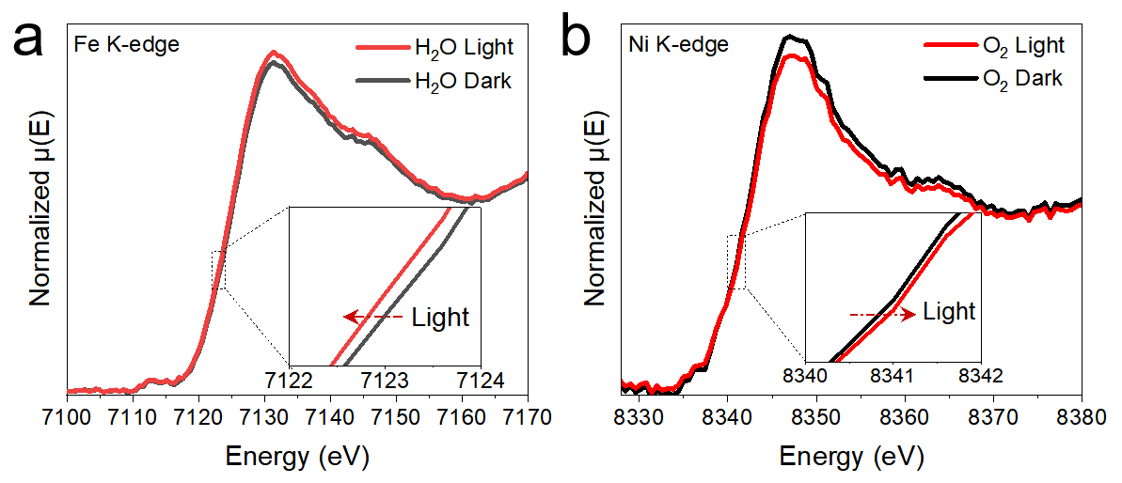
Fig. S34 In-situ XANES with or without visible-light illumination of (a) Fe k-edge in stimulated OER environment with H₂O and (b) Ni k-edge in stimulated ORR environment with O₂

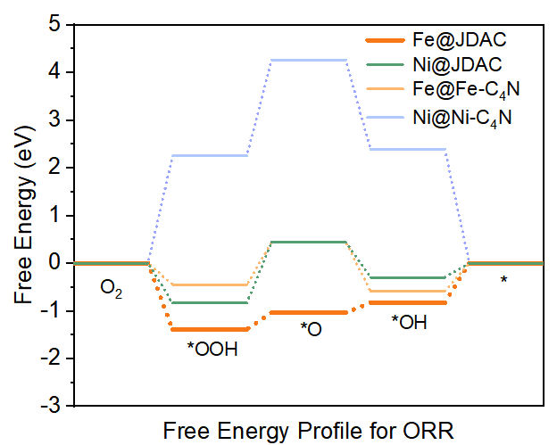
Fig. S35 Calculated Gibbs free energy diagram of ORR
Fig. S36 Free energy diagrams for ORR of JDAC without bias voltage

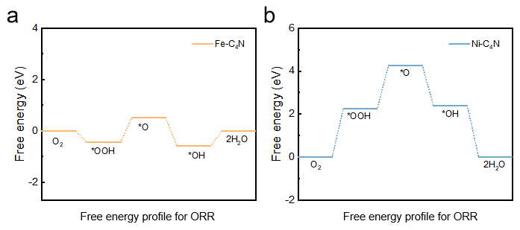

Fig. S37 Free energy diagrams for ORR of (a) Fe-C₄N, and (b) Ni-C₄N

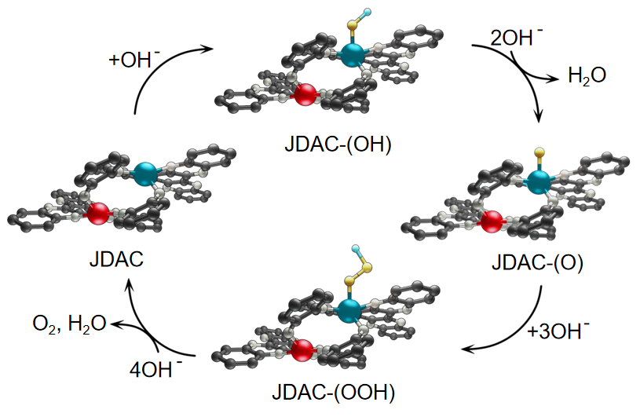
Fig. S38 The reaction pathways of JDAC for OER. Blue, red, white, and grey balls are Ni, Fe, N, and C atoms, respectively
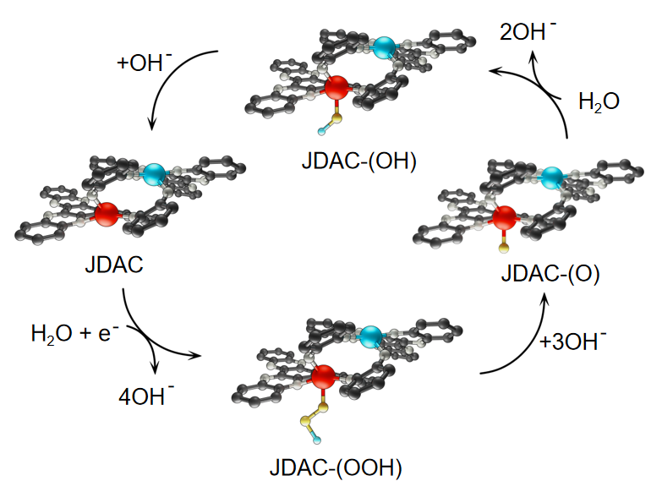
Fig. S39 The reaction pathways of JDAC for ORR. Blue, red, white, and grey balls are Ni, Fe, N, and C atoms, respectively
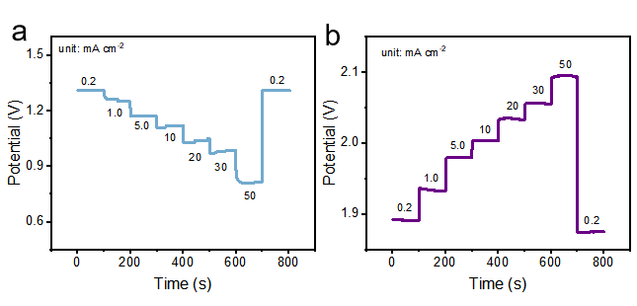
Fig. S40 (a) Galvanostatic discharge and (b) galvanostatic charge curves of RZAB at different current densities under AM 1.5 G illumination
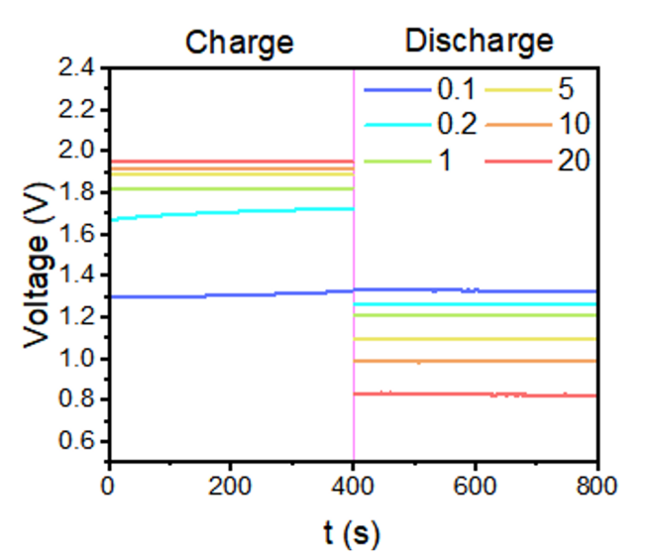
Fig. S41 Comparison of galvanostatic charge/discharge curves of RZAB under AM 1.5 G illumination
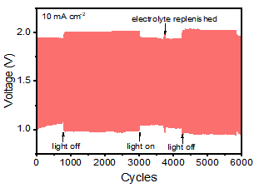
Fig. S42 Galvanostatic discharge-charge cycling curves with/without AM 1.5 G illumination 10 mA cm⁻²

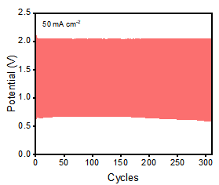
Fig. S43 Galvanostatic discharge-charge cycling curves under AM 1.5 G at 50 mA cm⁻²
Table S1 Elemental percentage for the catalysts based on the ICP-AES test
Sample | Fe (wt%) | Ni (wt%)
JDAC | 7.96 | 6.52
Table S2 Parameters of EXAFS fittings for the catalysts
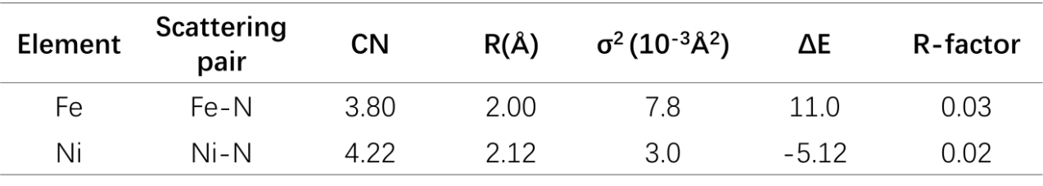

Table S3 Electrocatalysis performances of photo-assisted bifunctional oxygen catalysis
Bifunctional air cathode | Light source | Overpotential | Onset potential | ΔE | Ref
JDAC | visible light | 170 | 1.031 | 0.62 | This work
CZ |  | 410 | 0.8 | 0.84 | [S1]
CaFeRuO₆ (CFR) | visible light | 400 | 0.9 | 0.85 | [S2]
CoFe₂O₄-N,S-C | 300W Xe lamp | 410 | 0.92 | 0.8 | [S3]
ZnO/Cu₂O (ZnO/CuO) | visible light | - | 0.9 | - | [S4]
TiO₂@In₂Se₃@Ag₃PO₄ | 365 nm | -510 | 1.32 | -0.6 | [S5]
polytrithiophene (pTTh) | 365 nm | N.A. | 1.4 | - | [S6]
MnCo₂O₄ | visible light | ~310 | 0.87 | - | [S7]
NG/CCN | visible light | 300 | 0.77 | 0.76 | [S8]
pTTh | visible light | 760 | 0.91 | 1.16 | [S9]
Ni₁₂P₅@NCNT | AM 1.5G | 360 | 0.9 | - | [S10]
C₄N@TiO₂NR | 395 nm | ~140 | - | - | [S11]
C₄N |  | N.A. | 0.8 | - | [S12]
FeNi-S,N-HCS |  | 380 | - | 0.79 | [S13]
Tabel S4 Fitting parameters of the near-edge simulated spectra of Fe and Ni
Element | Radius | Ecent | Elarg | Gamma_max | Gamma_hole | E_Cut
Fe | 4 | 15 | 20 | 4 | 5 | 1.5
Ni | 6.5 | 10 | 3.18 | 6.95 | 3 | 1.5
Table S5 Performance comparison of photo-assisted liquid RZABs
Bifunctional air cathode | Current (mA cm⁻² ) | Charge Voltage (V) | Discharge Voltage (V) | Voltage Gap (V) | Stability | Refs
JDAC | 1 | 1.81 | 1.21 | 0.60 |  | This work
 | 5 | 1.88 | 1.09 | 0.79 |  | This work
 | 10 | 1.91 | 0.99 | 0.92 | 6000 cycles | This work
 | 20 | 1.95 | 0.83 | 1.12 | 1688 cycles | This work
 | 50 | 2.03 | 0.67 | 1.36 | 338 cycles | This work
CZ | 2 | 1.99 | 1.18 | 0.81 | 1000 cycles@2mA cm⁻² | [S1]
CZ | 5 | 2.01 | 1.11 | 0.9 | 334 hrs. @ 5 mA cm⁻² | [S1]
1@ZIF-67 | 2 | 2 | 1.15 | ~0.85 | ~50%@110 hrs. | [S14]
Co@NPCFs | 5 | 2.2 | 1.15 | ~1.05 | 80 hrs. | [S15]
FeCo–C/N | 2 | 2.05 | 1.15 | ~0.9 | 180 cycles 60 hrs. | [S16]
ZIF-67@Pt/CB | 5 | 2.08 | 1.17 | 0.91 | 50 hrs. | [S17]
Spinel Co₃O₄ | 2 | 2.01 | 1.19 | 0.82 | 70 hrs. | [S18]
Co-N-CNTs | 2 | ~2.30 | ~1 | ~1.30 | 145 cycles 16 hrs. | [S19]
CoNiFe-S MNs | 2 | 1.88 | 1.12 | 0.76 | 120 cycles 40 hrs. | [S20]
NiFe₂O₄/FeNi₂S₄ HNSs | 2 | ~2.10 | ~0.98 | 1.2 | 125 hrs. | [S21]
CNF@Zn/CoNC | 2 | 2.1 | 1.19 | 0.91 | 150 hrs. | [S22]
BNPC-1100 | 2 | 2.2 | 1.14 | 1.06 | 100 hrs. | [S23]
CoFe₂₀@CC | 5 | 1.10 – 2.10 |  | ~1.00 | 130 hrs. | [S24]
Fe/Co-N/P-9 | 5 | 0.9 | 2.05 | ~1.05 | 130 cycles | [S25]
CoFe₂O₄-N,S-C | 5 | ~2.04 | 1.19 | ~0.85 | 300 cycles @ 5mA cm⁻² | [S3]
ZnO/Cu2O (ZnO/CuO) | 0.1 | ~1.5 | 1.28 | ~0.22 | 22 hours @ 0.1 mA cm⁻² | [S4]
polytrithiophene (pTTh) | 0.1 | ~1.98 | ~1.78 | 0.2 | 64 hours @ 0.1 mA cm⁻² | [S6]
pTTh | 0.1 | 1.81 | 1.22 | 0.6 | 380 hours @ 0.1 mA cm⁻² | [S9]
Ni₁₂P₅@NCNT | 1 | 1.94 | 1.19 | 0.75 | 500 cycles @ 10 mA cm⁻² | [S10]
αFe₂O₃ | 0.5 | ~1.64 | ~1.15 | 0.49 | 50 hours @ 0.5 mA cm⁻² | [S14]
C4N | 0.01 | 1.35 | 1.32 | 0.03 | 50 cycles @ 0.01 mA cm⁻² | [S12]
FeNi-S,N-HCS | 5 | ~2.0 | ~1.1 | ~0.9 | 120 hours @ 5 mA cm⁻² | [S13]
Supplementary References
- R. Ren, G. Liu, J.Y. Kim, R.E.A. Ardhi, M.X. Tran et al., Photoactive g-C₃N₄/CuZIF-67 bifunctional electrocatalyst with staggered p-n heterojunction for rechargeable Zn-air batteries. Appl. Catal. B Environ. 306, 121096 (2022). https://doi.org/10.1016/j.apcatb.2022.121096
- N. Kumar, K. Naveen, M. Kumar, T. C. Nagaiah, R. Sakla et al., Multifunctionality exploration of Ca₂FeRuO₆: an efficient trifunctional electrocatalyst toward OER/ORR/HER and photocatalyst for water splitting. ACS Appl. Energy Mater. 4, 1323–1334 (2021). https://doi.org/10.1021/acsaem.0c02579
- Z. Xiao, X. Lv, S. Liu, Q. Liu, F. Wang et al., Electronic band structure engineering of transition metal oxide-N, S-doped carbon catalysts for photoassisted oxygen reduction and oxygen evolution catalysis. Adv. Mater. Interfaces 9(1), 2101386 (2022). https://doi.org/10.1002/admi.202101386
- D. Bu, M. Batmunkh, Y. Zhang, Y. Li, B. Qian et al., Rechargeable sunlight-promoted Zn-air battery constructed by bifunctional oxygen photoelectrodes: Energy-band switching between ZnO/Cu₂O and ZnO/CuO in charge-discharge cycles. Chem. Eng. J. 433, 133559 (2022). https://doi.org/10.1016/j.cej.2021.133559
- H. Feng, C. Zhang, Z. Liu, J. Sang, S. Xue et al., A light-activated TiO₂@In₂Se₃@Ag₃PO₄ cathode for high-performance Zn-Air batteries. Chem. Eng. J. 434, 134650 (2022). https://doi.org/10.1016/j.cej.2022.134650
- H. Feng, C. Zhang, Z. Liu, J. Sang, S. Xue et al., A light-activated TiO₂@In₂Se₃@Ag₃PO₄ cathode for high-performance Zn-Air batteries. Chem. Eng. J. 434, 134650 (2022). https://doi.org/10.1016/j.cej.2022.134650
- C. Tomon, S. Sarawutanukul, S. Duangdangchote, A. Krittayavathananon, M. Sawangphruk, MnCo₂O₄ nanofibers as efficient photo-electrocatalyst for oxygen evolution reaction and oxygen reduction reaction. ECS Trans. 97(7), 71–86 (2020). https://doi.org/10.1149/09707.0071ecst
- Y. Yang, B. Hu, W. Zhao, Q. Yang, F. Yang et al., Bridging N-doped graphene and carbon rich C₃N₄ layers for photo-promoted multi-functional electrocatalysts. Electrochim. Acta 317, 25–33 (2019). https://doi.org/10.1016/j.electacta.2019.05.140
- Y. Yang, B. Hu, W. Zhao, Q. Yang, F. Yang et al., Bridging N-doped graphene and carbon rich C₃N₄ layers for photo-promoted multi-functional electrocatalysts. Electrochim. Acta 317, 25–33 (2019). https://doi.org/10.1016/j.electacta.2019.05.140
- J. Lv, S.C. Abbas, Y. Huang, Q. Liu, M. Wu et al., A photo-responsive bifunctional electrocatalyst for oxygen reduction and evolution reactions. Nano Energy 43, 130–137 (2018). https://doi.org/10.1016/j.nanoen.2017.11.020
- J. Lv, S.C. Abbas, Y. Huang, Q. Liu, M. Wu et al., A photo-responsive bifunctional electrocatalyst for oxygen reduction and evolution reactions. Nano Energy 43, 130–137 (2018). https://doi.org/10.1016/j.nanoen.2017.11.020
- Z. Fang, Y. Li, J. Li, C. Shu, L. Zhong et al., Capturing visible light in low-band-gap C₄N-derived responsive bifunctional air electrodes for solar energy conversion and storage. Angew. Chem. Int. Ed. 60(32), 17615–17621 (2021). https://doi.org/10.1002/anie.202104790
- S. Zheng, M. Chen, K. Chen, Y. Wu, J. Yu et al., Solar-light-responsive zinc–air battery with self-regulated charge–discharge performance based on photothermal effect. ACS Appl. Mater. Interfaces 15(2), 2985–2995 (2023). https://doi.org/10.1021/acsami.2c19663
- Z. Liang, H. Guo, G. Zhou, K. Guo, B. Wang, H. Lei, W. Zhang, H. Zheng, U. Apfel, R. Cao, Metal–organic-framework-supported molecular electrocatalysis for the oxygen reduction reaction. Angew. Chem. Int. Ed. 133, 8553-8557 (2021). https://doi.org/10.1002/ange.202016024
- Y. Chen, W. Zhang, Z. Zhu, L. Zhang, J. Yang et al., Co nanoparticles combined with nitrogen-doped graphitic carbon anchored on carbon fibers as a self-standing air electrode for flexible zinc–air batteries. J. Mater. Chem. A 8, 7184-7191 (2020). https://doi.org/10.1039/D0TA00793E
- C. Zhang, H. Yang, D. Zhong, Y. Xu, Y. Wang et al., A yolk–shell structured metal–organic framework with encapsulated iron-porphyrin and its derived bimetallic nitrogen-doped porous carbon for an efficient oxygen reduction reaction. J. Mater. Chem. A 8, 9536-9544 (2020). https://doi.org/10.1039/D0TA00962H
- J. Li, Z. Meng, D.J.L. Brett, P.R. Shearing, N.T. Skipper et al., High-performance zinc–air batteries with scalable metal–organic frameworks and platinum carbon black bifunctional catalysts. ACS Appl. Mater. Interfaces 12(38), 42696–42703 (2020). https://doi.org/10.1021/acsami.0c10151
- C. Tomon, S. Sarawutanukul, S. Duangdangchote, A. Krittayavathananon, M. Sawangphruk, Photoactive Zn–air batteries using spinel-type cobalt oxide as a bifunctional photocatalyst at the air cathode. Chem. Commun. 55(42), 5855–5858 (2019). https://doi.org/10.1039/c9cc01876j
- T. Wang, Z. Kou, S. Mu, J. Liu, D. He et al., 2D dual-metal zeolitic-imidazolate-framework-(ZIF)-derived bifunctional air electrodes with ultrahigh electrochemical properties for rechargeable zinc–air batteries. Adv. Funct. Mater. 28, 1705048 (2018). https://doi.org/10.1002/adfm.201705048
- H. Yang, B. Wang, H. Li, B. Ni, K. Wang et al., Trimetallic sulfide mesoporous nanospheres as superior electrocatalysts for rechargeable Zn–air batteries. Adv. Energy Mater. 8(34), 1801839 (2018). https://doi.org/10.1002/aenm.201801839
- L. An, Z. Zhang, J. Feng, F. Lv, Y. Li et al., Heterostructure-promoted oxygen electrocatalysis enables rechargeable zinc–air battery with neutral aqueous electrolyte. J. Am. Chem. Soc. 140, 17624-17631 (2018). https://doi.org/10.1021/jacs.8b09805
- Y. Zhao, Q. Lai, J. Zhu, J. Zhong, Z. Tang et al., Controllable construction of core–shell Polymer@Zeolitic imidazolate frameworks fiber derived heteroatom-doped carbon nanofiber network for efficient oxygen electrocatalysis. Small 14(19), 1704207 (2018). https://doi.org/10.1002/smll.201704207
- Y. Qian, Z. Hu, X. Ge, S. Yang, Y. Peng et al., A metal-free ORR/OER bifunctional electrocatalyst derived from metal-organic frameworks for rechargeable Zn-Air batteries. Carbon 111, 641-650 (2017). https://doi.org/10.1016/j.carbon.2016.10.046
- J. Di, J. Guo, N. Wang, G. Ma, Multicomponent doped sugar-coated haws stick-like nanofibers as efficient oxygen reduction reaction catalysts for the Zn–air battery. ACS Sustainable Chem. Eng. 7(8), 7716–7727 (2019). https://doi.org/10.1021/acssuschemeng.8b06447
- C. Hou, L. Zou, Q. Xu, Hierarchical superstructures: a hydrangea-like superstructure of open carbon cages with hierarchical porosity and highly active metal sites. Adv. Mater. 31, 1904689 (2019). https://doi.org/10.1002/adma.201970327

