Supporting Information for
Design of Ultra-Stable Solid Amine Adsorbents and Mechanisms of Hydroxyl Group-Dependent Deactivation for Reversible CO₂ Capture from Flue Gas
Meng Zhao^{1,2}, Liang Huang^{1,2}, Yanshan Gao^{1,2}*, Ziling Wang^{1,2}, Shuyu Liang^{1,2}, Xuancan Zhu³, Qiang Wang^{1,2}*, Hong He⁴, Dermot O’Hare⁵*
¹College of Environmental Science and Engineering, Beijing Forestry University; Beijing 100083, P. R. China
²State Key Laboratory of Efficient Production of Forest Resources, Beijing Forestry University; Beijing 100083, P. R. China
³Research Center of Solar Power & Refrigeration, Institute of Refrigeration and Cryogenics, Shanghai Jiao Tong University, Shanghai 200240, P. R. China
⁴State Key Joint Laboratory of Environment Simulation and Pollution Control, Research Centre for Eco-Environmental Sciences, Chinese Academy of Sciences; Beijing 100085, P. R. China
⁵Chemistry Research Laboratory, Department of Chemistry, University of Oxford, Mansfield Road, Oxford OX1 3TA, United Kingdom
*Corresponding authors. E-mail: yanshan_gao@bjfu.edu.cn (Yanshan Gao); qiangwang@bjfu.edu.cn (Qiang Wang); dermot.ohare@chem.ox.ac.uk (Dermot O’Hare)
Supplementary Figures and Tables
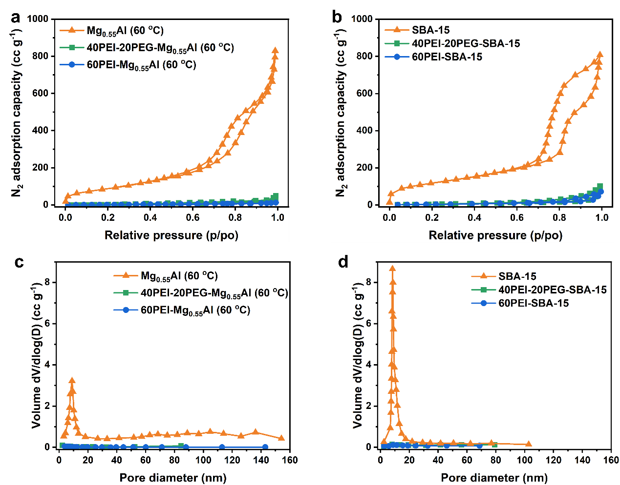
Fig. S1 N₂ isotherms for the pristine and PEI/PEG-functionalized a Mg_{0.55}Al (60 ºC) and b SBA-15 samples. Pore distributions for the pristine and PEI/PEG-functionalized c Mg_{0.55}Al (60 ºC) and d SBA-15 samples

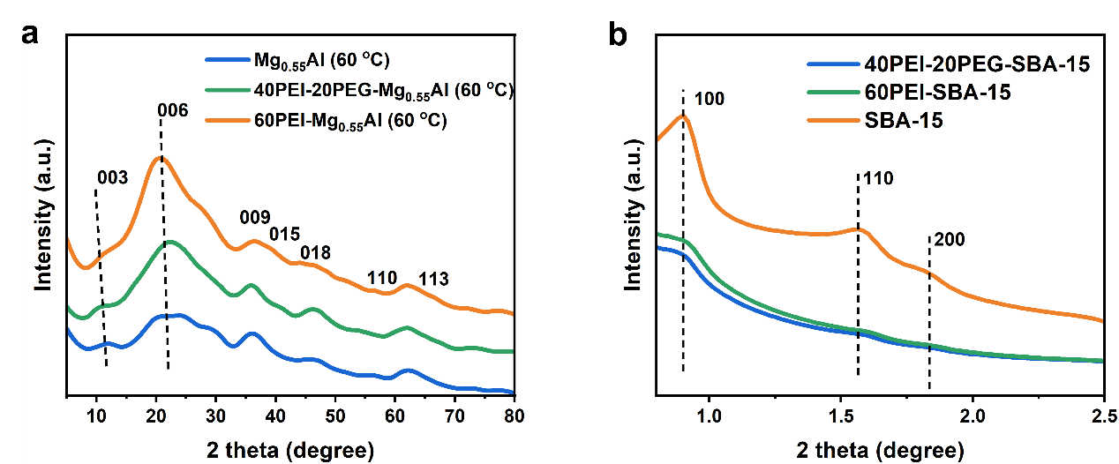Fig. S2 XRD patterns of the pristine and PEI/PEG-functionalized a Mg_{0.55}Al (60 ºC) and b SBA-15 samples
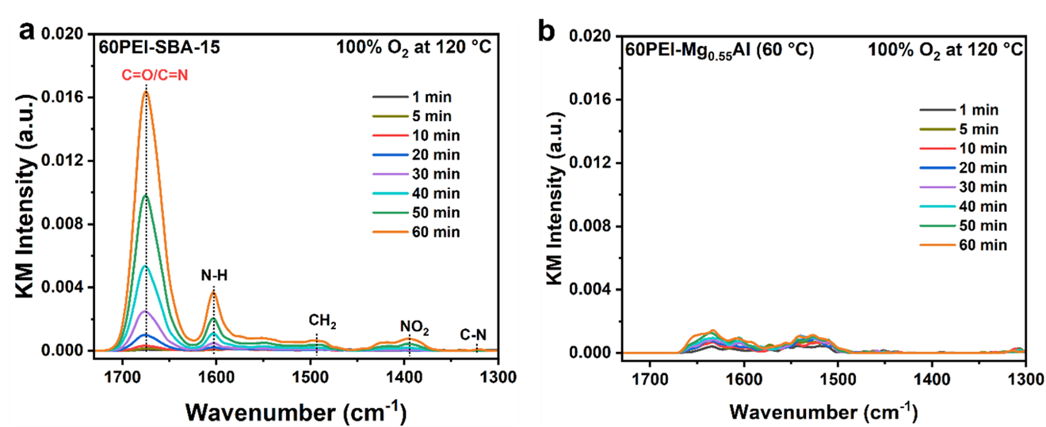
Fig. S3 In-situ DRIFTS spectra recorded at 120 ºC of passing pure O₂ over the a 60PEI-SBA-15 and b 60PEI-Mg_{0.55}Al (60 °C)

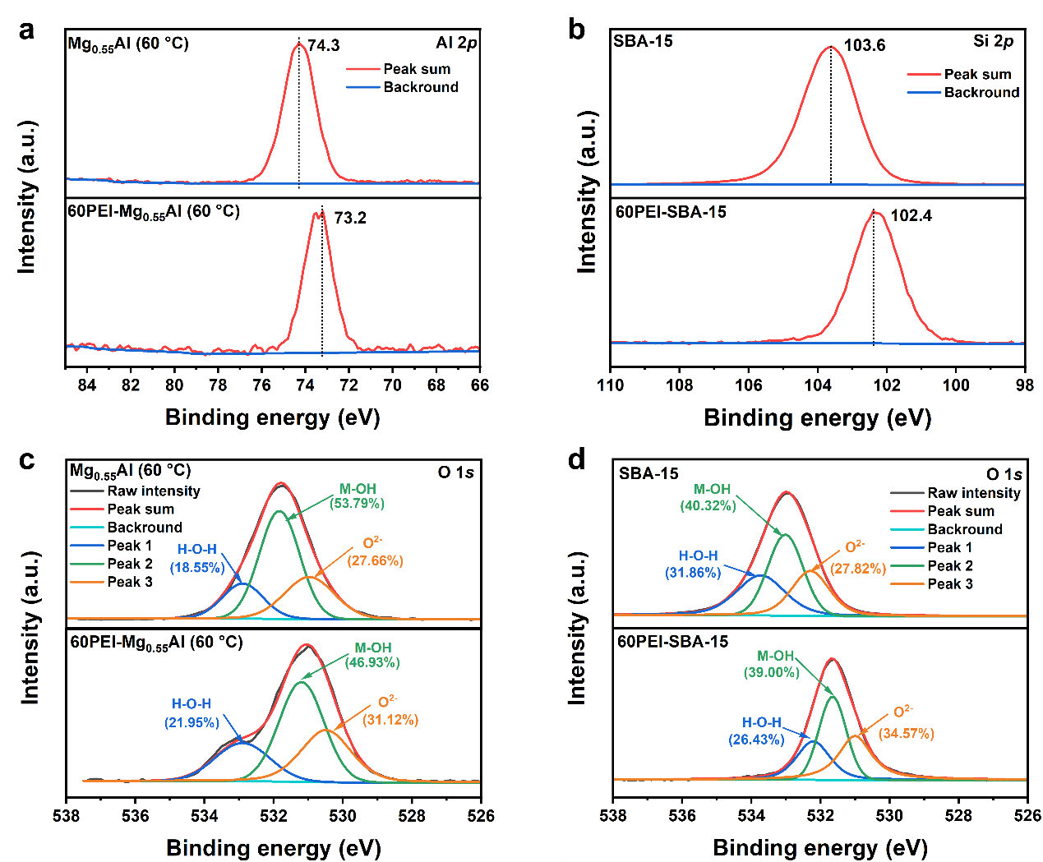
Fig. S4 XPS spectra of a Al 2p for Mg_{0.55}Al (60 °C), b Si 2p for SBA-15, and c, d O 1s for Mg_{0.55}Al (60 °C) and SBA-15, respectively, before and after 60 wt% PEI impregnation
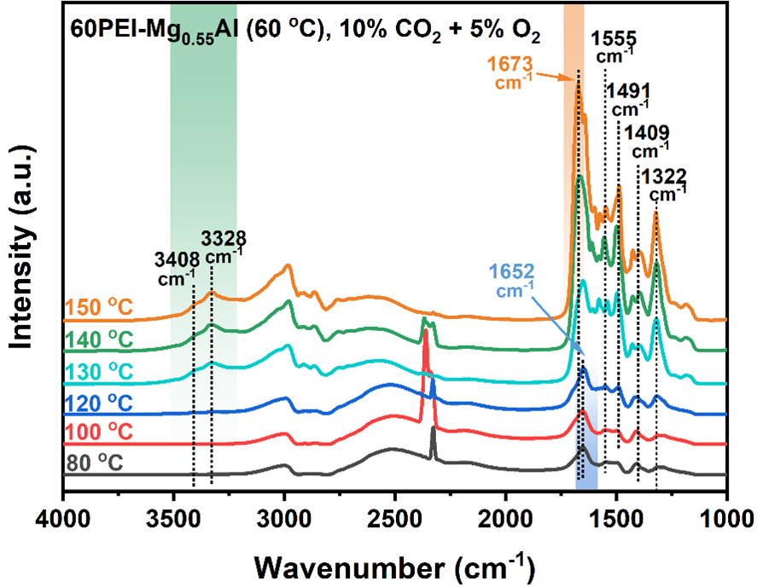
Fig. S5 In-situ DRIFTS spectra of passing 10% CO₂ + 5% O₂ over the 60PEI-Mg_{0.55}Al (60 °C) sample while continuously increasing the temperature from 80 °C to 150 °C
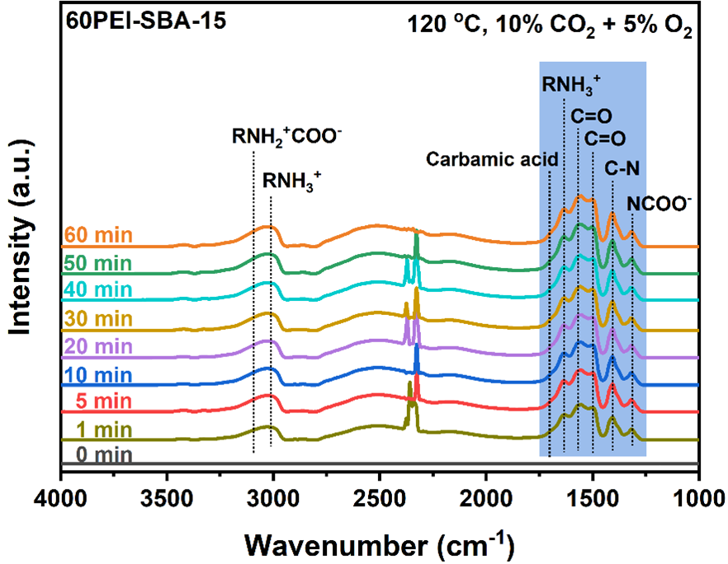
Fig. S6 In-situ DRIFTS spectra recorded at 120 ºC of passing 10% CO₂ + 5% O₂ over the 60PEI-SBA-15 adsorbents
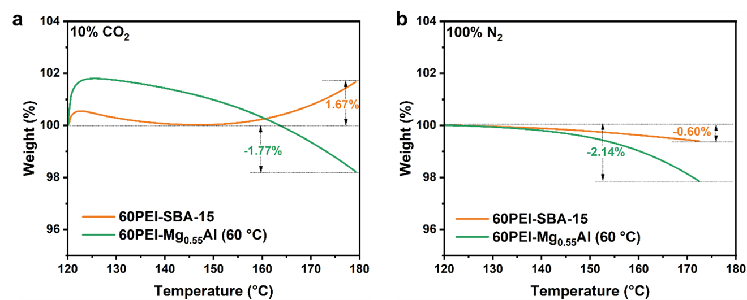
Fig. S7 TG curves of passing a 10% CO₂, and b 100% N₂ over the 60PEI-Mg_{0.55}Al (60 °C) and 60PEI-SBA-15 samples
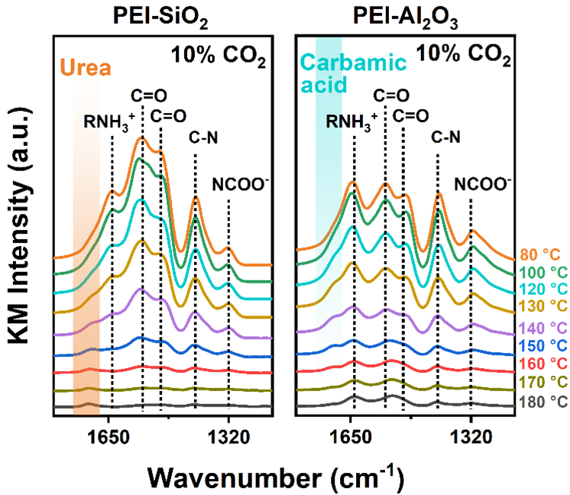
Fig. S8 In-situ DRIFTS spectra of passing 10% CO₂ over the 33PEI-SiO₂ and 33PEI-Al₂O₃
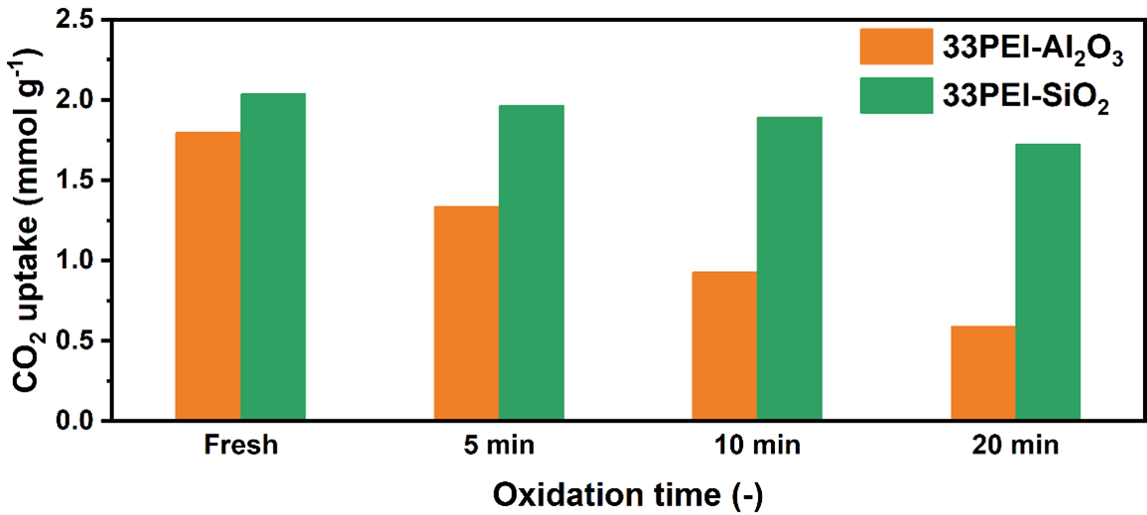
Fig. S9 CO₂ uptakes at 75 °C under 10% CO₂ for 33PEI-Al₂O₃ and 33PEI-SiO₂ before and after aging at 120 °C in 10% CO₂ + 5% O₂ + 3% H₂O
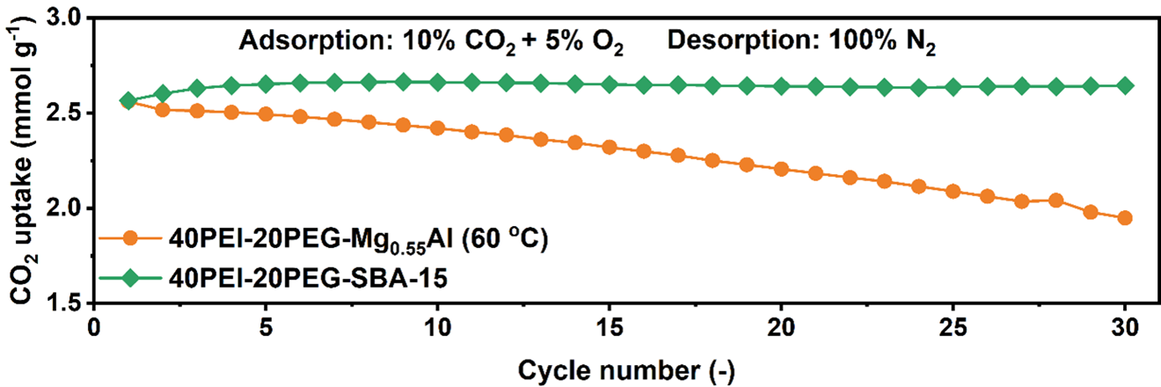
Fig. S10 CO₂ uptakes of 40PEI-20PEG-Mg_{0.55}Al (60 °C) and 40PEI-20PEG-SBA-15 over 30 cycles (adsorption at 75 °C in 10% CO₂ + 5% O₂ for 10 min and desorption at 120 °C in 100% N₂ for 15 min

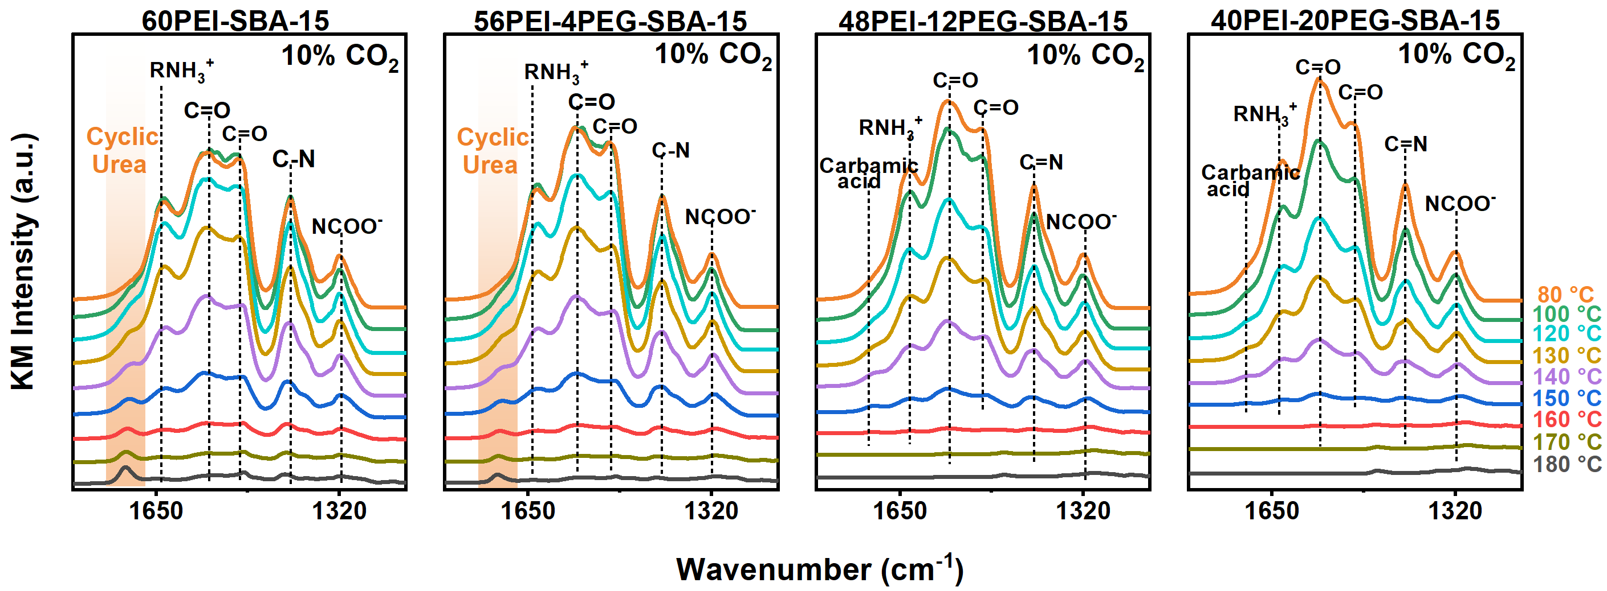
Fig. S11 In-situ DRIFTS spectra of passing 10% CO₂ over the supported PEI/PEG adsorbents while continuously increasing the temperature from 80 to 180 °C

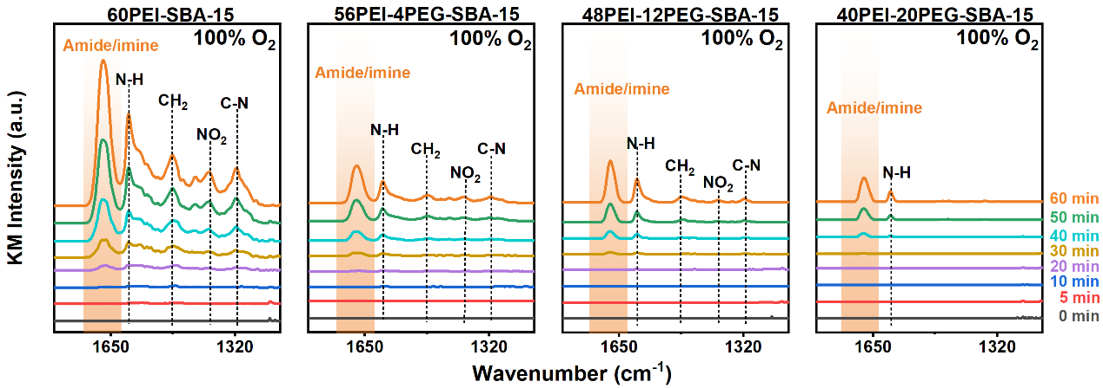
Fig. S12 In-situ DRIFTS spectra recorded at 120 °C of passing 100% O₂ over the supported PEI/PEG adsorbents
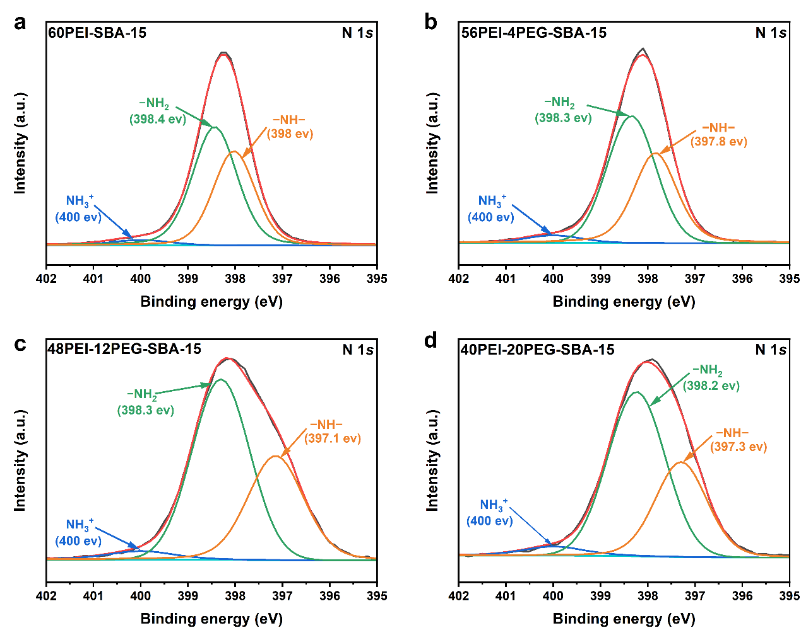
Fig. S13 XPS spectra of N 1s of a 60PEI-SBA-15, b 56PEI-4PEG-SBA-15, c 48PEI-12PEG-SBA-15, and d 40PEI-20PEG-SBA-15 sample

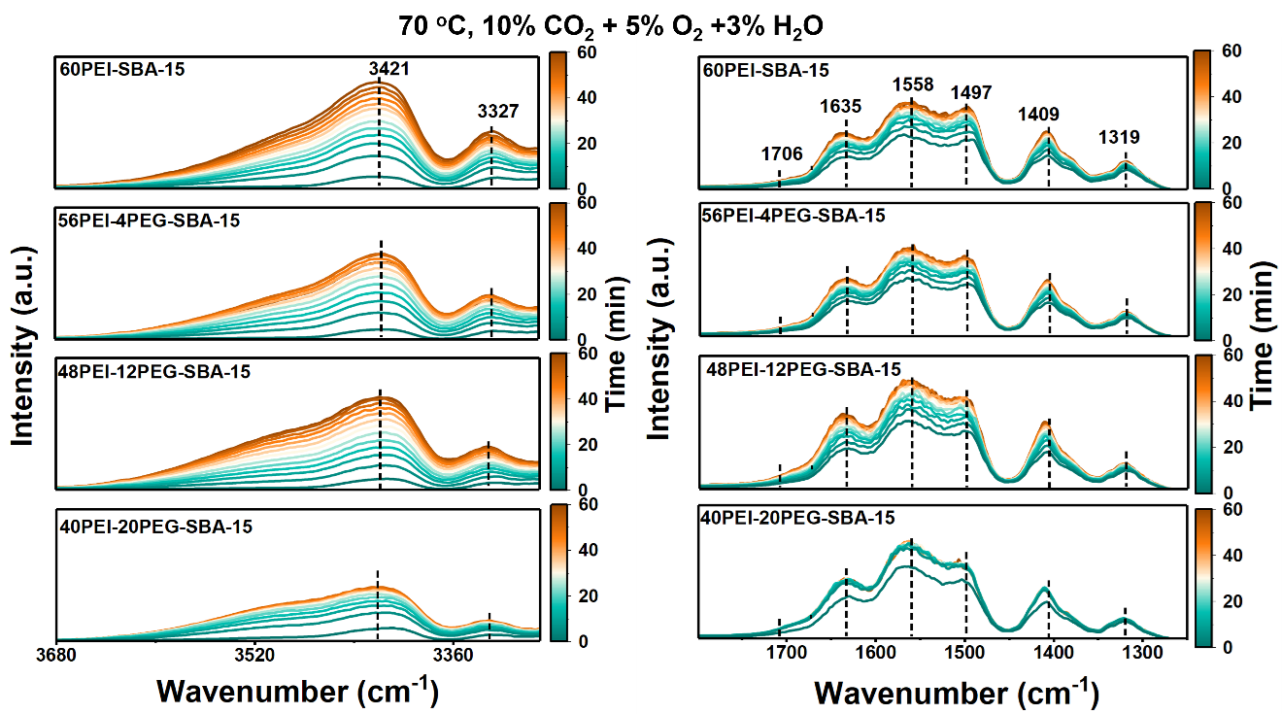
Fig. S14 In-situ DRIFTS spectra recorded at 70 °C of passing 10% CO₂ + 5% O₂ + 3 vol% H₂O over the supported PEI/PEG adsorbents
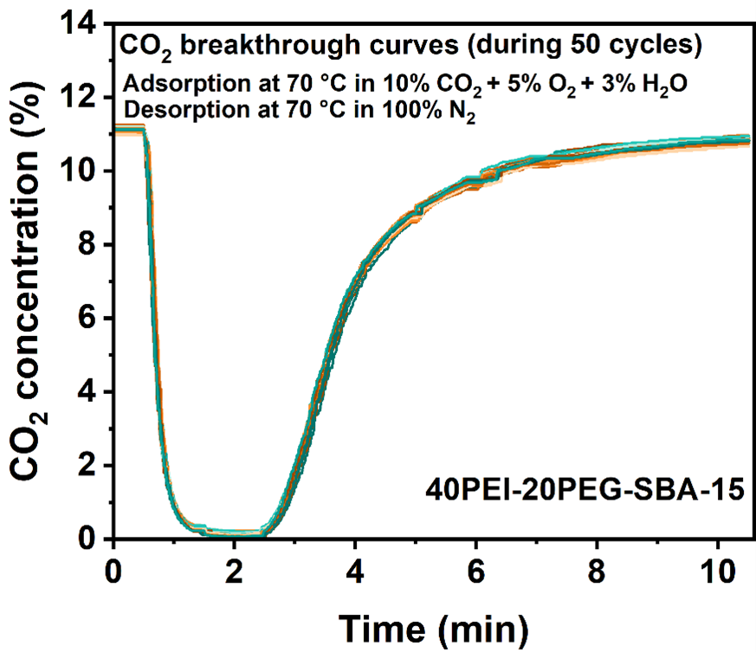
Fig. S15 CO₂ breakthrough curves of 40PEI-20PEG-SBA-15
Table S1 Textural properties of the pristine and PEI/PEG-functionalized Mg_{0.55}Al (60 °C) samples
Sample | Specific  surface area  (m² g⁻¹) | Average  pore size  (cc g⁻¹) | Average pore volume (nm)
Mg_{0.55}Al (60 °C) | 328.1 | 1.50349 |  | 7.96
60PEI-Mg_{0.55}Al (60 °C) | 6.1622 | 0.027186 |  | 6.28
40PEI-20PEG-  Mg_{0.55}Al (60 °C) | 8.5496 | 0.08757 |  | 17.79
Table S2 Textural properties of the pristine and PEI/PEG-functionalized SBA-15 samples
Sample | Specific  surface area  (m² g⁻¹) | Average  pore size  (cc g⁻¹) | Average pore volume (nm)
SBA-15 | 420.0883 | 1.430324 |  | 5.95
60PEI-SBA-15 | 16.5764 | 0.123793 |  | 13.43
40PEI-20PEG-SBA-15 | 19.123 | 0.167791 |  | 16.4

