Supporting Information for
Fluorine Modulated MXene-derived Catalysts for Multi-Phase Sulfur Conversion in Lithium-Sulfur Battery
Qinhua Gu^{1,2}, Yiqi Cao^{1,3}, Junnan Chen^{1,2}, Yujie Qi¹, Zhaofeng Zhai¹, Ming Lu^{1,3,}*, Nan Huang^{1,2}, Bingsen Zhang^{1,2,}*
¹ Shenyang National Laboratory for Materials Science, Institute of Metal Research, Chinese Academy of Sciences, Shenyang 110016, P. R. China
² School of Materials Science and Engineering, University of Science and Technology of China, Shenyang 110016, P. R. China
³ The Joint Laboratory of MXene Materials, Key Laboratory of Functional Materials Physics and Chemistry of the Ministry of Education, Key Laboratory of Preparation and Application of Environmental Friendly Materials of the Ministry of Education, Jilin Normal University, Changchun 130103, P. R. China
*Corresponding authors. Email: luming@jlnu.edu.cn (Ming Lu); bszhang@imr.ac.cn (Bingsen Zhang)
Supplementary Figures and Tables
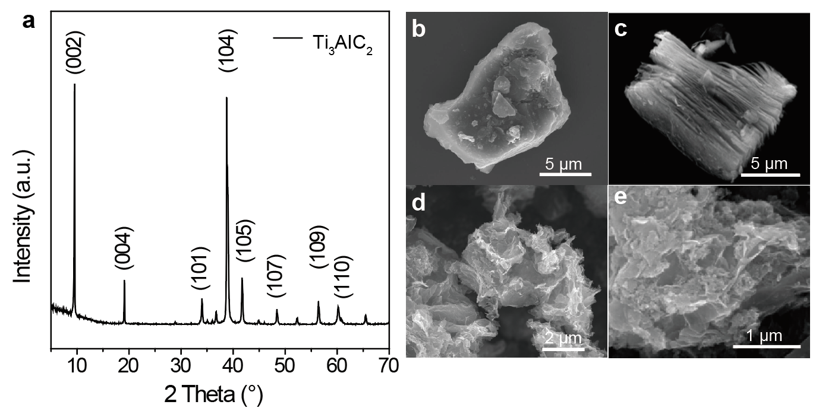
Fig. S1 a XRD pattern of Ti₃AlC₂. SEM images of b Ti₃AlC₂ MAX, c multilayer Ti₃C₂, d TiO/Ti₃C₂ powders, and e TiO/Ti₃C₂ powders

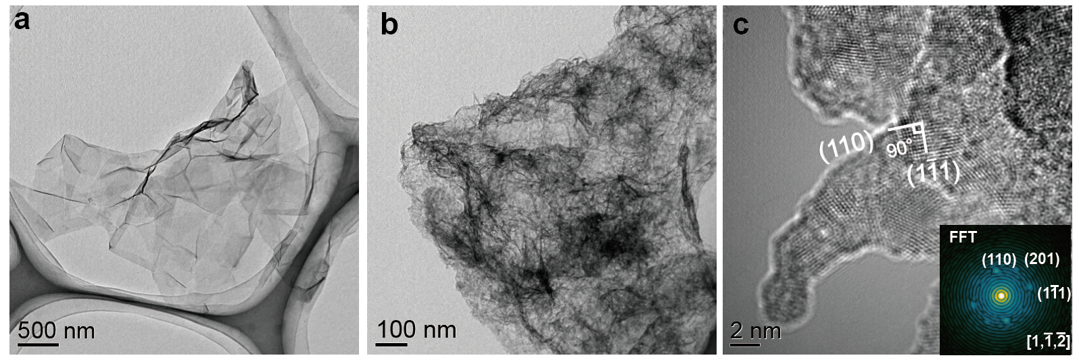
Fig. S2 TEM images of a Ti₃C₂ nanosheets and b TiO/Ti₃C₂. c HRTEM images of TiO/Ti₃C₂ (The inset is corresponding to local FFTs)
Fig. S3 XPS spectra of Ti₃C₂, TiO/Ti₃C₂, and TiOF/Ti₃C₂
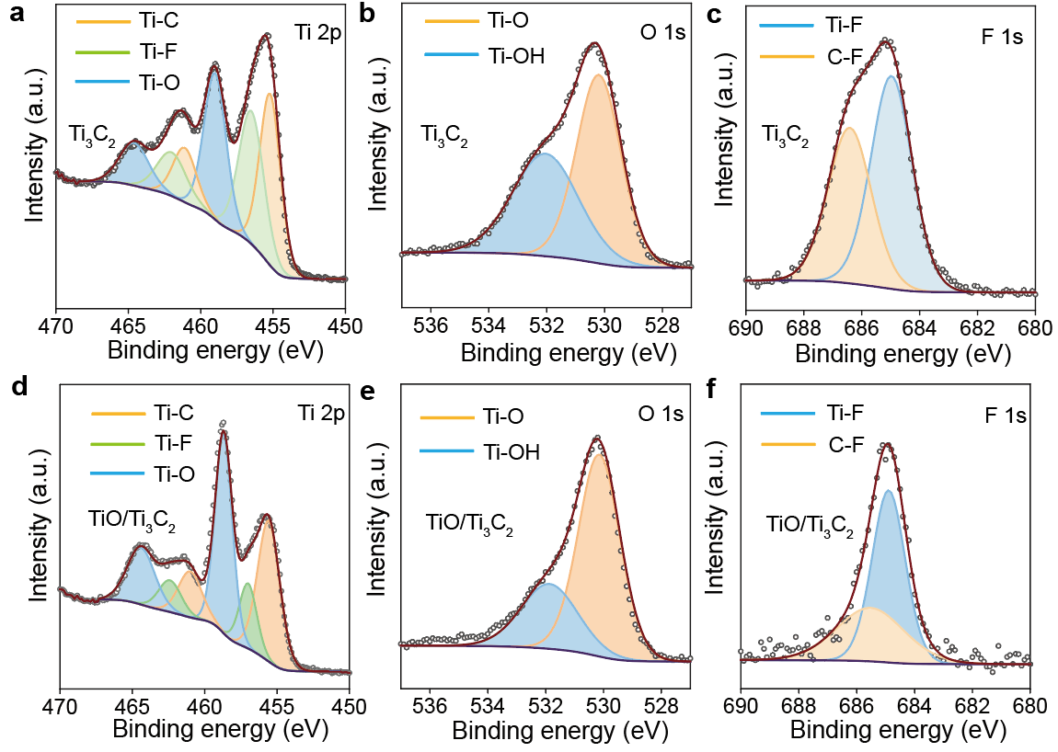
Fig. S4 XPS spectra of a, d Ti 2p, b, e O 1s, and c, f F 1s for Ti₃C₂ and TiO/Ti₃C₂
Fig. S5 EELS spectra of TiOF/Ti₃C₂

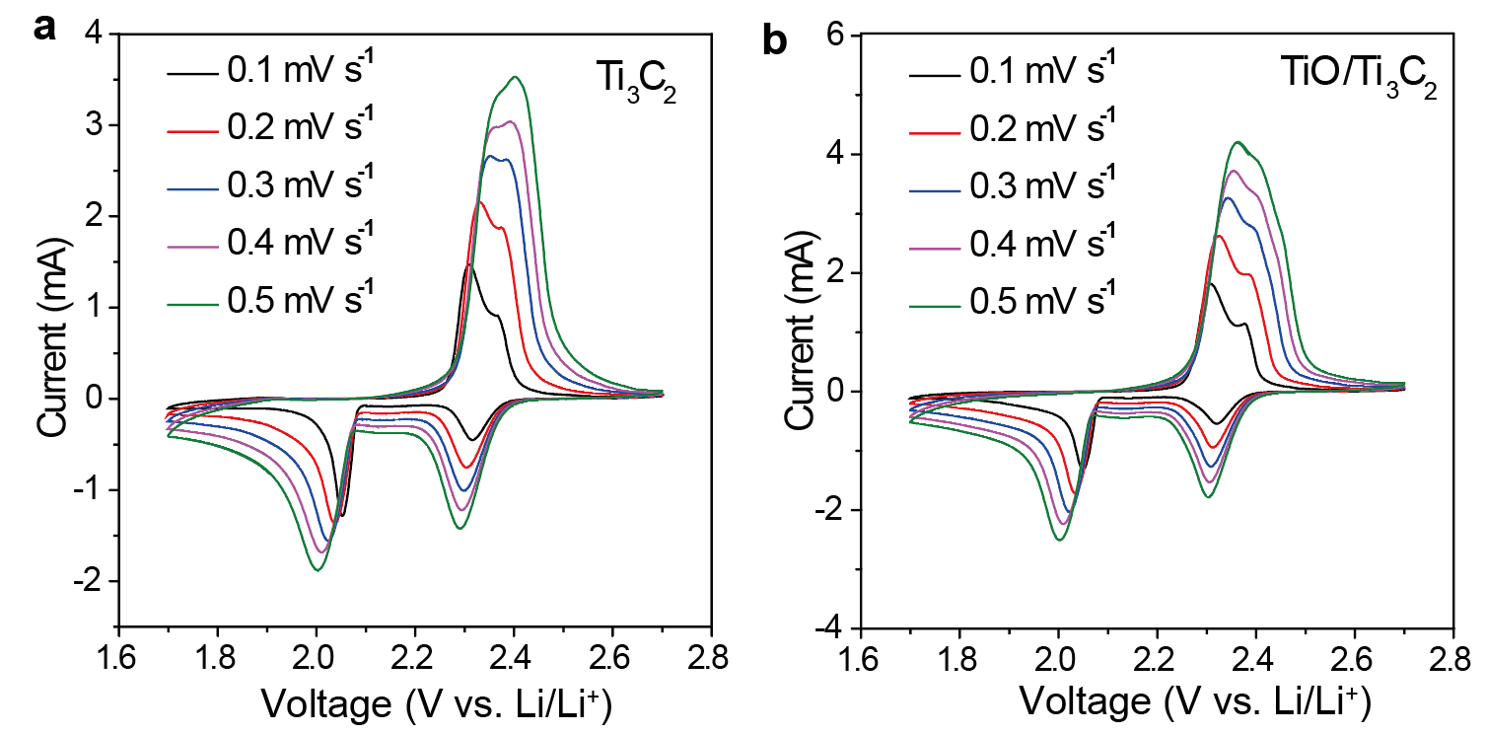Fig. S6 CV curves of a Ti₃C₂ and b TiO/Ti₃C₂ batteries at scan rates from 0.1 to 0.5 mV s⁻¹
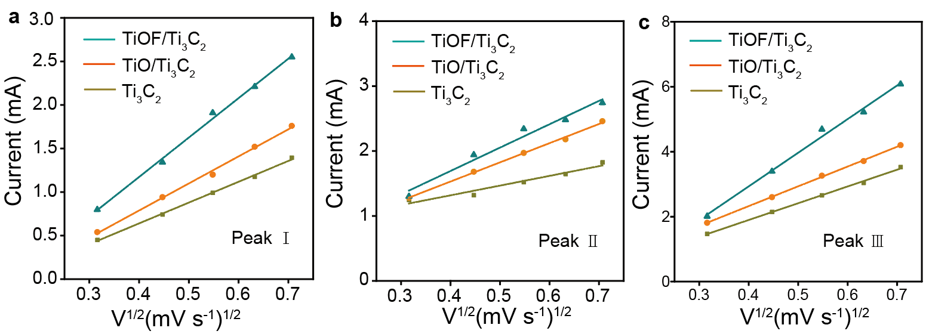Fig. S7 Linear fits of the peak current of a peak Ⅰ, b peak Ⅱ and c peak Ⅲ from CV curves
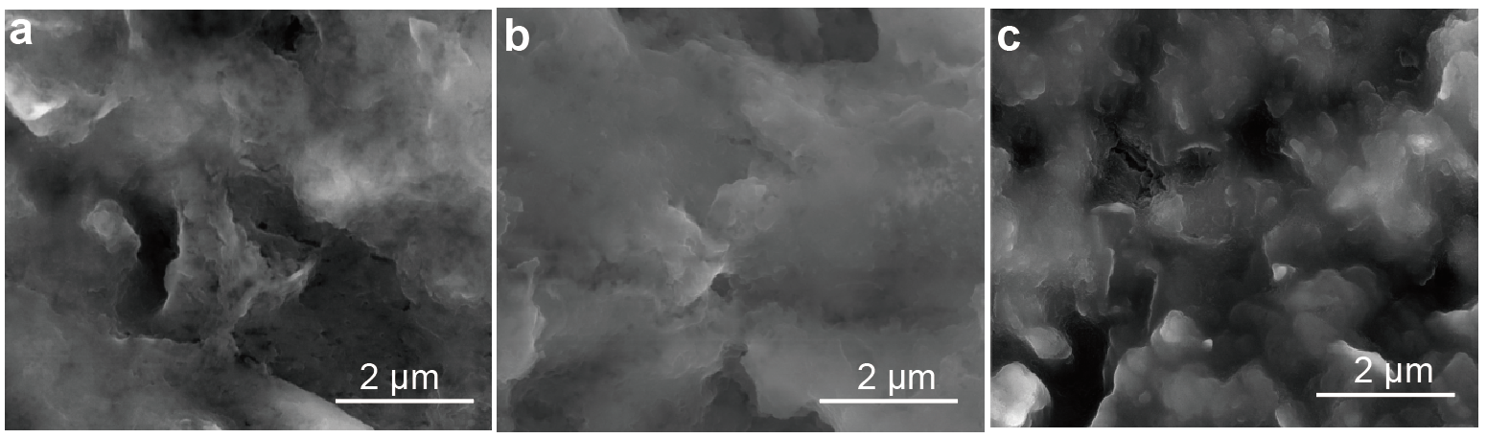
Fig. S8 SEM images of the Li₂S deposition morphology on a TiOF/Ti₃C₂, b TiO/Ti₃C₂, and c Ti₃C₂

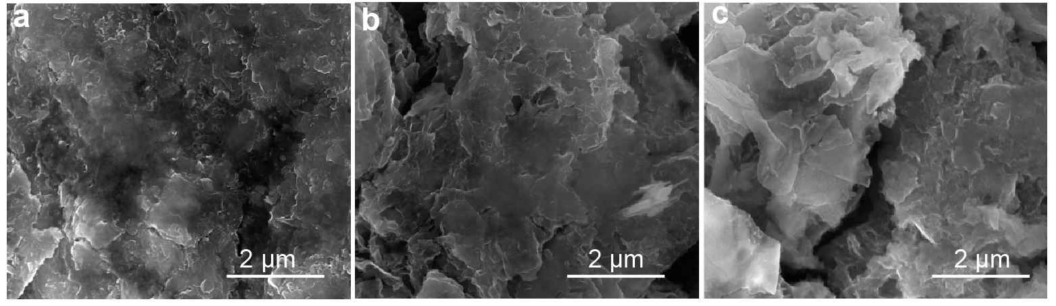
Fig. S9 SEM images of the Li₂S dissolution morphology on a TiOF/Ti₃C₂, b TiO/Ti₃C₂, and c Ti₃C₂

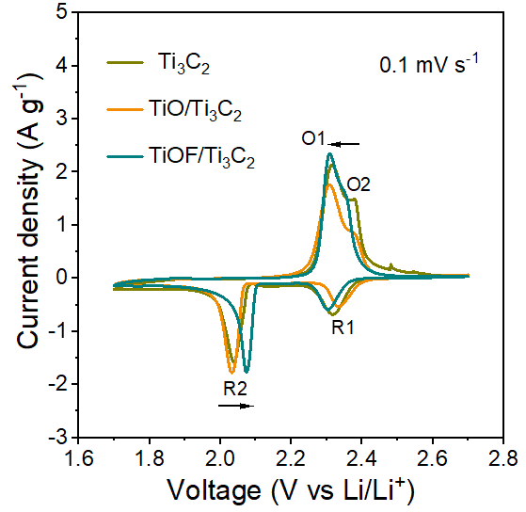
Fig. S10 CV curves of Ti₃C₂, TiO/Ti₃C₂, and TiOF/Ti₃C₂ batteries

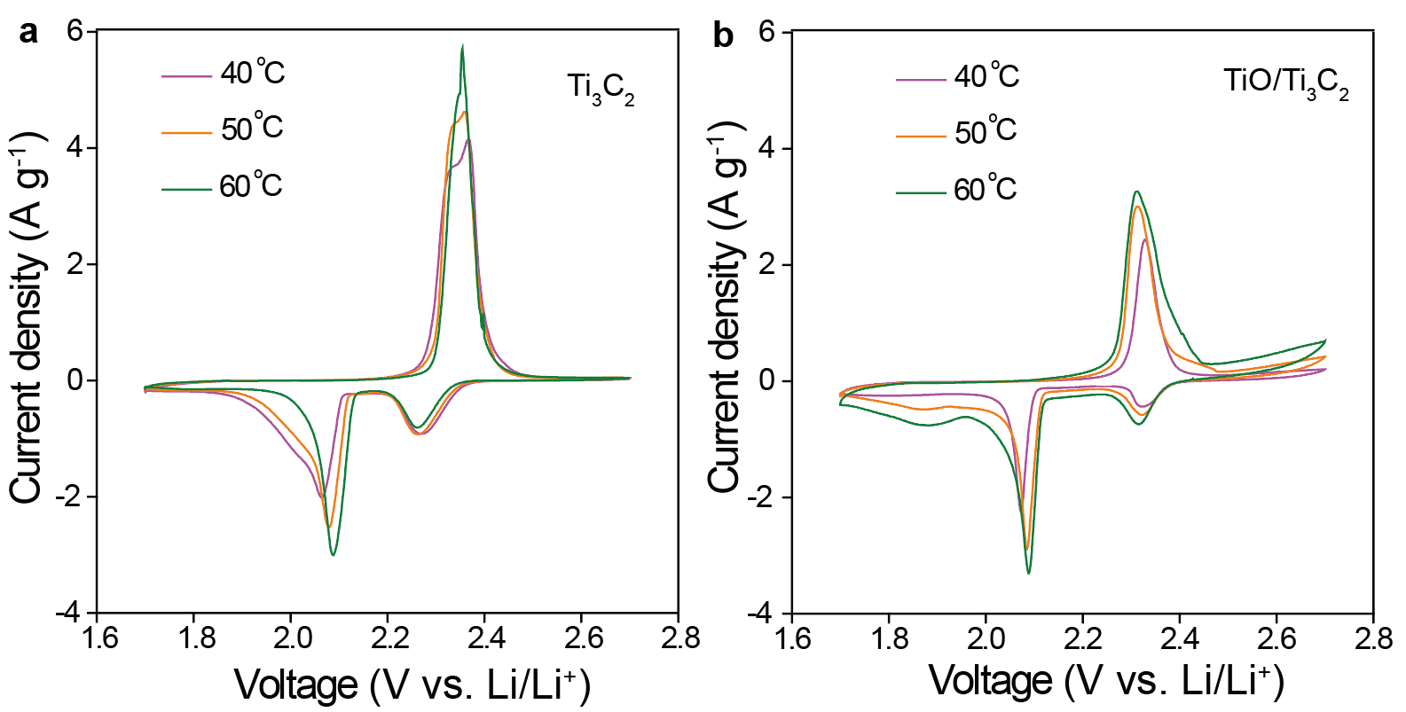
Fig. S11 CV curves at 0.1 mV s⁻¹ with a Ti₃C₂ and b TiO/Ti₃C₂ at 40, 50, and 60 °C
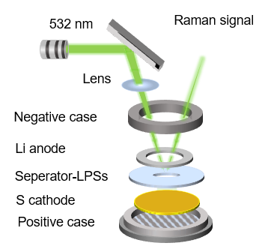
Fig. S12 Schematic diagram of the battery assembly for operando Raman spectroscopy.
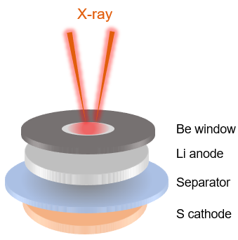
Fig. S13 Schematic diagram of the battery assembly for operando XRD spectroscopy
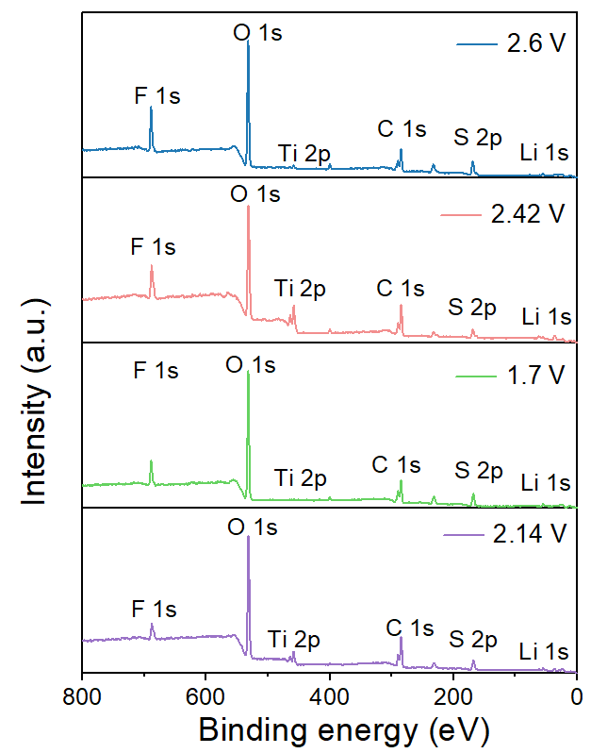
Fig. S14 XPS of TiOF/Ti₃C₂-Li₂S₆ at different discharge/charge states

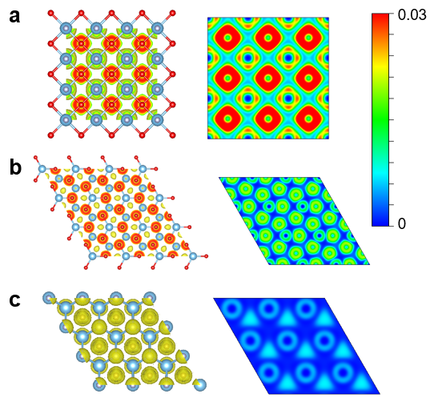
Fig. S15 ELF of a TiOF/Ti₃C₂, b TiO/Ti₃C₂, and c Ti₃C₂
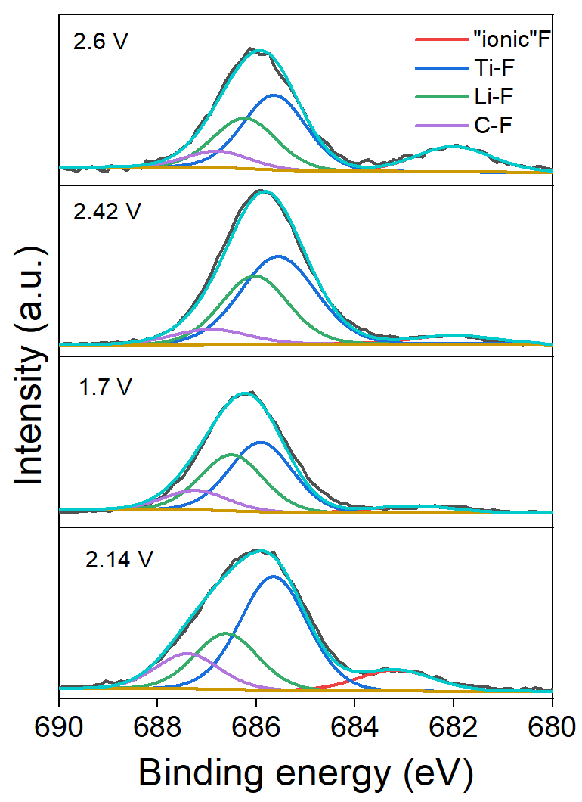
Fig. S16 XPS of F 1s on the TiO/Ti₃C₂-Li₂S₆ at different discharge/charge states

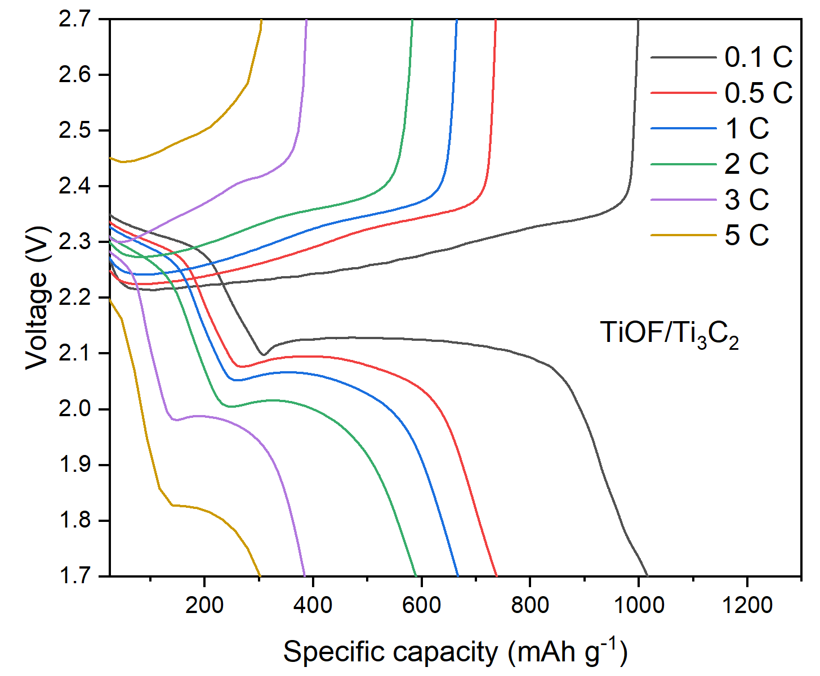
Fig. S17 Charge/discharge curves of TiOF/Ti₃C₂ cathodes at different current rates
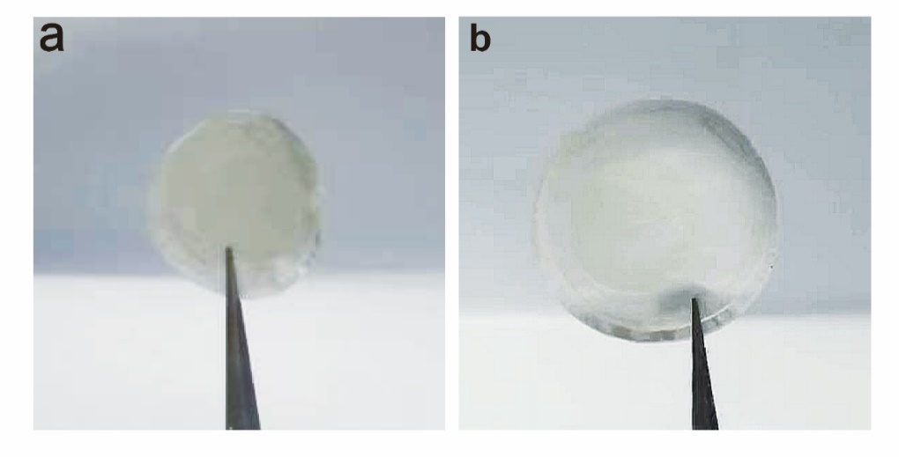
Fig. S18 Optical photos of separators a with the TiO/Ti₃C₂ cathode and b with the TiOF/Ti₃C₂ cathode after 500 cycles at 0.2 C

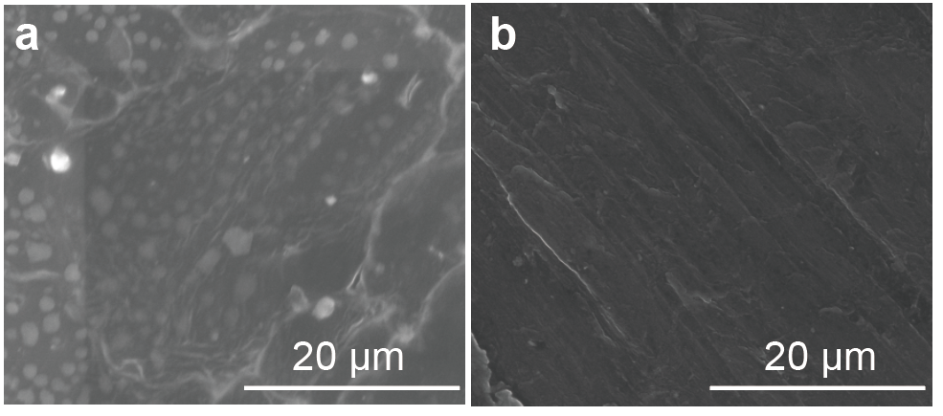
Fig. S19 SEM images of Li anodes of batteries a with the TiO/Ti₃C₂ cathode and b with the TiOF/Ti₃C₂ cathode after 500 cycles at 0.2 C

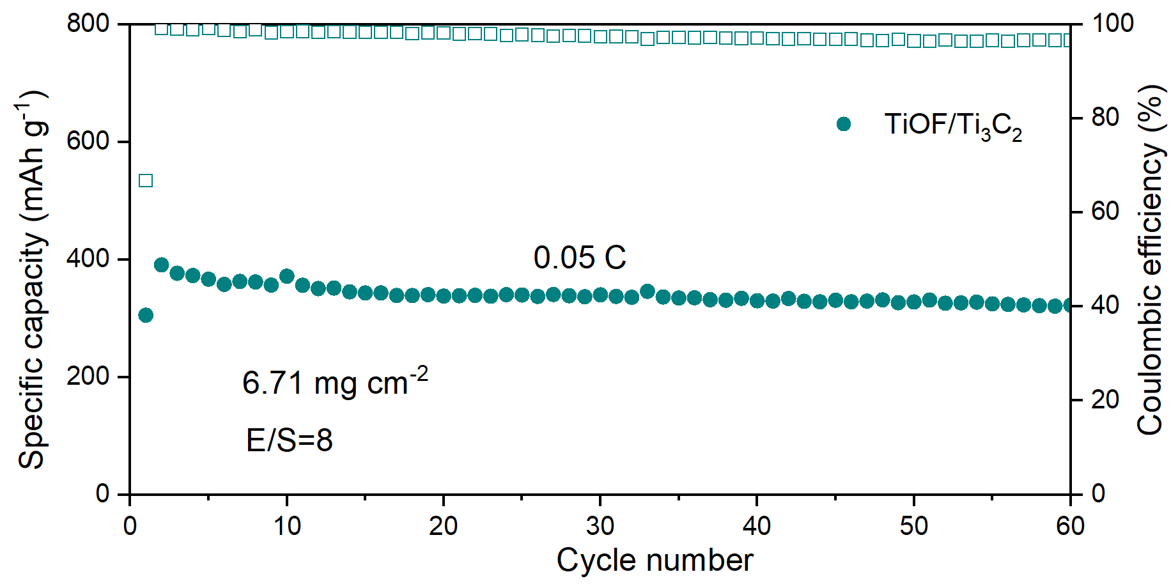
Fig. S20 Cycling performance with a sulfur mass loading of 6.71 mg cm⁻² at 0.05 C

Fig. S21 Li-S battery performance comparison
Table S1 The element content of Ti₃C₂, TiO/Ti₃C₂, and TiOF/Ti₃C₂
Materials | Ti (at%) | C (at%) | O (at%) | F (at%)
TiOF/Ti₃C₂ | 24.06 | 44.96 | 23.63 | 7.36
TiO/Ti₃C₂ | 21.85 | 40.99 | 32.13 | 5.03
Ti₃C₂ | 22.19 | 36.76 | 25.89 | 14.25
Table S2 Peaks potentials and potential difference from Fig. S10
Electrode | Reduction peak (R1, R2)  (V) | Oxidation peak (O1, O2)  (V)
Ti₃C₂ | 2.31, 2.037 |  | 2.31, 2.378
TiO/Ti₃C₂ | 2.33, 2.025 |  | 2.295, 2.376
TiOF/Ti₃C₂ | 2.306, 2.068 |  | 2.308, 2.35
Table S3 Bader charge of TiOF/Ti₃C₂, TiO/Ti₃C₂, and Ti₃C₂
 | TiOF/Ti₃C₂ | TiO/Ti₃C₂ | Ti₃C₂
Ti | -1.9409 | -1.1306 | -1.586
Table S4 Shift values of binding energy for Li, F, S and Ti at different discharge/charge states
Potentials | Li (eV) | F (eV) | S (eV) | Ti (eV)
2.14 V | 0 | 0 | 0 | 0
1.7 V | -0.2 | 0.6 | -1.09 | -0.3
2.42 V | 0 | 0.4 | 1.82 | 0
2.6 V | 0.2 | 0 | 2.13 | 0.5

