Supporting Information for
Amorphous Iridium Oxide Integrated Anode Electrodes with Ultrahigh Material Utilization for Hydrogen Production at Industrial Current Densities
Lei Ding^{1, #}, Kui Li^{1, #}, Weitian Wang¹, Zhiqiang Xie¹, Shule Yu¹, Haoran Yu², David A. Cullen², Alex Keane³, Kathy Ayers³, Christopher B. Capuano³, Fangyuan Liu⁴, Pu-Xian Gao^{4,5}, and Feng-Yuan Zhang^{1,}*
¹ Department of Mechanical, Aerospace & Biomedical Engineering, University of Tennessee, Knoxville, TN, 37996, USA
² Center for Nanophase Materials Sciences, Oak Ridge National Lab, Oak Ridge, TN 37831, USA
³ Nel Hydrogen, Wallingford, CT 06492, USA
⁴ Institute of Materials Science, University of Connecticut, Storrs, CT 06269, USA
⁵ Department of Materials Science & Engineering, University of Connecticut, Storrs, CT 06269, USA
# Lei Ding and Kui Li contribute equally to this work.
*Corresponding author. E-mail: fzhang@utk.edu (Feng-Yuan Zhang)
Supplementary Figures and Tables
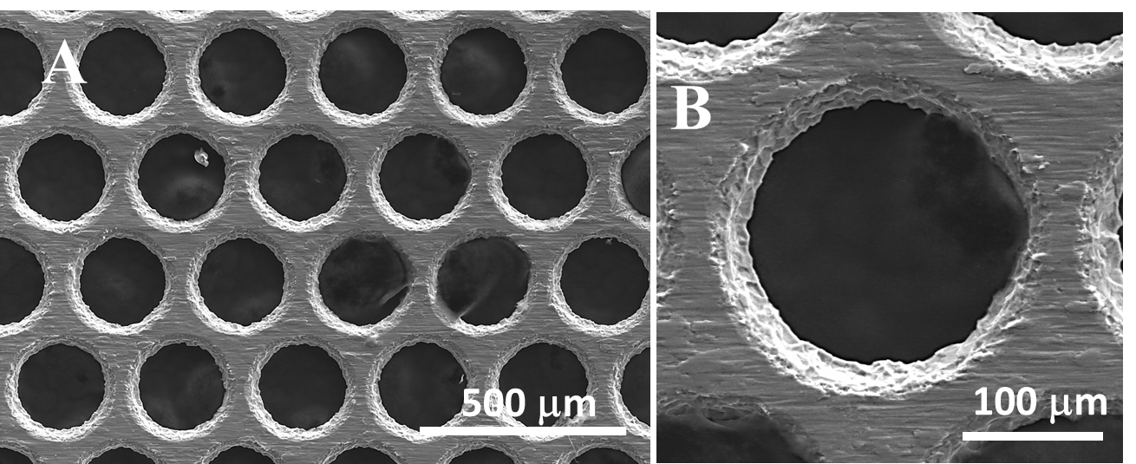
Fig. S1 Top-view SEM image (A, B) of the TTLGDL with a pore size of 200 μm and a porosity of 40%

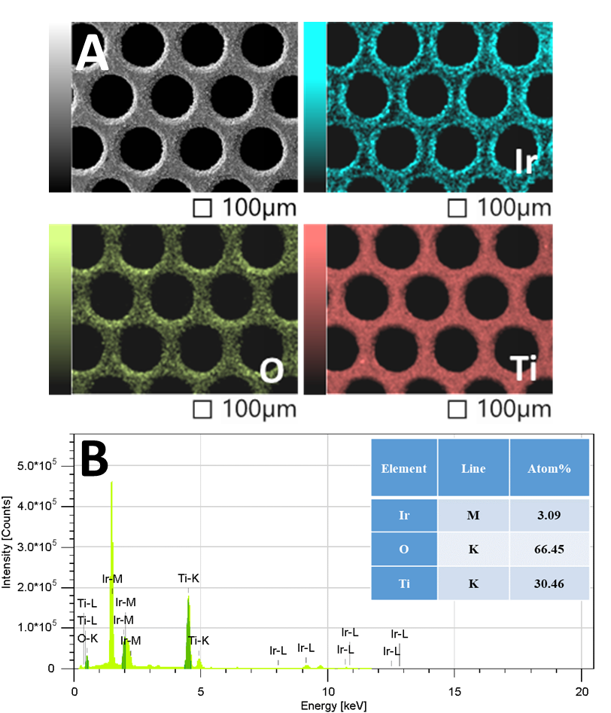
Fig. S2 (A) SEM-EDS mapping images of IrO_{x} CCLGDL (0.075 mg cm⁻²); (B) EDS analysis of IrO_{x} CCLGDL (0.075 mg cm⁻²)

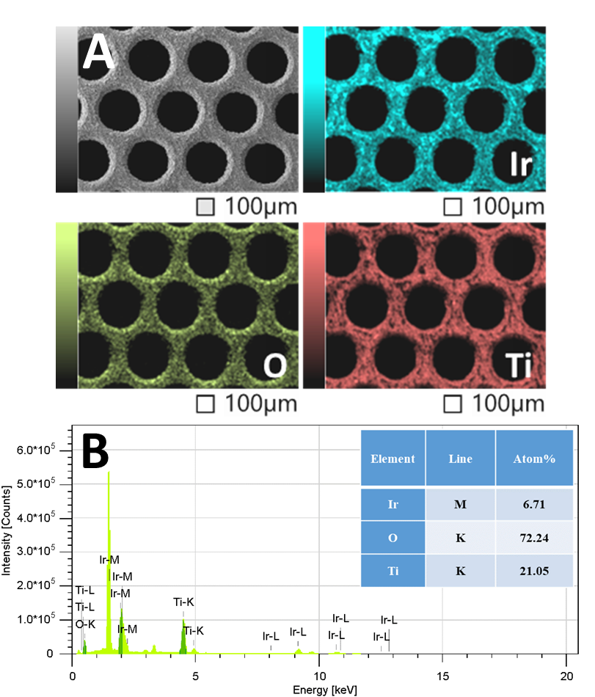
Fig. S3 (A) SEM-EDS mapping images of IrO_{x} CCLGDL (0.170 mg cm⁻²); (B) EDS analysis of IrO_{x} CCLGDL (0.170 mg cm⁻²)

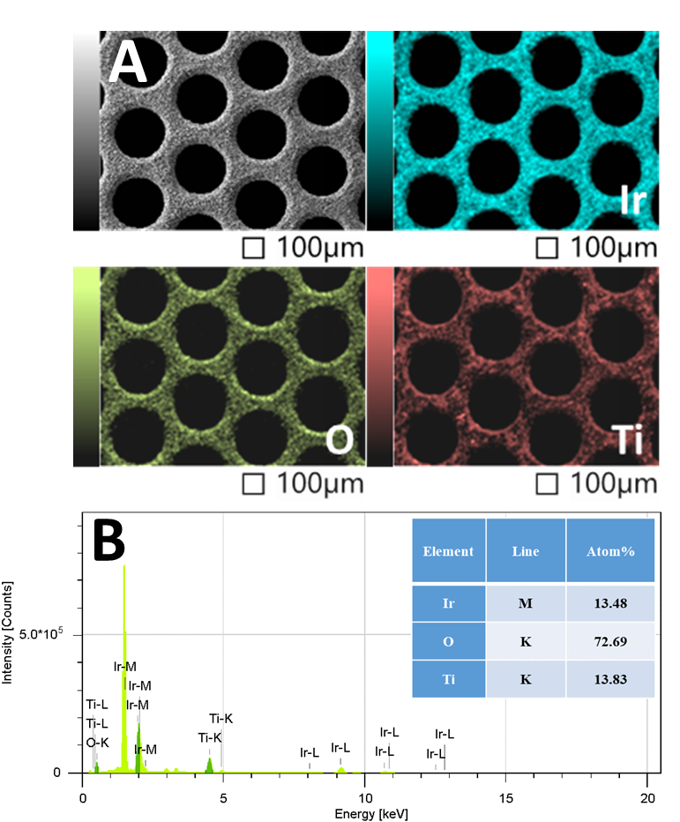
Fig. S4 (A) SEM-EDS mapping images of IrO_{x} CCLGDL (0.340 mg cm⁻²); (B) EDS analysis of IrO_{x} CCLGDL (0.340 mg cm⁻²)

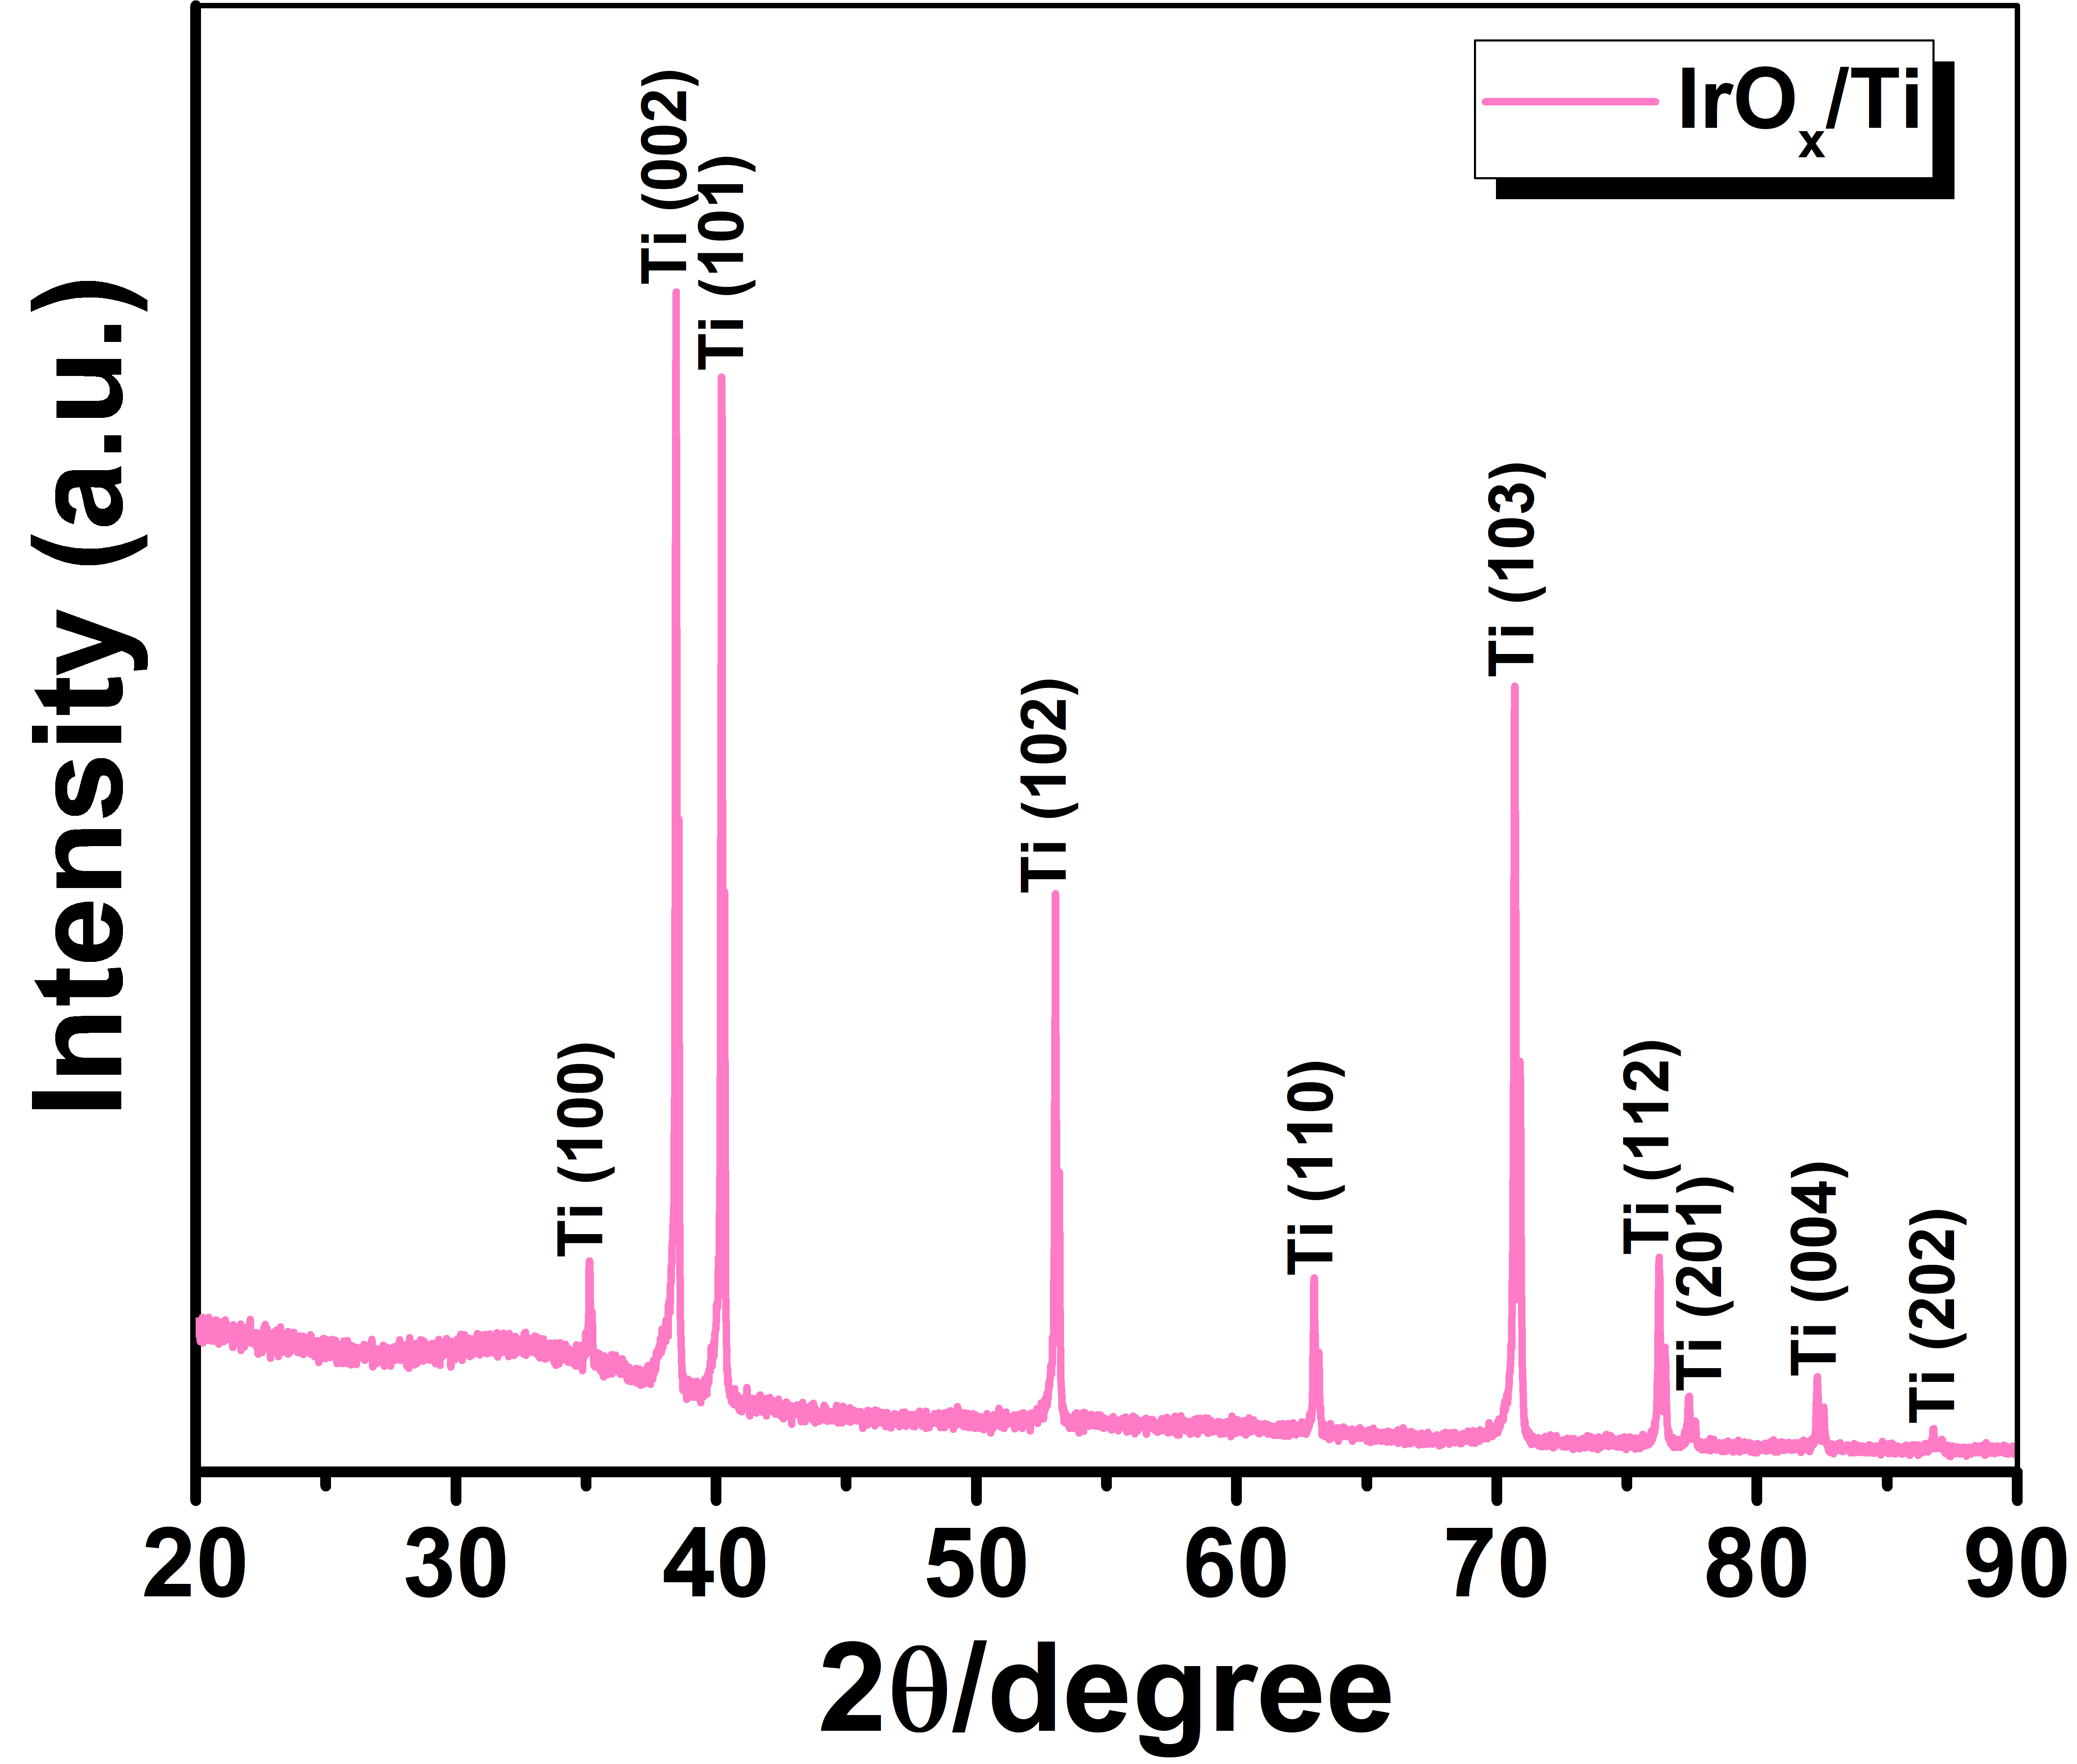
Fig. S5 XRD pattern of the IrO_{x}/Ti
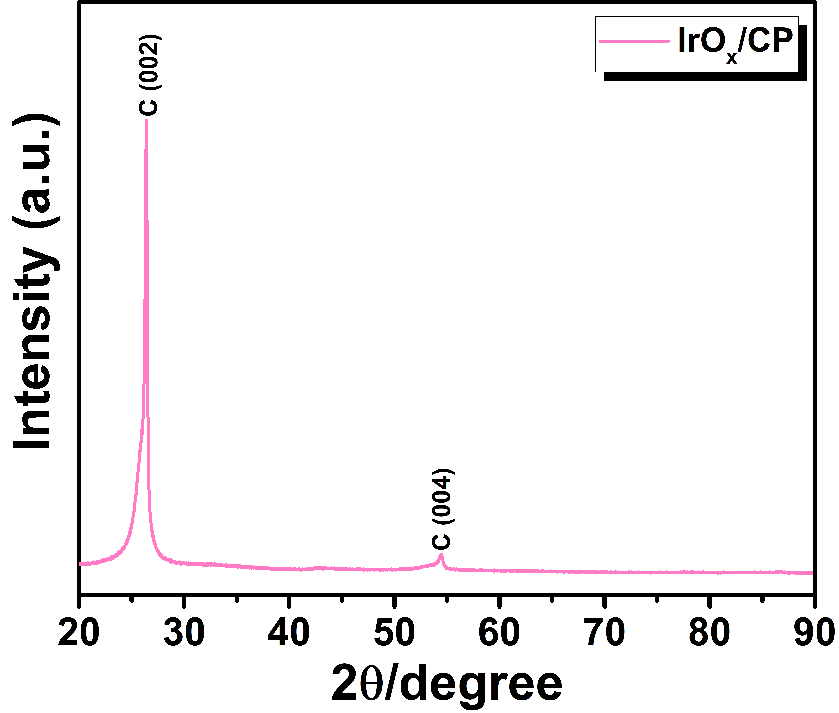
Fig. S6 XRD pattern of the IrO_{x}/CP
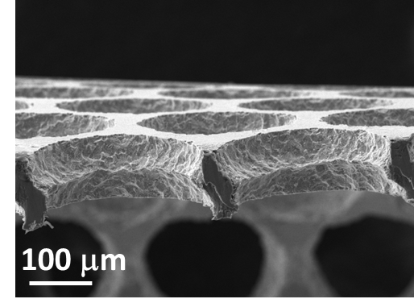
Fig. S7 Cross-section SEM image of the IrO_{x} CCLGDL
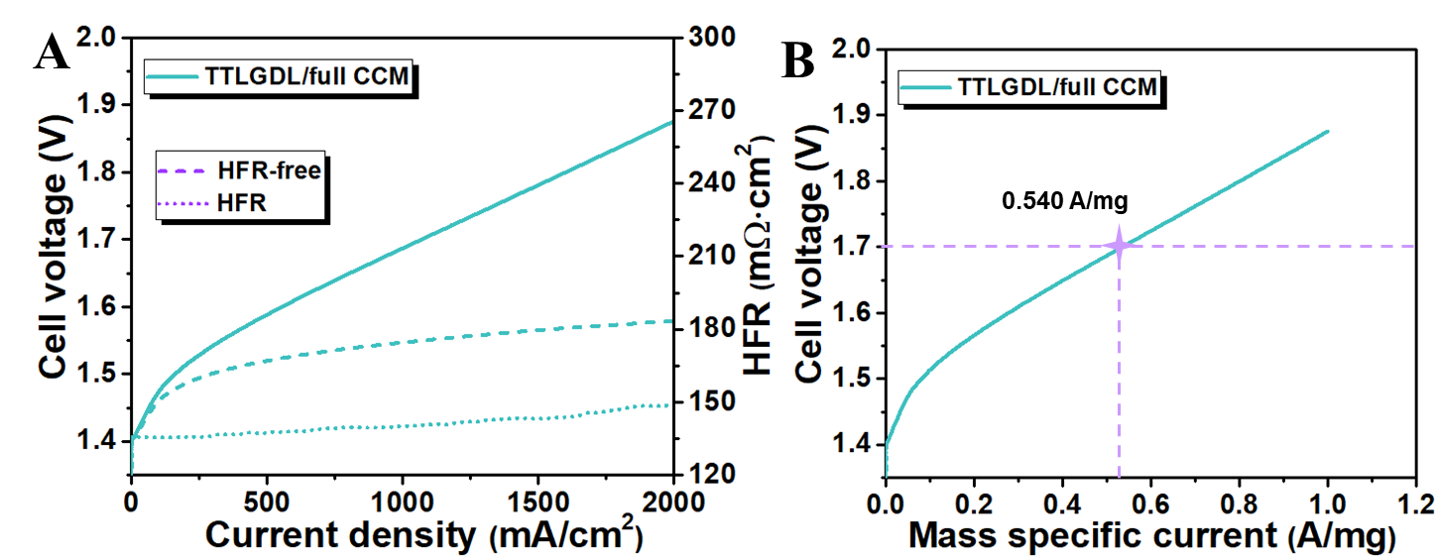
Fig S8 (A) Cell polarization curves and related HFR plot of the TTLGDL coupled with full CCM; (B) Ir mass normalized cell polarization curves of the TTLGDL coupled with full CCM
Table S1 EIS fitting parameters derived from Fig. 6C

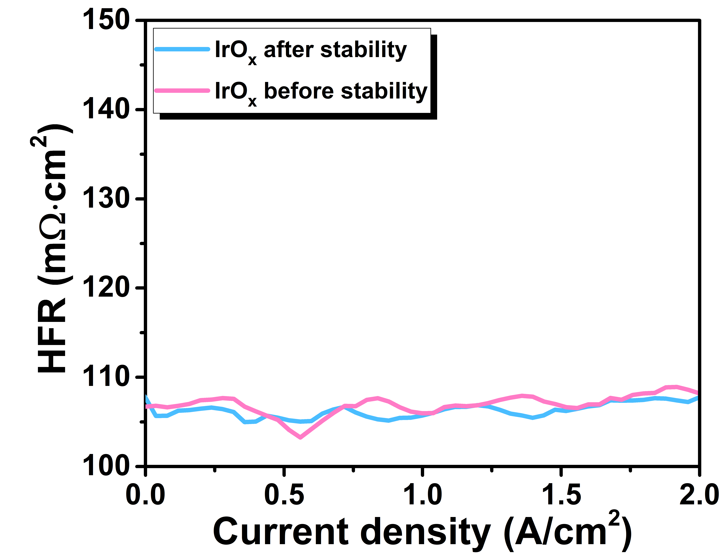
Fig. S9 HFR plots of IrO_{x} CCLGDL before and after the stability test

Table S2 Cell test property comparison of previously reported PEMECs with different anodes
Catalysts | Anode fabrication | Catalyst loading (mg cm⁻²) | Membrane | Voltage (V) at 1 A cm⁻² | Voltage (V)  at 2 A cm⁻² | Mass-specific current at 1.7 V (A mg⁻¹) | Refs.
0.075-based CCLGDL | Electrodeposition | 0.075 | N117 | 1.68 | 1.84 | 15.26 | This work
0.170-based CCLGDL | Electrodeposition | 0.170 | N117 | 1.66 | 1.80 | 7.732 | This work
0.340-based CCLGDL | Electrodeposition | 0.340 | N117 | 1.64 | 1.77 | 4.383 | This work
IrO2  (pattern-3) | Commercial/spray | 0.42 | N117 | 1.69 | 1.89 | 2.43 | ACS Appl. Mater. Interfaces 14 (2022) 2335
IrO2 | Adams fusion method/  spray | 2.5 | N117 | 1.75 | / | 0.352 | Applied Surface Science 514 (2020) 145943
IrRuOX | Spray-drying+  calcination/  spray + decal | 1.8 | N115 | 1.67 | 1.85 | 0.711 | Adv. Energy Mater. 9 (2019) 1802136
IrOX | Spray-drying+  calcination/  spray + decal | 2 | N115 | 1.68 | 1.85 | 0.575 | Adv. Energy Mater. 9 (2019) 1802136
IrO2 nanoneedles | Adams’ fusion method/  spray + decal | 4 | N117 | 1.80 | 2.18 | 0.178 | Adv. Funct. Mater. 2028 (2018) 1704796
IrO2 | Hydrothermal reaction/spray | 1.5 | N117 | 1.72 | / | 0.603 | Chem. Eng. J. 419 (2021) 129455
Ir0.7Ru0.3OX  (TT) | Wet chemical method/spray | 1 | N212 | 1.74 | / | 0.835 | Nano Energy 34 (2017) 385
IrOX@IrO2 (A-450) | Adams’ fusion method/  spray | 1 | N115 | 1.79 | 2.21 | 0.750 | Electrochim. Acta 390 (2021) 138885

