Supporting Information for
Accelerating Oxygen Electrocatalysis Kinetics on Metal-Organic Frameworks via Bond Length Optimization
Fan He¹, Yingnan Liu¹, Xiaoxuan Yang¹, Yaqi Chen¹, Cheng-Chieh Yang⁵, Chung-Li Dong⁵, Qinggang He¹, Bin Yang¹, Zhongjian Li¹, Yongbo Kuang³, Lecheng Lei¹, Liming Dai⁶, Yang Hou^{1,2,4,}*
¹ Key Laboratory of Biomass Chemical Engineering of Ministry of Education, College of Chemical and Biological Engineering, Zhejiang University, Hangzhou 310027, P. R. China
² Institute of Zhejiang University - Quzhou, Quzhou 324000, P. R. China
³ Ningbo Institute of Materials Technology and Engineering, Chinese Academy of Sciences, Ningbo 315201, P. R. China
⁴ School of Biological and Chemical Engineering, NingboTech University, Ningbo, 315100, P. R. China
⁵ Department of Physics, Tamkang University, New Taipei, 25137 Taiwan, P. R. China
⁶ Australian Carbon Materials Centre (A-CMC), School of Chemical Engineering, University of New South Wales, Sydney, New South Wales 2051, Australia
*Corresponding author. E-mail: yhou@zju.edu.cn (Yang Hou)
S1 Experimental Section
S1.1 Synthesis of CoNDA
2,6-NDA (172.9 mg) and CoCl₂·6H₂O (190.2 mg) were dissolved in a mixed solution containing 32 mL dimethyl formamide (DMF), 2 mL ethanol, and 2 mL deionized water. Afterwards, 1.0 mL triethylamine (TEA) was injected into above mixed solution with vigorous stirring to form a uniform colloidal suspension. The formed suspension was sealed and further ultrasonicated for 300 min under a power of 70 kHz at room temperature. Subsequently, the precipitates were washed with DMF and ethanol for three times, and dried in vacuum oven at 60 ºC.
S1.2 Synthesis of AE-CoNDA with different concentrations of acetic acid etching
2,6-NDA (172.9 mg) and CoCl₂·6H₂O (190.2 mg) were dissolved in a mixed solution containing 32 mL dimethyl formamide (DMF), 2 mL ethanol, and 2 mL deionized water. Afterwards, 1.0 mL triethylamine (TEA) was injected into above mixed solution with vigorous stirring to form a uniform colloidal suspension. The formed suspension was sealed and further ultrasonicated for 300 min under a power of 70 kHz at room temperature. The obtained sample was further immersed in 0.1 mM, 0.2 mM, 0.5 mM or 1.0 mM acetic acid solution for etching. The obtained precipitate was washed with DMF and ethanol for three times, and dried in vacuum oven at 60 ºC.
S1.3 Synthesis of AE-CoNDA with different etching time by 0.2 mM acetic acid
2,6-NDA (172.9 mg) and CoCl₂·6H₂O (190.2 mg) were dissolved in a mixed solution containing 32 mL dimethyl formamide (DMF), 2 mL ethanol, and 2 mL deionized water. Afterwards, 1.0 mL triethylamine (TEA) was injected into above mixed solution with vigorous stirring to form a uniform colloidal suspension. The formed suspension was sealed and further ultrasonicated for 300 min under a power of 70 kHz at room temperature. The obtained sample was further immersed in 0.2 mM acetic acid solution for 0.5 h, 1 h, 2 h or 3 h etching. The obtained precipitate was washed with DMF and ethanol for three times, and dried in vacuum oven at 60 ºC.
S1.4 Synthesis of BiVO₄
The BiOI precursor was electrodeposited on an FTO substrate in a three-electrode cell, which was prepared by a 100 mL of HNO₃ mixture solution containing 0.0075 M Bi(NO₃)₃, 0.4 M NaI, and 45 mL of 0.3 M p-benzoquinone in ethanol. To convert the BiOI precursor into BiVO₄, the as-prepared BiOI electrode was immersed in a 0.4 M C₁₅H₂₁O₆V dissolved in dimethylsulfoxide (DMSO) for 20 s, and then transferred into a muffle furnace preheated to 120 °C, then hold at 450 °C for 1 h. The resulting BiVO₄ electrode was soaked in a 0.05 M NaOH solution for 5 min then rinsed with DI water and dried in air for further use⁷.
S1.5 Synthesis of CoNDA@BiVO₄
10 mg of CoNDA catalyst was dispersed in 5 mL ethanol, then sprayed on the as-prepared BiVO₄. Then, the above electrode was annealed at 100 °C for 30 min to obtain the CoNDA@BiVO₄ photoanode.
S1.6 Synthesis of AE-CoNDA@BiVO₄
10 mg of AE-CoNDA catalyst was dispersed in 5 mL ethanol, and sprayed on the as-prepared BiVO₄. Then, the above electrode was annealed at 100 °C for 30 min to obtain the AE-CoNDA@BiVO₄ photoanode.
S1.7 PEC-OER measurements
The charge transfer efficiencies were estimated as functions of applied potential by using Na₂SO₃ as hole scavenger under AM 1.5 G irradiation. We assume that the oxidation kinetics of Na₂SO₃ is very fast and its charge transfer efficiency is 100%. Therefore, the ratio of photocurrent densities measured in H₂O and Na₂SO₃ can be used to calculate charge transfer efficiency. The ABPE that is the conversion efficiency from light energy to chemical energy, is calculated as:
ABPE= [(1.23-V_{app}) × (J_{light}-J_{dark})/P_{light}] × 100%
where V_{app} is the applied potential vs. RHE, J_{dark} and J_{light} are the respective current densities in dark and under AM 1.5 G irradiation, and P_{light} is the power density of AM 1.5 G (100 mW cm⁻²).
The EIS was performed at a DC bias of 0.9 V in the frequency range of 10⁵-0.01 Hz with an AC voltage of 10 mV.
IPCE was calculated using the equation, IPCE = ((1240/λ) × (J_{light} - J_{dark})/P_{λ})) × 100%
The electrolysis was carried out with a constant potential at 0.7 V vs. RHE, and the actual amount of O₂ generated was determined by gas chromatography (GC-2014 SHIMADZU) every ca. 30 min. The theoretical amount of produced O₂ can be obtained by converting the charge passed to generated gas (μmol) according to Faraday’s Law. The Faradaic efficiency was calculated according to the equation: FE (%) = O₂ (actual) / O₂ (theoretical) × 100%.
S1.8 Computational methods
The (1 × 2) surface of bulk CoNDA (100) was chosen, which contains 16 Co atoms, 83 O atoms, 96 C atoms and 64 H atoms. A vacuum slab of about 15 Å was maintained in the super-cell configuration that was large enough for the calculations. To simulate the tensile state of structure, tensile CoNDA structure was constructed by expanding the lattice parameters of the pristine CoNDA in three directions by 5%.
The reaction pathways for OER under alkaline environment are simulated as follows:
*OH→OH* S1
OH* + (OH⁻ + e⁻) →O* + H₂O S2
O* + (OH⁻ + e⁻) →OOH* S3
OOH* + (OH⁻ + e⁻) → O₂↑+H₂O S4
In these equations, the * denotes the catalytic active site on surface; the OH*, O* and OOH* denote the reaction intermediates with adsorbed groups of OH, O, and OOH, respectively.
The equation for the Gibbs free energy calculations is as follows:
G = E_{o} + E_{zpv} - TS + G_{U} S5
where E₀ is the total energy obtained from DFT calculation, E_{zpv}, T and S stand for the zero point vibration energy, temperature (298.15 K) and entropy corrections, respectively. G_{U} is depended on the electrode potential V and electron charge e.
S2 Supplementary Figures
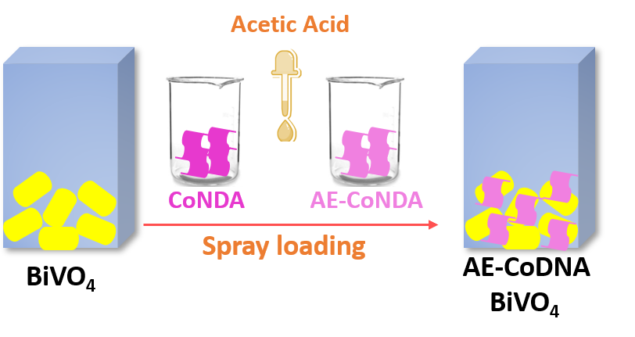
Fig. S1 Schematic illustration of the synthesis process of AE-CoNDA@BiVO₄
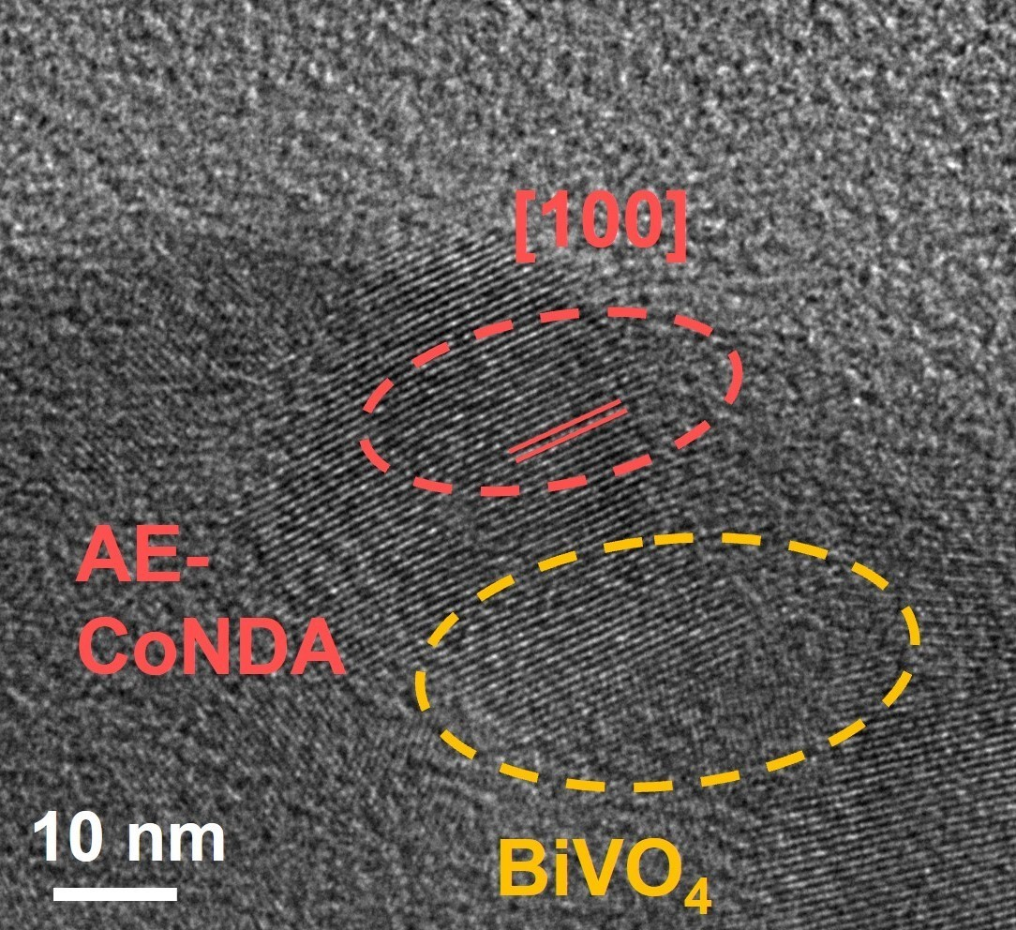
Fig. S2 HR-TEM image of AE-CoNDA@BiVO₄
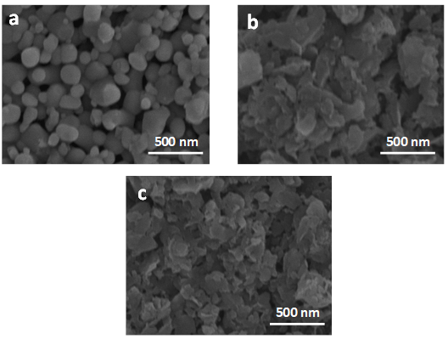
Fig. S3 FESEM images of BiVO₄ (a), CoNDA@BiVO₄ (b), and AE-CoNDA@BiVO₄ (c)
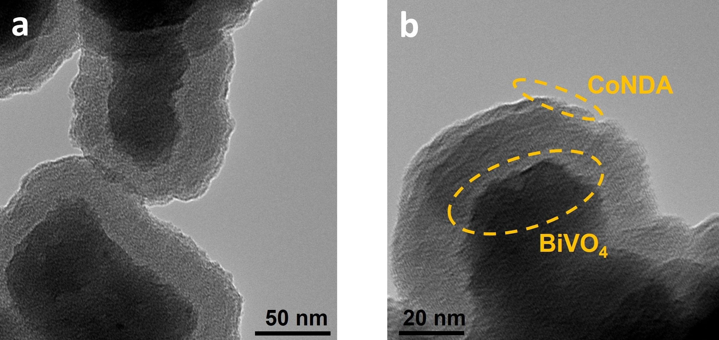
Fig. S4 TEM images of BiVO₄ (a) and CoNDA@BiVO₄ (b)
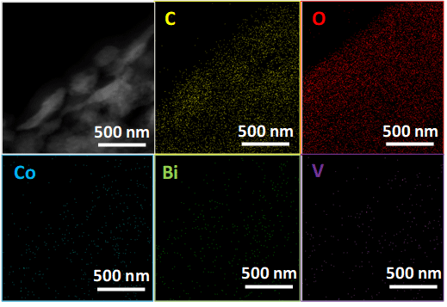
Fig. S5 HR-TEM and EDX elemental mapping images of AE-CoNDA@BiVO₄
Fig. S6 XRD patterns of AE-CoNDA@BiVO₄, CoNDA@BiVO₄ and BiVO₄
Fig. S7 Raman spectra of BiVO₄, CoNDA@BiVO₄, and AE-CoNDA@BiVO₄

Fig. S8 Polarization curves of BiVO₄ (a) and AE-CoNDA@BiVO₄ with different spray layers of AE-CoNDA (b-f), without adding Na₂SO₃ under chopped AM 1.5G irradiation
Fig. S9 EIS Nyquist plots of AE-CoNDA@BiVO₄, CoNDA@BiVO₄, and BiVO₄ under AM 1.5G light illumination

Fig. S10 Polarization curves of BiVO₄, CoNDA@BiVO₄, and AE-CoNDA@BiVO₄ with or without Na₂SO₃ under AM 1.5G irradiation
To understand the positive effect of AE-CoNDA on the promotion of photogenerated charge carrier separation, the charge transfer efficiencies (η_{transfer}= J_{H2O}/J_{Na2SO3}) and the charge transport efficiencies (η_{transport} = J_{Na2SO3}/J_{abs}) of the AE-CoNDA are decoupled and quantified by using Na₂SO₃ as hole scavenger. The specific efficiency is calculated by polarization curves [S1].

Fig. S11 Solar irradiance of AM 1.5G and UV-Vis DRS of BiVO₄, CoNDA@BiVO₄, and AE-CoNDA@BiVO₄. The overlapped area is Jabs
Fig. S12 Charge transfer efficiencies of BiVO₄, CoNDA@BiVO₄, and AE-CoNDA@BiVO₄
At 1.23 V, AE-CoNDA@BiVO₄ delivers a much higher η_{transfer} of 90.0% than CoNDA@BiVO₄ (81.1%) and bare BiVO₄ (62.5%), illustrating that AE-CoNDA effectively weaken surface charge recombination and improve charge transfer from BiVO₄ to electrolyte, thus facilitating PEC-OER kinetics.
Fig. S13 Charge transport efficiencies of BiVO₄, CoNDA@BiVO₄, and AE-CoNDA@BiVO₄
Fig. S14 Stability of CoNDA@BiVO₄ at 1.5 mA cm⁻² and BiVO₄ at 1.0 mA cm⁻² under AM 1.5G irradiation
Fig. S15 Operando irradiated high-resolution Co 2p (a) and V 2p (b) XPS spectra of AE-CoNDA@BiVO₄
After light illumination, the Co 2p XPS peaks of AE-CoNDA@BiVO₄ evidently shifted to higher binding energy compared with AE-CoNDA, while V 2p XPS peak shifted to lower binding energy, which strongly claim the photo-induced holes transferred from BiVO₄ to AE-CoNDA cocatalyst, achieving a favorable charge transfer of bare BiVO₄ photoanode.
Fig. S16 (a) Polarization curves of CoNDA with different concentrations of acid after acid etching. (b) Polarization curves of CoNDA with different acid etching time
With the concentration of acetic acid increases, the OER performance of AE-CoNDA is significantly improved, which proves that the proper concentration for acid etching could efficiently increase the OER activity. After the concentration of acetic acid exceeds 0.2 mM, the OER performance of AE-CoNDA is reduced, which means that the high concentration of acetic acid induces a poor OER performance, which is attributed to the damage of the original structure of CoNDA. Thus, the optimal concentration of acetic acid for acid etching is determined to be 0.2 mM.
To explore the optimal acid etching time, a series of AE-CoNDA samples with different acid etching times were prepared. With an increase in the acid etching time, the OER performance of AE-CoNDA is improved, which proves that the proper acid etching treatment is favorable for electrocatalytic OER. When the acid etching time is longer than 1 h, the OER performance of AE-CoNDA is reduced, indicating that the long acid etching time will destroy the pristine CoNDA structure, and the short acid etching time is insufficient to regulate the Co-O bond in the pristine CoNDA structure. Therefore, the optimal acid etching time is determined to be 1 h.

Fig. S17 XRD patterns of CoNDA with different concentrations of acetic acid after acid etching
Fig. S18 XRD patterns of CoNDA with different acetic acid etching time
Fig. S19 EIS Nyquist plots and equivalent electrical circuit fitting of CoNDA and AE-CoNDA
Fig. S20 Calculation for internal and external voltametric charge densities. Linear plot of (a) q⁻¹ vs. v^{0.5} and (c) q vs. v^{-0.5} of CoNDA, and AE-CoNDA (b) and (d) are enlarged graphs of the red dotted boxes in (a) and (c), respectively

Fig. S21 CV curves of (a) CoNDA and (b) AE-CoNDA at different scan rates of 10 mV s⁻¹ to 50 mV s⁻¹ in 1.0 M KOH
Fig. S22 Cdl of CoNDA and AE-CoNDA (a). Polarization curves of CoNDA and AE-CoNDA normalized by ECSA (b)
Fig. S23 Chronopotentiometric durability of CoNDA at 1.5 V
Fig. S24 (a) XRD patterns and (b) Raman spectra of AE-CoNDA before and after OER process
Fig. S25 High-resolution C 1s XPS spectra of CoNDA and AE-CoNDA
Fig. S26 EPR spectra of CoNDA and AE-CoNDA
Fig. S27 Crystal structures of AE-CoNDA model after bond length regulation (a) and CoNDA models (b)
Fig. S28 The free energy diagrams of CoNDA and AE-CoNDA of OER at U = 0.4 V
Table S1 Comparison of PEC-OER performances of AE-CoNDA@BiVO₄ with other reported Co-based cocatalyst loaded on BiVO₄
Photoanode | Photocurrent density (mA cm⁻²) |  | IPCE (%) | ABPE  (%) | Stability  (h) | Refs.
Photoanode | 0.6 V | 1.23 V
AE-CoNDA@BiVO₄ | 2.4 | 4.3 | 52.5 | 1.6 | 20 | This work
CoPiB/BiVO₄/ZnO | 0.1 | 3.5 | 40 | 1.1 | 3 | [S2]
NiCo-LDH/BiVO₄ | 0.6 | 3.4 | 59 | 0.66 | 3 | [S3]
NiO/CoOx/BiVO₄ | 2.5 | 3.5 | 60 | 1.5 | 16 | [S4]
Mo-BiVO₄ | 3.4 | 4.98 | 71 | 0.65 | 10 | [S5]
CoNi-MOF/BiVO₄ | 0.3 | 3.2 | 32 | 1.8 | 3 | [S6]
CoBDA FcCA/BiVO₄ | 2.8 | 3.5 | 44.3 | 0.67 | 2.7 | [S7]
Table S2 EIS fitting data of CoNDA and AE-CoNDA cocatalyst in 1.0 M KOH in this work
Sample | Potential (V) | R_{ct} (kΩ) |  | Sample | Potential (V) | R_{ct} (kΩ)
 | 1.20 | 7.653 |  |  | 1.20 | 2.355
 | 1.25 | 6.127 |  |  | 1.25 | 1.773
 | 1.30 | 3.302 |  |  | 1.30 | 1.032
CoNDA | 1.35 | 2.177 |  | AE-CoNDA | 1.35 | 0.667
 | 1.40 | 1.489 |  |  | 1.40 | 0.128
 | 1.45 | 0.995 |  |  | 1.45 | 0.099
 | 1.50 | 0.623 |  |  | 1.50 | 0.064
 | 1.55 | 0.356 |  |  | 1.55 | 0.043
 | 1.60 | 0.088

Table S3 Comparison of OER performances of AE-CoNDA with other reported non-carbonized Co-MOF-based OER catalysts in alkaline media
Catalyst | Overpotential @10 mA cm⁻² | Tafel slope | Substrate | Refs.
AE-CoNDA | 260 mV | 62 mV dec⁻¹ | GCE | This work
CoP-InNC@CNT | 270 mV | 84 mV dec⁻¹ | GCE | [S8]
CoFe20@CC | 286 mV | 58.8 mV dec⁻¹ | GCE | [S9]
A_{2.7}B-MOF-FeCo_{1.6} | 288 mV | 39 mV dec⁻¹ | GCE | [S10]
Co₃O₄C-NA | 290 mV | 70 mV dec⁻¹ | GCE | [S11]
FeCo-MNS-1.0 | 298 mV | 21.6 mV dec⁻¹ | GCE | [S12]
NCF-MOF | 320 mV | 49 mV dec⁻¹ | RDE | [S13]
Co₃O₄/HNCP-40 | 333 mV | 69 mV dec⁻¹ | GCE | [S14]
MAF-X27-OH | 387 mV | 60 mV dec⁻¹ | GCE | [S15]
Table S4 Structural parameters of CoNDA and AE-CoNDA nanosheets extracted from the EXAFS fitting (S₀² = 0.85)
Sample | Scattering pair | CN | R(Å) | σ²(10⁻³Å²) | ΔE₀(eV) | R
CoNDA | Co-O | 5.68(4) | 2.07 | 11(8) | -1.04(5) | 0.002
AE-CoNDA | Co-O | 5.47(5) | 2.09 | 13(8) | -1.41(5) | 0.002
S₀² is the amplitude reduction factor; CN is the coordination number; R is interatomic distance (the bond length between central atoms and surrounding coordination atoms); σ² is Debye-Waller factor (a measure of thermal and static disorder in absorber-scatterer distances); ΔE₀ is edge-energy shift (the difference between the zero kinetic energy value of the sample and that of the theoretical model). R factor is used to value the goodness of the fitting.
Table S5 ICP-MS elemental analysis results of Co content for CoNDA, and AE-CoNDA with different concentrations of acetic acid etching for 1 h
Samples | Co (wt%)
CoNDA | 23.07
AE-CoNDA-0.1 mM | 22.88
AE-CoNDA-0.2 mM | 21.98
AE-CoNDA-0.5 mM | 18.41
AE-CoNDA-1.0 mM | 16.22

Table S6 ICP-MS elemental analysis results of Co content for CoNDA, and AE-CoNDA with different acid etching time by 0.2 mM acetic acid
Samples | Co (wt%)
CoNDA | 23.07
AE-CoNDA-0.5 h | 22.43
AE-CoNDA-1 h | 21.98
AE-CoNDA-2 h | 20.15
AE-CoNDA-3 h | 18.27
Supplementary References
- Y. Hou, M. Qiu, M. Kim, P. Liu, G. Nam, et al., Atomically dispersed nickel-nitrogen-sulfur species anchored on porous carbon nanosheets for efficient water oxidation. Nat. Commun. 10, 1392 (2019). https://doi.org/10.1038/s41467-019-09394-5.
- J. Yang, J. Wu, Low-potential driven fully-depleted BiVO₄/ZnO heterojunction nanodendrite array photoanodes for photoelectrochemical water splitting. Nano Energy 32, 232-240 (2017). https://doi.org/10.1016/j.nanoen.2016.12.039.
- H. She, P. Yue, X. Ma, J. Huang, L. Wang, et al., Fabrication of BiVO₄ photoanode cocatalyzed with NiCo-layered double hydroxide for enhanced photoactivity of water oxidation. Appl. Catal. B: Environ. 263, 118280 (2020). https://doi.org/10.1016/j.apcatb.2019.118280.
- M. Zhong, T. Hisatomi, Y. Kuang, J. Zhao, M. Liu, et al., Surface modification of CoO_{x} loaded BiVO₄ photoanodes with ultrathin p-type NiO layers for improved solar water oxidation. J. Am. Chem. Soc. 137, 5053-5060 (2015). https://doi.org/10.1021/jacs.5b00256.
- K. Ye, H. Li, D. Huang, S. Xiao, W. Qiu, et al., Enhancing photoelectrochemical water splitting by combining work function tuning and heterojunction engineering. Nat. Commun. 10, 3687 (2019). https://doi.org/10.1038/s41467-019-11586-y.
- S. Zhou, K. Chen, J. Huang, L.Wang, M. Zhang, et al., Preparation of heterometallic CoNi-MOFs-modified BiVO₄: a steady photoanode for improved performance in photoelectrochemical water splitting. Appl. Catal. B: Environ. 266, 118513 (2020). https://doi.org/10.1016/j.apcatb.2019.118513.
- F. He, Y. Zhao, X. Yang, S. Zheng, B. Yang, et al., Metal-Organic frameworks with assembled bifunctional microreactor for charge modulation and strain generation toward enhanced oxygen electrocatalysis. ACS Nano 6, 9523-9534 (2022). https://doi.org/10.1021/acsnano.2c02685.
- L. Chai, Z. Hu, X. Wang, Y. Xu, L. Zhang, et al., Stringing bimetallic metal-organic framework-derived cobalt phosphide composite for high-efficiency overall water splitting. Adv. Sci. 7, 1903195 (2020). https://doi.org/10.1002/advs.201903195.
- C. Hou, L. Zou, Q. Xu, A hydrangea-like superstructure of open carbon cages with hierarchical porosity and highly active metal sites. Adv. Mater. 31, 1904689 (2019). https://doi.org/10.1002/adma.201904689.
- Z. Xue, Y. Li, Y. Zhang, W. Geng, B. Jia, et al., Modulating electronic structure of metal-organic framework for efficient electrocatalytic oxygen evolution. Adv. Energy Mater. 8, 1801564 (2018). https://doi.org/10.1002/aenm.201801564.
- T. Ma, S. Dai, M. Jaroniec, S. Qiao, Metal-organic framework derived hybrid Co₃O₄-carbon porous nanowire arrays as reversible oxygen evolution electrodes. J. Am. Chem. Soc. 136, 13925-13931 (2014). https://doi.org/10.1021/ja5082553.
- L. Zhuang, L. Ge, H. Liu, Z. Jiang, Y. Jia, et al., A surfactant-free and scalable general strategy for synthesizing ultrathin two-dimensional metal-organic framework nanosheets for the oxygen evolution reaction. Angew. Chem. Int. Ed. 58, 13565-13572 (2019). https://doi.org/10.1002/anie.201907600.
- W. Ahn, M. Park, D. Lee, M. Seo, G. Jiang, et al., Hollow multivoid nanocuboids derived from ternary Ni-Co-Fe prussian blue analog for dual-electrocatalysis of oxygen and hydrogen evolution reactions. Adv. Funct. Mater. 28, 1802129 (2018). https://doi.org/10.1002/adfm.201802129.
- D. Ding, K. Shen, X. Chen, H. Chen, J. Chen, et al., Multi-level architecture optimization of MOF-templated Co-based nanoparticles embedded in hollow N-doped carbon polyhedra for efficient OER and ORR. ACS Catal. 8, 7879-7888 (2018). https://doi.org/10.1021/acscatal.8b02504.
- X. Lu, P. Liao, J. Wang, J. Wu, X. Chen, et al., An alkaline-stable, metal hydroxide mimicking metal-organic framework for efficient electrocatalytic oxygen evolution. J. Am. Chem. Soc. 138 8336-8339 (2016). https://doi.org/10.1021/jacs.6b03125.

