Supporting Information for
Interface Engineering of Titanium Nitride Nanotube Composites for Excellent Microwave Absorption at Elevated Temperature
Cuiping Li^{1, 2,} #, Dan Li^{1, 2,} #, Shuai Zhang², Long Ma^{1, 2}, Lei Zhang^{1,} *, Jingwei Zhang², Chunhong Gong^{1,} ^{2,} *
¹ College of Chemistry and Molecular Sciences, Henan University, Kaifeng 475004, China
² National & Local Joint Engineering Research Center for Applied Technology of Hybrid Nanomaterials, Henan University, Kaifeng 475004, China
# Cuiping Li and Dan Li contributed equally to this work.
*Corresponding author. E-mail: gong@henu.edu.cn (Chunhong Gong) and zhangl@henu.edu.cn (Lei Zhang)

Supplementary Figures
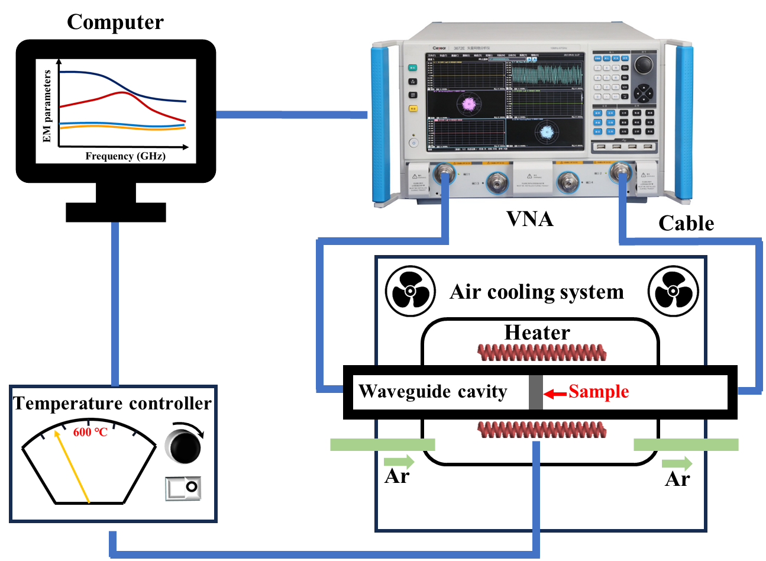
Fig. S1 Measurement of the high-temperature EM properties
Fig. S2 The EM parameters a–d and optical photographs e of PDMS matrix versus frequency at 298–573 K: (a, b) first test results, (c, d) second test results

